2025

Accessible Adirondack Tourism, Inc.

September 8, 2025
ADA Self-Evaluation Assessment
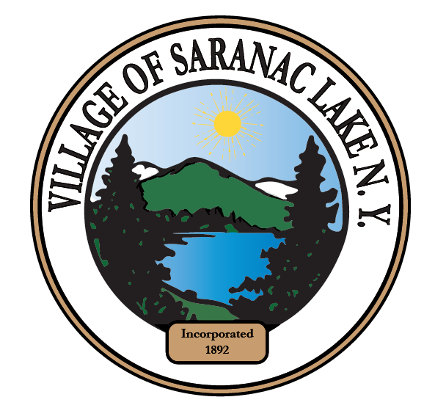
Contents
1. Statement of Appreciation 3
2. Introduction 3
3. Deadlines and Scheduling Conflicts 4
4. Recommended Resources and Documents 5
5. Executive Summary 6
5.1 Background 6
5.2 About Accessible Adirondack Tourism 6
5.3 Disclaimer 7
6. Demographics and Requirements 7
6.1 Disability Demographics 7
6.2 Americans with Disabilities Act (ADA) 7
6.3 Architectural Barriers Act (ABA) 8
6.4 International Building Code (IBC) 8
6.5 Requirements Interaction 8
6.6 ADA Self-Evaluation and Transition Plan Requirements 9
6.7 Discrimination and Accessibility 9
6.8 Definition of “undue burden” 10
7. Scope of Self-Evaluation 11
7.1 Built Environment 11
7.2 Policies, Communications, and Access 12
7.3 ADA Coordinator and ADA Liaisons 12
7.4 Policies and Procedures 12
7.5 Program Communication and Access 13
8. Assessment Methodology 13
8.1 Priority Ratings and Definitions 15
9. Park Assessments 16
1. Berkeley Green 16
2. Hydro Point Park 19
3. Mt. Pisgah Recreation Center 23
4. Prescott IPW Park 29
5. Riverfront Park 31
6. Riverside Park 35
7. Saranac Lake Riverwalk 39
8. Saranac Lake Skateboard Park 54
9. Ward Plumadore Park 56
10. William Morris Park 59
11. William Wallace Park/Lake Colby Beach/Saranac Lake Village Beach 61
12. World War 1 Memorial 67
Appendix A. Images 70
1. Berkeley Green 70
2. Hydro Point Park 74
3. Mount Pisgah Recreation Center 79
4. Prescott IPW Park 91
5. Riverfront Park 92
6. Riverside Park 98
7. Saranac Lake Riverwalk 103
8. Saranac Lake Skatepark 139
9. Ward Plumadore Park 141
10. William Morris Park 145
11. William Wallace Park (Lake Colby Beach) 146
12. World War I Memorial 152
Appendix B. Glossary 157
Appendix C. Resolution of the Village Board 159

Statement of Appreciation
The successful completion of this ADA Self-Evaluation Assessment for the Village of Saranac Lake would not have been possible without the dedicated cooperation and support of Village leadership and staff.
We, the Board of Directors of Accessible Adirondack Tourism, Inc., extend our sincere gratitude to Mayor Jimmy Williams, Deputy Mayor and Trustee Matthew Scollin, Trustee Kelly Brunette, Trustee Aurora White, and Trustee Sean P. Ryan, whose sponsorship of the resolution to ensure that this important project could move forward is sincerely appreciated.
Special thanks are also due to Village Manager Bachana Tsiklauri, Community Development Director Katrina Glynn, Assistant Community Development Director Bayle Reichert, and Parks Manager John Dixon, whose commitment, guidance, and collaboration were instrumental in advancing this effort.
Their leadership and collective vision have been essential to ensuring that the Village continues to move toward a more inclusive and accessible future for all residents and visitors.

Introduction
This ADA Self-Assessment for the Village of Saranac Lake New York (hereinafter the “Village”) was conducted by Accessible Adirondack Tourism, Inc. (hereinafter “Accessible Adirondack Tourism”), in partnership with the Village. The assessment process was designed to provide a comprehensive review of the accessibility of public facilities, with a particular focus on Village parks and recreation areas, to ensure compliance with the Americans with Disabilities Act (ADA) through the most recent standards promulgated by the Architectural Barriers Act (ABA), and the International Building Code (IBC), upon which the New York State Building Code is based, in support the Village’s commitment to inclusion for all residents and visitors.
A total of twelve Village parks were assessed during this project. To strengthen the evaluation process and ensure that real-world accessibility needs were represented, two individuals with disabilities participated directly in the assessments. Their lived experience provided valuable insight that complemented the technical expertise of the assessors and allowed for more meaningful recommendations.
The assessment team consisted of Accessible Adirondack Tourism personnel, and included two people with disabilities, Tara Gagne, who suffered a traumatic brain injury, and Lynn DeWalt, who lost his leg in a motorcycle accident two years ago and utilizes a wheelchair. This ensured real-world experiences would be taken into account for this Assessment, as measurements and math may sometimes not equate to real world experiences.
The assessment team encountered several challenges over the course of the project. Inclement weather conditions in the early spring occasionally limited the ability to measure, document, or photograph site features, requiring careful scheduling and return visits.

Deadlines and Scheduling Conflicts
This Assessment was initially to be delivered in two parts. First, to accommodate the CWP the Riverwalk portion of the assessment was to be delivered by May 30, 2025. However, inclement weather conditions during the month of May, lasting into early June, required frequent rescheduling and the deadline could not be met. Accessible Adirondack Tourism discussed this with the provider of the CWP who indicated delays were acceptable under the circumstances. The remainder of the assessment was due July 15, 2025, yet in the interim Accessible Adirondack Tourism personnel learned that there was substantial confusion from the Village as to which route constituted the Riverwalk.
There are various signs throughout the Village which designate “the” Riverwalk, one route directs visitors down multiple flights of stairs, while another route directs visitors down a steep driveway then up a steep back alley, down (or up) a steep back-alley hill. This added a substantial, unanticipated workload to the assessment team, delaying the Riverwalk assessment further. It then became clear that the Riverwalk assessment, and that of the other eleven parks should be combined to save time, as preparing two separate assessment documents would have caused even more delays.
Following the conclusion of the assessment’s information gathering period, and when this document was nearing completion, stencils were painted upon various portions of sidewalk that added a third route which sends visitors through a bridge walkway that is too narrow for wheelchairs, forcing wheelchair users into a vehicle lane without guardrail protection that is offered to able-bodied pedestrians (see section 9. Park Assessments § 7. Saranac Lake Riverwalk, below). This redesignation of the Saranac Lake Riverwalk, without notice to Accessible Adirondack Tourism, required an assessment of the Riverwalk for a third time to ensure that the updated findings were accurately reflected herein, and significantly delayed the preparation of this document. By the time Accessible Adirondack Tourism personnel happened upon the stencils, the Adirondack Nature Festival for People with Disabilities, within which Accessible Adirondack Tourism personnel were extensively involved and were previously committed, was just weeks away. Necessary follow-up after the festival was required, further delaying the third assessment of the Riverwalk.
Despite these challenges, the assessments yielded a thorough and reliable picture of accessibility across Village parks. This report is intended to guide the Village in planning future improvements, prioritizing barrier removal, and building upon its commitment to equitable access in public spaces.

Recommended Resources and Documents
- ADA Update: A Primer for State and Local Governments
https://www.ada.gov/resources/title-ii-primer/
- ADA Topics Title II - State and Local Governments
https://www.ada.gov/topics/title-ii/
- Architectural Barriers Act Accessibility Standards
https://www.access-board.gov/aba/
- The ADA and City Governments: Common Problems
https://www.ada.gov/resources/ada-city-governments/

Executive Summary

5.1 Background
Community Development personnel had contacted Accessible Adirondack Tourism to provide the Village with an ADA evaluation of all Village parks. Subsequently, it was learned that a Comprehensive Wayfinding Proposal (“CWP”) was approved by the Village to develop and implement trailhead kiosks, printed maps, interpretive signage, on-trail directional signs, and a mobile-friendly interactive map to support Riverwalk access, navigation, and visitor experience. The CWP provided that “A key focus of this project is highlighting accessibility, ensuring that the signage and maps emphasize accessible routes and features for all visitors.” and that “Inclusive Routes and Amenities must ensure all visitors, including those with mobility challenges, can navigate comfortably.” However, there was no preceding accessibility survey of the Riverwalk upon which the CWP could rely upon to provide those services.
Accordingly, on May 7, 2025, Accessible Adirondack Tourism proposed to provide this ADA Self-Evaluation Assessment for all twelve of the Village’s active parks to provide the Village with a comprehensive view of the accessibility status of the entirety of their active park system. On May 12, 2025, the Village Board of Trustees unanimously approved the proposal citing the CWP and that “the Village Board acknowledges that accessibility for people with disabilities is important for the people of the Village of Saranac Lake at all of our municipal parks;”

5.2 About Accessible Adirondack Tourism
Accessible Adirondack Tourism is a 501(c)(3) non-profit organization that provides people with disabilities with a single, reliable resource for choosing were to visit, dine, shop, stay, and play, by virtue of the assurance that reasonable accommodations for their disabilities will be provided, actively and/or passively, when they choose to travel, live and/or work within the Adirondack region. We also provide educational and assessment resources to organizations within the Adirondack region, vigorously advocate for organizations to serve their entire community, including people with disabilities, and promote organizations that are accessible, in their physical locations, websites and social media presences, and direct tourists who rely on accessibility accommodations, to those organizations.

5.3 Disclaimer
This ADA Self-Assessment has been prepared for the Village to assist in evaluating accessibility under the Americans with Disabilities Act (ADA) and related standards. The information, findings, and recommendations contained herein are based on available records, site observations, and professional judgment at the time of preparation. While reasonable care has been taken to ensure accuracy, this document is not warranted to be free of human error, omissions, or interpretive differences. It should not be construed as legal advice, nor does it represent a guarantee of full compliance with federal, state, or local accessibility requirements. The Village reserves the right to update, amend, or supplement this assessment as additional information becomes available or as regulations are revised.

Demographics and Requirements

6.1 Disability Demographics
In 2022, approximately 44.1 million non-institutionalized individuals in the U.S., about 13.4% of the population reported having a disability. The New York State Department of Health provides that “more than 1 in 4 or 27% of New York State adults” self-report at least one disability.

6.2 Americans with Disabilities Act (ADA)
Applies to: All state and local governments (Title II) and their programs, services, and facilities.
- Program access requirement: Local governments must ensure that all services, programs, and activities are accessible to people with disabilities, when viewed in their entirety (28 CFR §35.150). This does not mean every facility must be retrofitted, but accessibility must be available.
- Self-evaluation and transition plan: Required for governments with 50+ employees. A self-assessment must identify barriers, and a transition plan must describe how and when those barriers will be removed (28 CFR §35.105–.150).
- Facilities and new construction: Any new or altered facilities must comply with the 2010 ADA Standards for Accessible Design (DOJ/DOTr enforce these).
- Communications and policies: Governments must provide effective communication (e.g., interpreters, large-print materials) and modify policies where needed to avoid discrimination.

6.3 Architectural Barriers Act (ABA)
Applies to:
- Facilities designed, built, altered, or leased with federal funds or on federal property.
- Local governments are subject to ABA only if they build or alter facilities with federal funding or on federal land.
- Such projects must comply with the ABA Accessibility Standards (closely aligned with ADA Standards).
Examples: A federally funded community center, or a park built with federal grant money, must meet ABA standards in addition to ADA obligations.

6.4 International Building Code (IBC)
- Applies to: Local governments as the authority having jurisdiction (AHJ), and to public facilities they construct.
- IBC is a model code adopted by most states and municipalities (New York State uses the NYS Building Code, based on the IBC).
- Chapter 11 of the IBC requires accessible design and construction of public buildings and facilities, referencing ICC A117.1 Accessible and Usable Buildings and Facilities (technical standard).
For local governments, this means:
- When constructing or renovating facilities, they must meet IBC accessibility provisions as enforced by building officials.
- Compliance with IBC accessibility generally also ensures compliance with ADA construction requirements, since both align closely.

6.5 Requirements Interaction
- ADA (civil rights law): Requires program accessibility and nondiscrimination in all services, programs, and facilities of local governments.
- ABA (design standards law): Applies only when federal money or property is involved.
- IBC (building code): Enforced through local permitting/inspections to ensure accessible design at construction stage.

6.6 ADA Self-Evaluation and Transition Plan Requirements
The Village is dedicated to inclusion, accessibility, and the removal of barriers.
The Village's ADA requirements are to:
- Evaluate all programs, services, and activities to ensure they meet ADA standards
- Identify and address any physical or other barriers that might limit access to these services and programs
- Propose and implement effective solutions to achieve compliance
- Develop a phased schedule for putting these solutions into place
In addition, the ADA requires the Village to:
- Appoint an ADA Coordinator to oversee all compliance efforts
- Establish a formal ADA grievance procedure for public use
- Maintain the Self-Evaluation and Transition Plan and make it available for public review for three years

6.7 Discrimination and Accessibility
ADA Title II, along with regulations from the EEOC, DOJ, and DOT, connects the idea of discrimination with access. This includes both physical access and program access.
Physical Access
Physical access means a facility must be free of barriers that prevent people from participating. Barriers are any obstacles, as defined by ADA Title II, Section 35.1493, that restrict or stop access to a building, right-of-way, or park.

Program Access
Program access, as defined in ADA Title II, Section 35.150(a), goes beyond just physical accessibility. It also covers a public entity's policies, procedures, communications, and practices. Program access ensures people with disabilities have an equally effective opportunity to participate in or benefit from programs and services.
This can be achieved through both structural and non-structural methods. Non-structural solutions might include getting new equipment, providing auxiliary aids, or offering services at different locations.
Important Exceptions
While both physical and program access are used to ensure participation, some exceptions apply to existing facilities under ADA Title II, Section 35.150. A public entity is not required to:
- Make every existing facility accessible
- Do anything that would harm the historic significance of a property
- Fundamentally change its services, programs, or activities
- Create hazardous conditions
- Incur an undue financial or administrative burden
Program access includes many areas, such as advertising, eligibility, physical access, providing auxiliary aids, transportation, and communication.

6.8 Definition of “undue burden”
State/local governments need to make reasonable modifications when necessary to accommodate people with disabilities.
Under Title II of the Americans with Disabilities Act (ADA), public entities are not required to take any action that would result in an "undue financial and administrative burden." As outlined in the Department of Justice's regulations, specifically 28 C.F.R. 35.150(a)(3), this provision is a key exception to the general requirement for program accessibility in existing facilities. The term "undue burden" is defined as a "significant difficulty or expense." The burden of proving this rests with the public entity, and the decision must be made by the head of the entity or their designee after considering all available resources. The determination must be accompanied by a written statement of the reasons for the decision. If an action is deemed an undue burden, the public entity is still obligated to find and implement alternative measures that do not create such a burden but still ensure individuals with disabilities receive the benefits or services provided. This balancing act ensures that accessibility is prioritized while acknowledging the real-world financial and administrative constraints that public entities may face.

Scope of Self-Evaluation

7.1 Built Environment
The self-evaluation process assessed twelve parks owned by the Village. These include:
1. Berkeley Green (including adjacent restroom facilities and parking lot)
2. Hydro Point Park
3. Mt. Pisgah Recreation Center
4. Prescott Park
5. Riverfront Park
6. Riverside Park
7. Saranac Lake Riverwalk
8. Saranac Lake Skatepark
9. Ward Plumadore Park
10. William Morris Park
11. William Wallace Park/ Lake Colby Beach
12. World War 1 Memorial
In addition, the assessments included all sidewalks and hard-surface access points to those parks to ensure they comply with applicable ADA regulations and guidelines. The information collected by Accessible Adirondack Tourism will be used to help Village decision-makers effectively plan and budget for future accessibility improvements.
The New York State Building Code 2020 is based on the International Building Code 2018 (IBC 2018) (with amendments and additions) (hereinafter the “IBC”).

7.2 Policies, Communications, and Access
The Village provides municipal programs and services though the following 13 departments:
- Village Manager | - Village Clerk
- Village Treasurer | - Community Development
- Code Enforcement | - Public Works
- Streets | - Water and Sewer
- Central Garage | - Fire
- Police | - Parks
- Mount Pisgah

An online search and a request to the Village failed to locate any ADA related policies and procedures.
It is therefore recommended that the Village immediately implement the following policies and procedures in accordance with ADA requirements:

7.3 ADA Coordinator and ADA Liaisons
  - Provide official title of ADA Coordinator to a Village representative
  - Introduce and provide ADA Coordinator Training through ADA National Network
  - Develop centralized databases to effectively organize and monitor complaints, accommodation requests, and training efforts (recommended)
  - Establish an ADA Liaison within the Village’s Parks & Recreation Department (recommended)

7.4 Policies and Procedures
  - Develop a Village policy on other power-driven mobility devices
  - Develop a Village policy on service animals
  - Develop a Village policy in accessible ticket sales for events organized and run by the Village that require ticket sales
  - Maintain a list of pre-qualified contractors that ensure ADA compliance and assist in avoiding ADA compliance litigation (recommended)
  - Evaluate Village leased properties to ensure ADA compliance
  - Develop Law Enforcement Policies, Practices, and Procedures for dealing with people with disabilities

7.5 Program Communication and Access
  - Identify alternate, accessible locations for facilities that are non-compliant
  - Provide interpreters and captioning for City meetings
  - Provide assistive listening devices for all public meetings
  - Ensure the Village website is ADA/WCAG compliant. The current website uses an overlay solution that does not alter the actual code and content of the website. The W3C’s official WCAG conformance note says: “To conform to WCAG 2, you need to satisfy the success criteria, that is, there is no content which violates the success criteria.” An overlay cannot make non-conformant content conformant if violations remain in the underlying page. The overlay widget used in the Village’s website (Userway) is now the subject of a class action lawsuit, and the Federal Trade Commission filed a complaint against a similar overlay solution. The Village is therefore subject to significant legal liability for their current website and we strongly urge the Village to remediate their website as soon as possible

8. Assessment Methodology
The ADA Self-Assessment for the Village was conducted using a structured, multi-step approach designed to align with the 2010 ADA Standards for Accessible Design, the Architectural Barriers Act (ABA) Accessibility Standards, and International Building Code (IBC) standards for best practices in municipal accessibility planning. The following steps were taken:
- Pre-Assessment Coordination
    - Accessible Adirondack Tourism worked with Village staff to identify all parks and recreation sites under Village jurisdiction
    - A schedule was developed to ensure coverage of all twelve Village parks, with adjustments made to account for site availability. However, Accessible Adirondack Tourism’s schedule could not account for the redesignation of the Riverwalk route which was contrary to the signage posted prior to the assessment and then changed with sidewalk stenciling after the assessment without notification to us, and the unusually wet weather conditions during the initial phases of our assessment
- On-Site Evaluations
  - Assessors conducted field inspections of each park, documenting conditions related to accessible routes, parking, restrooms, picnic areas, playgrounds, seating, and other amenities
  - Two community members with disabilities joined the assessment team on multiple site visits, providing direct feedback on usability and barriers encountered in real time
  - Measurements were taken of paths, ramps, railings, surfaces, slopes, and clearances, using calibrated tools consistent with ADA, ABA and IBC technical requirements
  - GPS coordinates are provided as additional guidance as to the location of each feature and are typically accurate to with four feet
- Documentation and Analysis
  - Each site was photographed and mapped to record conditions accurately.
  - On each map, the direction north is towards the top of the map
  - Image numbers are taken from the original digital file names of the images to ensure consistency between the images presented herein and those retained by Accessible Adirondack Tourism
  - Findings were compared against applicable ADA, ABA, and IBC scoping and technical requirements to identify barriers and non-compliant elements
  - The redesignation of the Saranac Lake Riverwalk was incorporated into the process, requiring the team to conduct a reassessment to reflect its new scope and features
- Challenges and Adjustments
  - Weather interruptions required re-scheduling or revisiting sites, particularly where rain obscured features such as surface conditions or signage
  - In these cases, supplemental observations were made during improved conditions to ensure accuracy and completeness
- Reporting and Recommendations
  - Results from each park were compiled into this report, including identified barriers, compliance gaps, and practical recommendations for remediation
  - Priority levels were assigned to help the Village plan improvements based on safety, feasibility, and community impact
This methodology ensured that the Self-Assessment was not only a technical compliance review but also a practical evaluation grounded in user experience, providing the Village with a reliable foundation for its accessibility planning efforts.

8.1 Priority Ratings and Definitions
Each finding from the data collection team was assigned a priority: High, Medium, Low, or Accessible. This priority reflects the severity of the non-compliant element, or aspects of a location that is compliant.
ADA/ABA Audit and Priority Level for Action Suggested
Level Depiction | Level | Explanation of Level
 | 1 | HIGH PRIORITY – ADA Compliance and Safety Concern  This issue poses potential health and safety risks and may lead to significant legal consequences if not addressed. Immediate corrective action is strongly recommended. Implementing the required changes will greatly improve current accessibility conditions.
 | 2 | MEDIUM PRIORITY – Actions recommended for the near term to address access issues or implement improvements with a meaningful impact. These may involve simple, low-cost solutions that can be carried out quickly.
 | 3 | LOW PRIORITY – Actions suggested for the medium to long term that will contribute to meaningful improvements. These may involve higher costs or be best addressed as part of a future renovation or major upgrade plan.

9. Park Assessments
- Berkeley Green
Including adjacent restroom facilities and parking lot
Location: Downtown, Center, Saranac Lake, intersection of Broadway and Main streets.
Address: N/A
GPS”: 44.32720807562615, -74.13107175050963
Google Maps Plus Code: 8VG9+VH Saranac Lake, New York
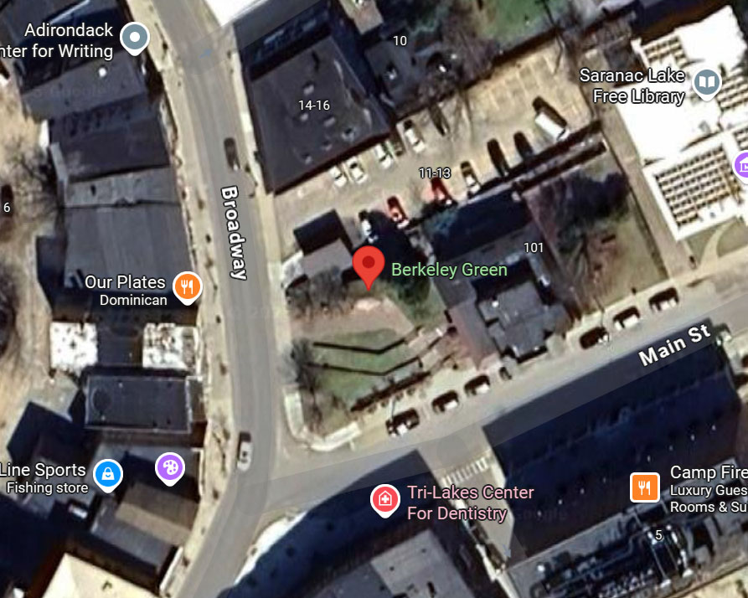
Summary: Multi-terraced performance park venue with a gazebo area for performers, speakers, etc., and an adjacent parking lot and two restrooms. Accessible sidewalk ramp at Main Street and Broadway lead to a brick path to access the space. Wheelchairs can be accommodated in various areas, but seating on the concrete block terraces can be awkward for those with mobility impairments. Gazebo has no wheelchair access and a step up of 10”, with no meaningful handrail access to the stage area as the only rail, to the left of the stage entrance, is more than 2 feet (25”) from the step and stage.
The parking lot is marked, signed and surfaced in accordance with ADA/ABA requirements, and has an accessible route via the sidewalk, to the park and performance area.
Important: Restrooms between the park and parking areas do not have visual and audible fire alarm systems. This presents serious hazards as the building housing the restrooms has a secured room with electrical and other equipment that, should a fire develop within it, smoke and fire may spread into the enclosed bathrooms without warning to the occupants to immediately evacuate.
Note: Restrooms between the park and parking areas have exterior doors which are very difficult to push open. A maximum opening force for exterior hinged doors is not specified in the ADA/ABA standards, as the opening force of exterior swing doors is impacted by wind loading and other exterior conditions, gasketing, HVAC systems, energy efficiency, and the weight of doors. On interior doors, accessibility standards restrict the amount of force to 5 pounds of force (lbf). The team tested each of the bathroom doors and recorded 89.8 lbf on the left door (see, image Berkeley Green (136)), and 48.7 lbf on the right door (see, image Berkeley Green (138)), after the doors were already unlatched and slightly opened.
Recommendation: Adjust the doors for access and/or install a push-button, power assisted door opening system.

Priority: HIGH
Feature: Restrooms adjacent to the park, and parking area.
Location on Property: Restrooms. The only object present on the ceiling of each restroom is a Test Switch for KEM Battery Backups. This is a built-in control that lets you simulate a power outage to check if the emergency lighting works properly.
Reference Image(s): Berkeley-Green-(142)
ABA Reference: Chapter 2, Fire Alarm Systems: Signs F215.2 “Alarms in public use areas and common use areas shall comply with 702.”, and 702 (Fire Alarm Systems / technical). Visible and audible alarms must comply with NFPA 72 (and ICC A117.1 guidance for accessibility),
IBC Reference: 907.9.1.1 Public and common areas. “Visible alarm notification appliances shall be provided in public areas and common areas.”, and IBC requires fire alarm systems where the occupancy/Chapter 9 scoping calls for them (and specifically requires notification appliance coverage per 907 and NFPA 72). IBC typically defers technical appliance sizing/placement to NFPA 72 and defers accessibility integration to ICC A117.1 / ADA/ABA rules. In practice IBC says: if a fire alarm system is required/provided, it must meet NFPA 72 and local accessibility requirements.
Remediation: Add a fire alarm alert system that conforms to ABA and IBC standards.

Priority: Medium
Feature: Primary park sign.
Location on Property: Lawn next to Broadway.
Reference Image(s): Berkeley Green (1)
ABA Reference: Chapter 7: Signs F216.2 “interior and exterior signs identifying permanent rooms and spaces, where provided”.
IBC Reference: ANSI 703 Signs.
Remediation: Add signage at the start of the red paver walkway that conforms with ABA Chapter 7, Signs. Note, Visual and tactile requirements apply to both interior and exterior signs labeling permanent rooms and spaces. However, exterior signs not located at the door to the space they serve (there is no ‘door’ to the park) do not have to be tactile but must meet visual requirements (F216.2, Ex. 1).

Priority: Medium
Feature: Gazebo stage access.
Location on Property: Gazebo.
Reference Image(s): Berkeley Green (75), (93), and (87)
ABA Reference: Changes in Level 303 “Changes in level can be up to ¼” without treatment or ½” if beveled with a slope no steeper than 1:2. Changes in level above a ½” must be treated as a ramp or curb ramp (or a walkway if a slope no steeper than 1:20 can be achieved). These specifications apply to all portions of accessible routes, including thresholds and carpet trim”.
IBC Reference: ANSI 403.4 Changes in Level. Changes in level shall comply with Section 303.
Remediation: Move the planter on the left side of the gazebo (see, image Berkeley Green (87)), then install an ADA compliant ramp with handrails. This will maintain the front visual elements of the gazebo, while providing required access.

Hydro Point Park
Location: Behind the hydroelectric generation structure located at
17 Main Street, Saranac Lake, NY 12983
Address: N/A
GPS”: 44.3247191658772, -74.13246328005492
Google Maps Plus Code: 8VF8+VXX Saranac Lake, New York
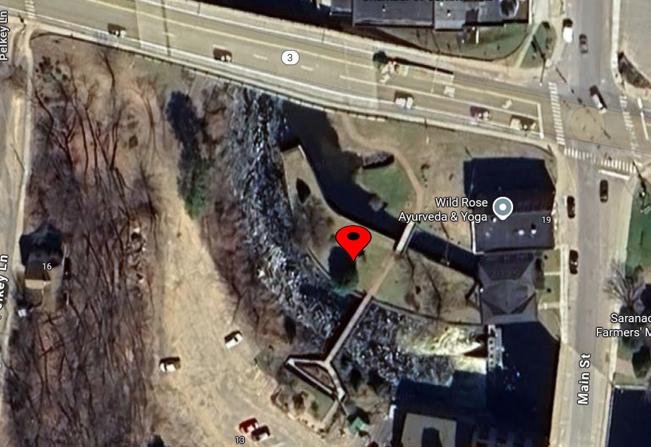
Summary: Hydro Point Park is a riverside recreational site along the Saranac River, extending roughly 500 feet downstream from Lake Flower Dam. The park is accessed from the parking lot to the south of the egress (in this document) from the Saranac Lake Riverwalk. The entrance from the parking lot is via a short path, then a landing area with interpretive signage and a picnic table, then down an accessible ramp, over a bridge where the park is present on the left and right sides.
There is no accessible picnic table within the park, although there is an inaccessible one. The grassy slope to enter the west side of the park exceeds the maximum ADA requirements for 10%.
The access path to this park is from two directions, which both are part of the Saranac Lake Riverwalk. To avoid duplication, evaluation of the access path to this park will be covered in the Riverwalk section of this document.
Important: A significant danger is present in the park; there is no warning of the hazard of a drop into the water from the top of the wall on the north end of the park.

Priority: HIGH
Feature: The north end of the park has a sudden drop off at least 6 feet into the water that does not have any guards as required by the IBC, nor hazardous area signage or other indicators of the potential hazard (see, Hydro-Point-Park (16) and (17).
Location on Property: North end of the park has a sudden drop off at least 6 feet into the water (GPS” 44.32480082696296, -74.13249955161857).
Reference Image(s): Hydro Point Park (17) and (18)
ABA Reference: Hazardous area signage is not mandated by the ADA. If signage is used as a key method of conveying safety information, it must be accessible to people with disabilities - especially those who are blind or have low vision. For more detailed rules on the design and color of hazardous warning signs, consult OSHA 1910.145 or ANSI Z535, which are safety-specific rather than ADA-specific. ABA Viewing Areas guidance: Guards/railings may be provided for safety but should obstruct the viewing window only as necessary; the clear viewing height should be between 32–51 in above the ground at the viewing space so wheelchair users can see over/through.
IBC Reference: IBC §1015 (Guards): Guards required at open-sided walking surfaces where drop ≥ 30 in; guard height ≥ 42 in. Openings: <4 in up to 36 in; ≤4-3/8 in between 36–42 in. Handrails (if present) 34–38 in (IBC §1014).
Remediation: Install railings/guards in compliance with IBC standards. Areas of concern should be cordoned off immediately to prevent injury to visitors until repairs can be made.

Priority: Medium
Feature: Picnic unit (table).
Location on Property: West lawn.
Reference Image(s): Hydro Point Park (16)
ABA Reference: Chapter 10, Outdoor Developed Areas, F106.5, F245.2.1 and F245.2.2. “A picnic facility is a site, or a portion of a site, that is developed for outdoor recreational purposes and contains picnic units.” “A picnic unit is an outdoor space in a picnic facility that is used for picnicking and contains at least one outdoor constructed feature.” F106.5, “When only one or two picnic units are provided in a picnic facility, each picnic unit must provide mobility features.” “When more than two picnic units are provided in a picnic facility, at least 20 percent, but no less than two, of the picnic units must provide mobility features.” F245.2.1, and “Picnic units with mobility features don’t have to be identified by signs. Entities should provide information on the location of picnic units with mobility features on Web sites, in brochures, and at bulletin boards or information kiosks at the picnic facility.” F245.2.2.
IBC Reference: N/A.
Remediation: Provide a wheelchair accessible picnic table at this location, and place information within the Village’s website, brochures, at bulletin boards or information kiosks at the location.

Priority: Medium
Feature: Access over west lawn to park and picnic area
Location on Property: The Outdoor Recreation Access Routes (ORAR) on west lawn to park and picnic area.
Reference Image(s): Hydro Point Park (19), (20), (21), (22), (23), and (24)
ABA Reference: Chapter 10, Outdoor Developed Areas, 1016.7.1 (Running Slope) and 1016.7.2 (Cross Slope). “Running slope, also referred to as grade, is the lengthwise slope of an ORAR, parallel to the direction of travel.” (ABA 1016.7.1). The running slope is made of grass, and cannot be greater than 10% for a 30-foot length. Running slope readings for the left side of the grass apron are 21.4%, the center is 13.2%, and the right side is 21.6% from the perspective of a person entering the west side of the park. Should a person enter the park at an angle, then the cross slope requirements equally apply and cannot be greater than 5% . “When the surface is constructed of materials other than concrete, asphalt, or boards, cross slopes no steeper than 1:20 (5 percent) are allowed when necessary for drainage.” (ABA 1016.7.2).
IBC Reference: N/A.
Remediation: Grade the west lawn into the park to a grade of less than 5%.

Priority: Medium
Feature: Primary park sign.
Location on Property: Any location at the actual entrance to Hydro Point Park.
Reference Image(s): Hydro Point Park (16) and (26)
ABA Reference: Chapter 7: Signs F216.2 “interior and exterior signs identifying permanent rooms and spaces, where provided”..
IBC Reference: ANSI 703 Signs.
Remediation: Add signage at the start of the red paver walkway that conforms with ABA Chapter 7, Signs. Note, Visual and tactile requirements apply to both interior and exterior signs labeling permanent rooms and spaces. However, exterior signs not located at the door to the space they serve (there is no ‘door’ to the park) do not have to be tactile but must meet visual requirements (F216.2, Ex. 1).

Mt. Pisgah Recreation Center
Location: Address Indicated
Address: 92 Mt. Pisgah Lane Saranac Lake, NY 12983
GPS”: 44.345763987739474, -74.12573125092477
Google Maps Plus Code: N/A
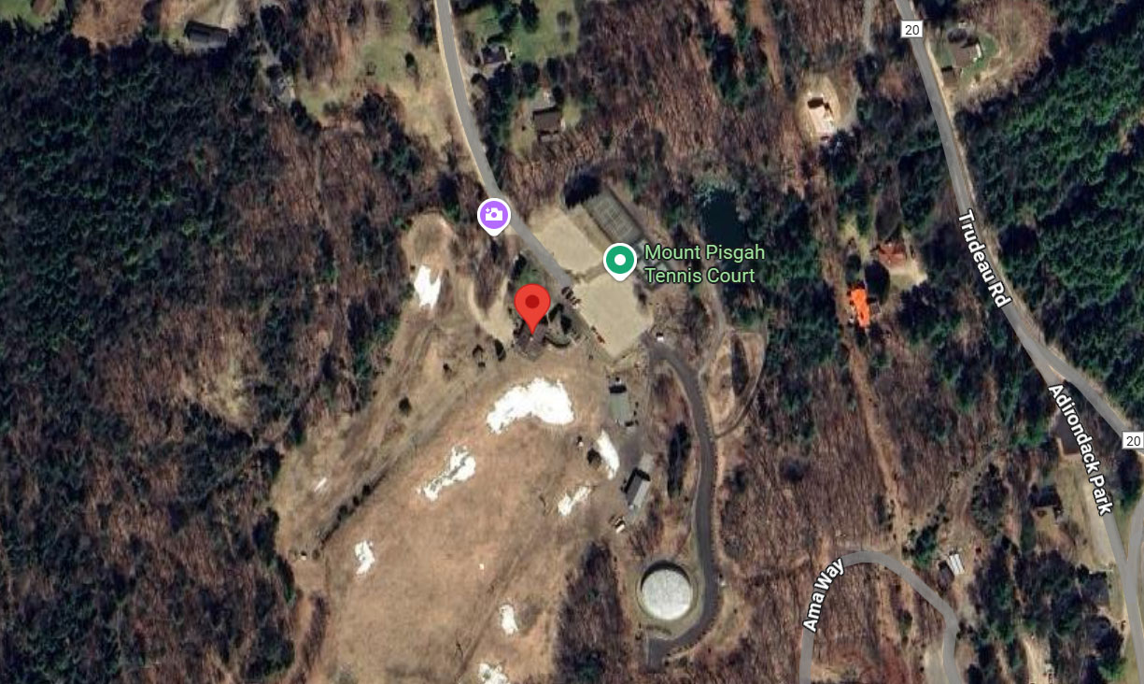
Summary: Mt. Pisgah Recreation Center is a multi-use recreation destination. Offering a variety of options for visitors including, in pertinent part, an event space, tennis and pickleball courts. There are no marked accessible parking spaces, and no clearly defined entrance for people with disabilities into the main building. While there is signage located at the beginning of the driveway up to the rear entrance to the main building, it notes that a reservation is required to use it. There is also a semi-portable restroom near the tennis courts that indicates accessibility, but access to the restroom is not ADA/ABA compliant.
The World War I Memorial section of the Center has no accessible approach. The stairway is not accessible, the slope on the lawn in front and that on the driveway to the right are too steep, with the concrete paver walkway traversing this area is in disrepair, even if there was an accessible route into the area.
Important: The front stairway (built in 2006 through an Eagle Scout project) to the main building is in disrepair, replete with various trip and fall hazards, including a partially protruding steel peg on the first step on the right side (see, Mt. Pisgah Recreation Center (107)). The tennis and pickleball courts themselves (excluding parking therefore) are ADA compliant.

Priority: HIGH
Feature: Front steps to main building.
Location on Property: Front of main building, nearly all steps pose some sort of hazard, from deep indentations, vegetation growth, slope and angle mismatches, and handrails that are rough and may subject users to splinters. Areas of concern should be cordoned off immediately to prevent injury to visitors until repairs can be made.
Reference Image(s): Mt. Pisgah Recreation Center (99), (102) and (107)
ABA Reference: 504.1 General, Access Board guidance: “Stable surfaces resist movement; firm surfaces resist deformation by indentations. Hardened materials (concrete, asphalt, wood, tile) are sufficiently firm and stable; some trail surfaces may be permitted but must meet the performance definitions.” (Access Board / Outdoor Developed Areas; ADA guidance §302 explainer).
IBC Reference: Section1009 Stairways and Handrails.
Remediation: Repair front steps and handrails to prove safe access for all visitors, and ADA compliance in accordance with ABA 504. Areas of concern should be cordoned off immediately to prevent injury to visitors until repairs can be made.

Priority: HIGH
Feature: World War I Memorial – Surface of concrete paver pathway poses a trip and fall hazard and is not ADA/ABA compliant.
Location on Property: Northwest of the stairs to the front entrance of the main building (GPS: 44.34562808195369, -74.12536572692862).
Reference Image(s): Mt. Pisgah Recreation Center (28), (29), and (30).
ABA Reference: 302.1 – Surface must be firm, stable, and slip-resistant. Concrete/asphalt/pavers allowed if installed properly.
IBC Reference: 1104.2 referencing ANSI A117.1 section 302.1. Same as ABA: walking surfaces must be firm, stable, and slip-resistant.
Remediation: Repair the pathway. Areas of concern should be cordoned off immediately to prevent injury to visitors until repairs can be made.

Priority: Medium
Feature: Primary park sign.
Location on Property: Any location at the entrance to the Recreation Center
Reference Image(s): N/A Multiple entrances from parking, back area, etc. to maintain signage.
ABA Reference: Chapter 7: Signs F216.2 “interior and exterior signs identifying permanent rooms and spaces, where provided”..
IBC Reference: ANSI 703 Signs.
Remediation: Add signage at the start of the red paver walkway that conforms with ABA Chapter 7, Signs. Note, Visual and tactile requirements apply to both interior and exterior signs labeling permanent rooms and spaces. However, exterior signs not located at the door to the space they serve (there is no ‘door’ to the park) do not have to be tactile but must meet visual requirements (F216.2, Ex. 1).

Priority: Medium
Feature: Parking spaces.
Location on Property: Back of main building.
Reference Image(s): Mt. Pisgah Recreation Center (37), (41) and (48)
ABA Reference: F208 Parking Spaces. Accessible parking spaces are required for each parking facility on a site, such as lots and garages. Requirements apply equally to public and employee or restricted parking. On sites with multiple parking facilities (such as at the base of Mt. Pisgah, the parking behind the main building, and the elevated parking area behind the main building), the minimum number of accessible spaces must be calculated separately for each parking facility instead of on the combined total of parking spaces provided on the site. At least one of every 6 accessible spaces, or fraction of 6, in each parking facility must be sized to accommodate vans.
IBC Reference: ANSI 502.1 General, ANSI 502.3 Vehicle Space Marking,
Remediation: Provide accessible parking spaces adjacent to the accessible entrance in the rear of the main building.

Priority: Medium
|Feature: Male restroom signage.
Location on Property: Main building.
Reference Image(s): Mt. Pisgah Recreation Center (66)
ABA Reference: 703.7.2.1 Accessible units must be identified with the International Symbol of Accessibility (ISA).
IBC Reference: 1110.1: Same as ABA. Must use the ISA to identify accessible features.
Remediation: Install ADA compliant signage.

Priority: Medium
Feature: Female Restroom signage.
Location on Property: Main building.
Reference Image(s): Mt. Pisgah Recreation Center (80)
ABA Reference: 703.7.2.1 Accessible units must be identified with the International Symbol of Accessibility (ISA).
IBC Reference: 1110.1: Same as ABA. Must use the ISA to identify accessible features.
Remediation: Install ADA compliant signage.

Priority: Medium
Feature: Approaches to accessible entrance.
Location(s) on Property: Driveway to accessible entrance in back of main building.
Reference Image(s): Mt. Pisgah Recreation Center (115), (116) and (117)
ABA Reference: 403.3 - ≤ 1:20 (5%) is allowed as a walking surface; steeper requires ramp. Current slope is 16.6%.
IBC Reference: 1104.2; ANSI 403.3 – Same as ABA: 1:20 max (5%) for walking surface, steeper requires ramp provisions.
Remediation: Create an alternative accessible approach to the accessible entrance for those who have mobility challenges and that either cannot, or do not wish to, drive up to the accessible entrance, or may drive up to find the lot full.

Priority: Medium
Feature: Portable toilet room .
Location(s) on Property: North-east of tennis courts (GPS: 44.34632100776017, -74.12552196559285).
Reference Image(s): Mt. Pisgah Recreation Center (137), (138), and (139)
ABA References:
- Signage: 703.7.2.1 Accessible units must be identified with the International Symbol of Accessibility (ISA)
- Entrance: 303.3 and 404.2.5: Max ½ inch (beveled; ¼ inch vertical max without bevel. Current height is over 9 inches (see, Mt. Pisgah Recreation Center (139))
IBC References:
- Signage: 1110.1: Same as ABA. Must use the ISA to identify accessible features
- Entrance: 1010.1.7: Max ½ inch at doorways on accessible routes
Remediation:
- Signage: Install ADA compliant signage
- Entrance: Use an ADA compliant ramp, but note that ramping directly up to the door of the unit makes it extremely difficult to pull the door open while positioned on a slope. If a ramp is provided, make sure that there is a level landing at least 5 feet long outside of the door to the unit and that it is in accordance with the above provisions. It may be easier and less expensive to replace the portable toilet room with one that is made to be ADA compliant, with the appropriate signage, at ground level and to keep the entrance and approach free of snow and ice when applicable

Priority: Medium
Feature: Path down to water feature.
Location(s) on Property: North-east of tennis courts (GPS: 44.34629942888114, -74.12540596006417).
Reference Image(s): Mt. Pisgah Recreation Center (143), (145) and (146)
ABA Reference: 403.3 - ≤ 1:20 (5%) is allowed as a walking surface; steeper requires ramp.
IBC Reference: 1104.2; ANSI 403.3 – Same as ABA: 1:20 max (5%) for walking surface, steeper requires ramp provisions.
Remediation: Current slope is 10.5%.Ensure an accessible route with a proper slope down to the water feature.

Priority: Medium
Feature: World War I Memorial – No accessible entrance.
Locations on Property: The stairs, grass slope, and driveway on the Northwest side all present barriers to accessibility.
Reference Image(s): Mt. Pisgah Recreation Center (24), (25 – grass 17.6% running slope), (26), (27 – driveway slope 15.1% running slope), (33 – stairs), and (36).
ABA Reference: 403.3 - ≤ 1:20 (5%) is allowed as a walking surface; steeper requires ramp.
IBC Reference: 1104.2; ANSI 403.3 – Same as ABA: 1:20 max (5%) for walking surface, steeper requires ramp provisions.
Remediation: Provide an accessible approach. A switchback path cut into the front grass may be the most economical avenue to achieve this goal as it would provide access, but not require modifications to the steps (except for safety), or the adjacent driveway.

Prescott IPW Park
Location: Bordering Lake Flower from the east side of the DEC Lake Flower Boat Launch to the to the intersection of River St. and Route 86
Address: N/A
GPS”: 44.32321060059611, -74.12502888095092
Google Maps Plus Code: 8VFF+7XQ Saranac Lake, New York
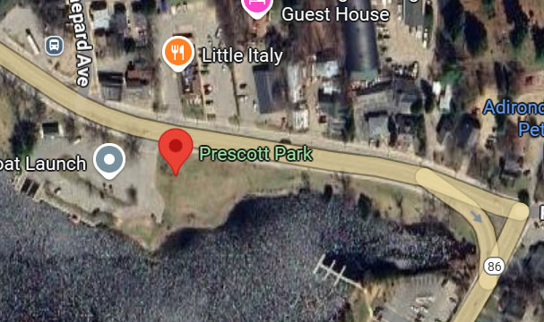
Summary: A greenery-filled setting featuring picnic tables, open lawns, and popular access for canoe and kayak launching, as well as being a favored spot for dog walking and casual outdoor enjoyment. While this location has two picnic tables, none are ADA/ABA compliant. Entrance to park is accessible over the level lawn.
Priority: Medium
Feature: Picnic units (tables).
Location on Property: Picnic tables are spaced to the east of the DEC boat launch where the park begins to narrow as it proceeds east.
Reference Image(s): Prescott Park (4)
ABA Reference: Chapter 10, Outdoor Developed Areas, F106.5, F245.2.1 and F245.2.2. “A picnic facility is a site, or a portion of a site, that is developed for outdoor recreational purposes and contains picnic units.” “A picnic unit is an outdoor space in a picnic facility that is used for picnicking and contains at least one outdoor constructed feature.” F106.5, “When only one or two picnic units are provided in a picnic facility, each picnic unit must provide mobility features.” “When more than two picnic units are provided in a picnic facility, at least 20 percent, but no less than two, of the picnic units must provide mobility features.” F245.2.1, and “Picnic units with mobility features don’t have to be identified by signs. Entities should provide information on the location of picnic units with mobility features on Web sites, in brochures, and at bulletin boards or information kiosks at the picnic facility.” F245.2.2.
IBC Reference: N/A.
Remediation: Provide a wheelchair accessible picnic table at this location, and place information within the Village’s website, brochures, at bulletin boards or information kiosks at the location.

Priority: Medium
Feature: Primary park sign.
Location on Property: Any location at the entrance to the park.
Reference Image(s): N/A Multiple entrances from side walk on River Street.
ABA Reference: Chapter 7: Signs F216.2 “interior and exterior signs identifying permanent rooms and spaces, where provided”.
IBC Reference: ANSI 703 Signs.
Remediation: Add signage at the start of the red paver walkway that conforms with ABA Chapter 7, Signs. Note, Visual and tactile requirements apply to both interior and exterior signs labeling permanent rooms and spaces. However, exterior signs not located at the door to the space they serve (there is no ‘door’ to the park) do not have to be tactile but must meet visual requirements (F216.2, Ex. 1).

Riverfront Park
Location: Bordering Lake Flower from the west side of the DEC Lake Flower Boat Launch to the to the east side of Riverside Park
Address: N/A
GPS”: 44.324239204223275, -74.12722695277431
Google Maps Plus Code: 8VFF+M4R Saranac Lake, New York
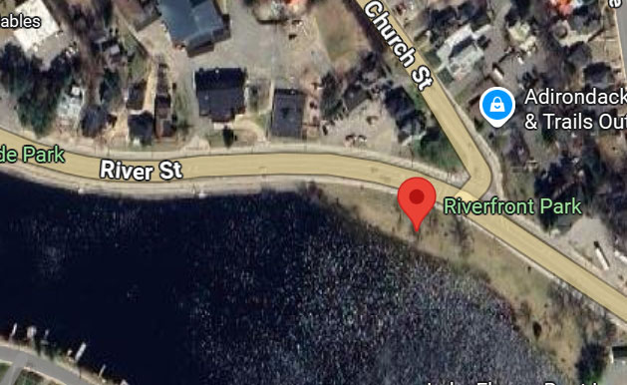
Summary: Bordering River Street on its north, Riverfront Park is accessed either by a 0.3-mile non-ADA/ABA compliant path from Riverfront Park to Riverside Park, or a parallel ADA/ABA compliant sidewalk that features concrete paver paths from the sidewalk to each of the two water feature overlooks over Lake Flower.
Priority: Medium
Feature: Overlook 1
Location on Property: First overlook when entering the main park area from the east of Riverside Park (GPS: 44.32449538392845, -74.129894368042). Edge is 3.5 inches high while the maximum allowable height is ½ inch in accordance with ABA and IBC standards.
Reference Image(s): Riverfront Park (28), (29), (31), (34), and (36)
ABA Reference: ABA 303 (via Access Board “changes in level”): Vertical change ≤ 1/4 in (6.4 mm) permitted; >1/4 in to 1/2 in (6.4–12.7 mm) must be beveled ≤ 1:2; >1/2 in requires a ramp or other compliant slope. ABA Outdoor Developed Areas §1016.5 (Obstacles): Obstacles (e.g., abutting surfaces, roots, speed bumps on shared routes) within the clear width of an ORAR are generally limited to 1/2 in (12.7 mm) in height at the highest point; guidance warns these create tripping/wheel device issues. ABA §405.9: Provide edge protection on ramp runs/landings. Options include: curb ≥ 4 in (405.9.1) or a barrier that prevents passage of a 4-in sphere ≤ 4 in above the surface (405.9.2); an extended floor/ground beyond handrails can also serve as edge protection.
IBC Reference: ICC A117.1 §303 (referenced by IBC Ch. 11): mirrors the same 1/4 in, 1/2 in beveled, >1/2 in = ramp rule. IBC Ch. 11 points to A117.1 for technical criteria. No direct IBC section for ORAR; in buildings/sites, IBC relies on ICC A117.1 §303 for the same 1/4 / 1/2 in beveled thresholds. Apply A117.1 where IBC Chapter 11 governs accessibility. ICC A117.1 §405.9 contains parallel edge-protection provisions for ramps; IBC adopts A117.1 via Ch. 11.
Remediation: Install a ramp to access the overlook in accordance with slope requirements of the ABA, and ensure the ramp has edge protection on ramps used as the transition (to reach the overlook) in accordance with ABA and IBC (adopting the ICC regulations) requirements noted above.

Priority: Medium
Feature: Overlook 2
Location on Property: Second overlook when entering the main park area from the east of Riverside Park (GPS: 44.32447427672415, -74.12903069677228). Edge is nearly 2.5 inches high while the maximum allowable height is 1/2 inch in accordance with ABA and IBC standards.
Reference Image(s): Riverfront Park (37), (39), (40), and (41)
ABA Reference: ABA 303 (via Access Board “changes in level”): Vertical change ≤ 1/4 in (6.4 mm) permitted; >1/4 in to 1/2 in (6.4–12.7 mm) must be beveled ≤ 1:2; >1/2 in requires a ramp or other compliant slope. ABA Outdoor Developed Areas §1016.5 (Obstacles): Obstacles (e.g., abutting surfaces, roots, speed bumps on shared routes) within the clear width of an ORAR are generally limited to 1/2 in (12.7 mm) in height at the highest point; guidance warns these create tripping/wheel device issues. ABA §405.9: Provide edge protection on ramp runs/landings. Options include: curb ≥ 4 in (405.9.1) or a barrier that prevents passage of a 4-in sphere ≤ 4 in above the surface (405.9.2); an extended floor/ground beyond handrails can also serve as edge protection.
IBC Reference: ICC A117.1 §303 (referenced by IBC Ch. 11): mirrors the same 1/4 in, 1/2 in beveled, >1/2 in = ramp rule. IBC Ch. 11 points to A117.1 for technical criteria. No direct IBC section for ORAR; in buildings/sites, IBC relies on ICC A117.1 §303 for the same 1/4 / 1/2 in beveled thresholds. Apply A117.1 where IBC Chapter 11 governs accessibility. ICC A117.1 §405.9 contains parallel edge-protection provisions for ramps; IBC adopts A117.1 via Ch. 11.
Remediation: Install a ramp to access the overlook in accordance with slope requirements of the ABA, and ensure the ramp has edge protection on ramps used as the transition (to reach the overlook) in accordance with ABA and IBC (adopting the ICC regulations) requirements noted above.

Priority: Medium
Feature: Park benches.
Location on Property: Interspersed throughout the park are numerous benches, none of which are ADA/ABA compliant as they are approximately 18 inches in depth, and the IBC requires them to be between 20 – 24 inches.
Reference Image(s): Riverfront Park (20), (21), and (25)
ABA Reference: Benches are explicitly listed as outdoor constructed features at outdoor recreation facilities. (ABA Guide Ch.10 “Outdoor Constructed Features – Definition” [F106.5]. At trailheads, along trails, and within viewing areas/picnic & camping facilities, at least 20% (but not less than one) of each type of outdoor constructed feature provided (including benches) must comply with the technical rules. (F247.3.1, F247.5, F246.3; also F244) for picnic/camping). Not specified in ABA outdoor bench section; ABA focuses on space & route. (Ch. 10 “Outdoor Constructed Features – Benches” table)
IBC Reference: IBC Ch. 11 scopes accessibility and points to ICC A117.1 for the technical rules; it does not enumerate “park benches.” (IBC Ch. 11 overview). IBC does not have a numeric requirement for outdoor park benches. Where benches are required in certain interior rooms (e.g., dressing/locker rooms, holding cells), those benches must meet A117.1 §903. (ICC A117.1 is the tech standard referenced by IBC; see A117.1 2009 §903). Explicit specs in ICC A117.1 §903: clear floor space for parallel approach (§903.2); seat length ≥ 42 in; depth 20–24 in (§903.3); back support from ≤2 in above seat to ≥18 in above, within 2½ in of rear edge (§903.4); seat height 17–19 in above floor (§903.5; child exceptions).
Remediation: Install at least 20% of benches in the park, but not less than one.

Priority: Medium
Feature: Primary park sign
Location on Property: Any location at the entrance to the park.
Reference Image(s): N/A Multiple entrances and opportunities to provide signage.
ABA Reference: Chapter 7: Signs F216.2 “interior and exterior signs identifying permanent rooms and spaces, where provided”.
IBC Reference: ANSI 703 Signs.
Remediation: Add signage at the start of the red paver walkway that conforms with ABA Chapter 7, Signs. Note, Visual and tactile requirements apply to both interior and exterior signs labeling permanent rooms and spaces. However, exterior signs not located at the door to the space they serve (there is no ‘door’ to the park) do not have to be tactile but must meet visual requirements (F216.2, Ex. 1).

Riverside Park
Location: Southeast corner of Main and River streets
Address: N/A
GPS”: 44.32462775507663, -74.13087547972063
Google Maps Plus Code: 8VF9+VJ5 Saranac Lake, New York
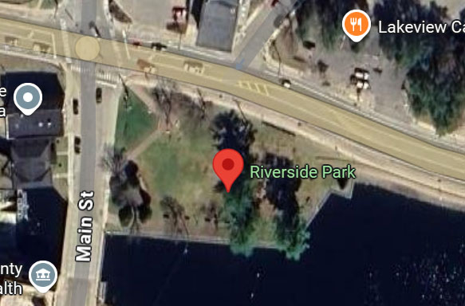
Summary: Riverside Park occupies a cherished location at the corner of Main and River Streets, right along the shore of Lake Flower in downtown Saranac Lake. This Park is a dynamic event space and home to the Saranac Lake Farmers Market in summer months, and a central venue for Music on the Green, a free Wednesday evening summer concert series featuring folk, jazz, blues, and indie performers. Highlights include a bandshell located lakeside, used for concerts and seasonal festivals like the Winter Carnival, which floods the park with activity during February, and convenient docks where those who arrive by boat can disembark and enjoy Saranac Lake’s downtown area.
Important: The entry to the boat dock area has a 3” minimum curb height to enter. As a trip or fall at this location may result in a visitor stumbling, then falling into the water, this presents a serious safety risk and should be remediated as soon as possible.
Additionally, the bandshell recently received a new front deck area, with steps on both sides, and a large single step-up access in front. None of the step areas have handrails. As new construction, the stage area extension was required to be made ADA/ABA compliant, yet those with mobility challenges may not be able to make it up the steps, and wheelchair users cannot access the stage area at all.
Priority: HIGH
Feature: Boat docks
Location on Property: East side of park on Lake Flower (GPS”: 44.32443224167006, -74.1308230002432).
Reference Image(s): Riverside Park (30), (31), (33) and (34)
ABA Reference: If boarding piers are provided at launch ramps, at least 5% but not less than one must comply and be on an accessible route (ABA F235.3; technicals in §1003.2.2 & §1003.3.2). Boating facilities that must be accessible are required to be on an accessible route. (ABA F206 / boating-specific F206.2.9; technical routes modified by §1003.2.). See, Chapter 10, Recreational Boating Facilities. Clear pier space along the slip/boarding pier, generally 60 in min along the full length, with specific exceptions for width and edge protection (1003.3.1–.2 & exceptions). Openings in floor/ground surfaces ≤ 1/2 in. (sphere rule). (§302.3) (3” gap between shore and dock).
IBC Reference: IBC §1111.4.9.3: Where boarding piers are provided at boat launch ramps, ≥5% but not less than one must be accessible and on an accessible route. Requires accessible routes to recreational facilities “to the extent specified in Section 1111.” Boating facilities covered by §1111.4.9 must be on an accessible route. (IBC 1104.3 Exceptions; 1111.4 & 1111.4.9.). IBC §1111.4.9.1 provides a table for minimum accessible boat slips and defines the “every 40 ft of slip edge = one slip” counting rule; §1111.4.9.2 requires dispersion by type. A117.1 Ch. 10 provides the matching technicals (e.g., 60-in clear pier space extending full length; edge protection allowances). IBC §1111.4.9 invokes these by reference to A117.1. The IBC relies on ICC A117.1 for these accessibility surface details; IBC does not itself set the 1/2-in. opening limit. (ICC A117.1 Ch. 3/4—referenced by IBC) (3” gap between shore and dock).
Remediation: Ensure the approach and entry to the boat dock has a ramp or slope (there is a 3” minimum curb to enter the dock area on the left, and a large hole on the right prohibiting wheelchair users from entering and posing a trip hazard). Install a transition plate between the shore and boat dock as the space between the shore and boat dock is 3”, and that the dock and boat slips comply with the above standards. Areas of concern should be cordoned off immediately to prevent injury to visitors until repairs can be made.
Priority: Medium
Feature: Bandshell.
Location on Property: West side of park abutting the Main Street sidewalk (GPS”: 44.32463396436345, -74.13154941237839).
Reference Image(s): Riverside Park (3), (4), and (5)
ABA Reference: Changes in Level 303 “Changes in level can be up to ¼” without treatment or ½” if beveled with a slope no steeper than 1:2. Changes in level above a ½” must be treated as a ramp or curb ramp (or a walkway if a slope no steeper than 1:20 can be achieved). These specifications apply to all portions of accessible routes, including thresholds and carpet trim”.
IBC Reference: ANSI 403.4 Changes in Level. Changes in level shall comply with Section 303.
Remediation: Install an ADA/ABA/IBC compliant ramp for access to the stage area of the bandshell.

Priority: Medium
Feature: Paver path near boat docks.
Location on Property: Paved path to the north of the entrance to the boat docks (GPS”: 44.32444206046112, -74.13083858754008).
Reference Image(s): Riverside Park (36) and (37)
ABA Reference: 302.1 – Surface must be firm, stable, and slip-resistant. Concrete/asphalt/pavers allowed if installed properly. 403.3 - ≤ 1:20 (5%) is allowed as a walking surface.
IBC Reference: 1104.2 referencing ANSI A117.1 section 302.1. Same as ABA: walking surfaces must be firm, stable, and slip-resistant. 1104.2; ANSI 403.3 – Same as ABA: 1:20 max (5%) for walking surface.
Remediation: Pathway slopes in odd directions away from the center line at a steep angle of 18.2%, potentially trapping a wheelchair user next to the gate. Repair the pathway to conform with the above standards.

Priority: Medium
Feature: Park benches
Location on Property: Interspersed throughout the park are numerous benches, none of which are accessible as they are approximately 19.5 inches in depth, and the IBC requires them to be between 20 – 24 inches.
Reference Image(s): Riverside Park (24)
ABA Reference: Benches are explicitly listed as outdoor constructed features at outdoor recreation facilities. (ABA Guide Ch.10 “Outdoor Constructed Features – Definition” [F106.5]. At trailheads, along trails, and within viewing areas/picnic & camping facilities, at least 20% (but not less than one) of each type of outdoor constructed feature provided (including benches) must comply with the technical rules. (F247.3.1, F247.5, F246.3; also F244) for picnic/camping). Not specified in ABA outdoor bench section; ABA focuses on space & route. (Ch. 10 “Outdoor Constructed Features – Benches” table).
IBC Reference: IBC Ch. 11 scopes accessibility and points to ICC A117.1 for the technical rules; it does not enumerate “park benches.” (IBC Ch. 11 overview). IBC does not have a numeric requirement for outdoor park benches. Where benches are required in certain interior rooms (e.g., dressing/locker rooms, holding cells), those benches must meet A117.1 §903. (ICC A117.1 is the tech standard referenced by IBC; see A117.1 2009 §903). Explicit specs in ICC A117.1 §903: clear floor space for parallel approach (§903.2); seat length ≥ 42 in; depth 20–24 in (§903.3); back support from ≤2 in above seat to ≥18 in above, within 2½ in of rear edge (§903.4); seat height 17–19 in above floor (§903.5; child exceptions).
Remediation: Install at least 20% of benches in the park, but not less than one.

Priority: Medium
Feature: Primary park sign
Location on Property: Any location at the entrance to the park.
Reference Image(s): N/A Multiple entrances and opportunities to provide signage.
ABA Reference: Chapter 7: Signs F216.2 “interior and exterior signs identifying permanent rooms and spaces, where provided”.
IBC Reference: ANSI 703 Signs
Remediation: Add signage at the start of the red paver walkway that conforms with ABA Chapter 7, Signs. Note, Visual and tactile requirements apply to both interior and exterior signs labeling permanent rooms and spaces. However, exterior signs not located at the door to the space they serve (there is no ‘door’ to the park) do not have to be tactile but must meet visual requirements (F216.2, Ex. 1).

Saranac Lake Riverwalk
Location: Varies based on signage, personal interpretation, and/or sidewalk stencils
Address: N/A
GPS”:
Next to RiverTrail Beerworks : 44.328959031832234, -74.12884201629144
Behind Hydro Point Park: 44.3244153969276, -74.1325863799974
Google Maps Plus Codes:
Next to RiverTrail Beerworks: 8VHC+HFM Saranac Lake, New York
Behind Hydro Point Park: 8VF8+QX7 Saranac Lake, New York
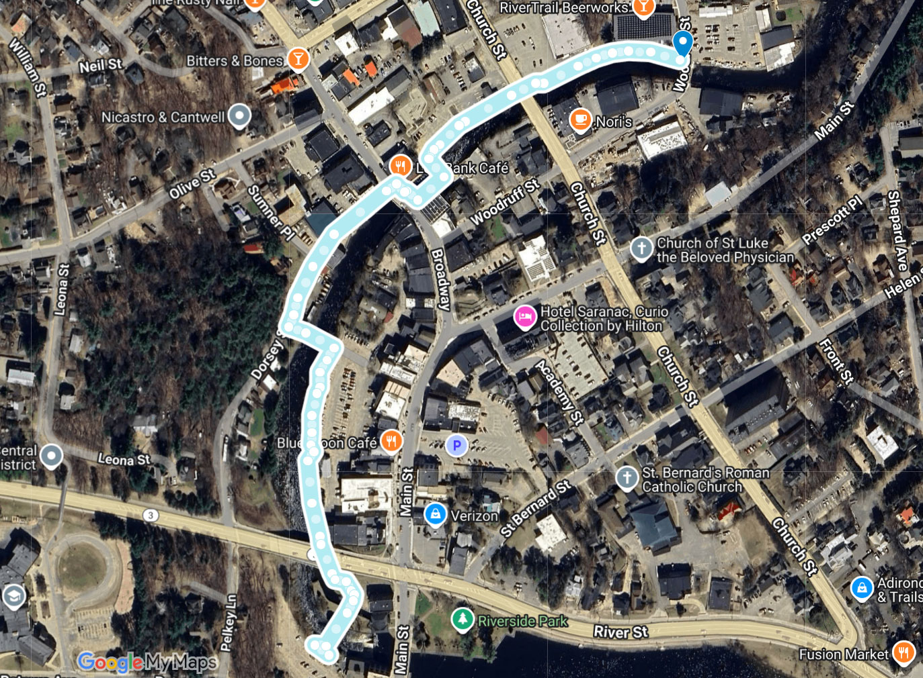
Summary: The Riverwalk is a central feature of the village, offers views of the lively Saranac River, its bridges, and the surrounding landscape, and connects to various shops, cafes, and restaurants, encouraging a stroll through the commercial district.
The assessors note that there is no official designation of the Riverwalk, per se. Signage and flags provide guidance, with new stencils on various sidewalks contradicting signage on Broadway. Entrance to experience the full Riverwalk can be made either from the sidewalk next to RiverTrail Beerworks, or from municipal parking behind Hydro Point Park. Visitors can enter and exit the Riverwalk at any point, and the route is not directional.
Important: There are several hazardous areas within the Riverwalk including but not limited to slip hazards from flooding at the crosswalk at Church Street that may result in pedestrians unfavorably interacting with vehicular traffic, falling into the Saranac River at the dock/kayak put-in, a 10" curb with no edge protection at the ramp from the sidewalk adjacent to the Skate Park, wheelchair users being unable to utilize the protected pedestrian crossing of the bridge over the Saranac River coming from or going to Dorsey Street, potential foot entrapment in a 7” hole on the right side of the bridge entrance across Saranac River south of Skate Park, abrasion and cut hazards from sharp edges on handrails due to corrosion on the on grey concrete accessible ramp structure behind Hydro Point Park, trip hazards due to crumbling masonry, and misalignment of pavers.


Priority: HIGH
Feature: Crosswalk flooding.
Location on Property: Intersection of the Riverwalk and Church Street (GPS” 44.32874244377578, -74.13048320097742).
Reference Image(s): Saranac Lake Riverwalk (4) and (5)
ABA Reference: 302.1 (Floor or Ground Surfaces): “Floor and ground surfaces shall be stable, firm, and slip resistant and shall comply with 302.”
IBC Reference: Requires that construction in flood hazard areas comply with IBC §1612 and ASCE 24 (flood-resistant design: elevation, wet/dry floodproofing, openings, protection of utilities, breakaway walls, etc.).
Remediation: While repair of the crosswalk is a NYS DOT concern, the Village, by its designation of the Riverwalk to utilize this crosswalk, directs users to hazardous conditions of trip, slip and fall hazards, or even death if a person slips and falls into vehicular cross traffic, thereby assuming liability for visitors using this route. NYS DOT should be contacted by the Village to repair the crosswalk to mitigate the fractured surface and flooding. Areas of concern should be cordoned off immediately to prevent injury to visitors until repairs can be made.

Feature: Kayak put in (dock area).
Location on Property: Behind the Dorsey Street parking lot (GPS” 44.325918053023365, -74.13279794735396).
Reference Image(s): Saranac Lake Riverwalk (41), (42), (43), (44)
ABA Reference: Accessible routes serving recreational boating facilities (including gangways & floating piers) must meet Ch. 4 except as modified in §1003.2.
IBC Reference: IBC points to A117.1 for the technical criteria. (IBC Ch. 11 references ICC A117.1; see A117.1 Ch. 10 for recreational boating facilities tech like clear pier space.)
Remediation: Repair the kayak put in. This feature is very slippery when wet, has cross slope and angular irregularities that can disorient those with balance and mobility challenges, which may result in a visitor falling into the Saranac River which can cause serious injury or death. Areas of concern should be cordoned off immediately to prevent injury to visitors until repairs can be made.

Priority: HIGH
Feature: Ramp access to Riverwalk.
Location on Property: Ramp from parking area at Skate Park (GPS” 44.328333263983176, -74.13140115563421).
Reference Image(s): Saranac Lake Riverwalk (90), (91)
ABA Reference: ADA 2010 §405.8: “Ramp runs with a rise greater than 6 inches (150 mm) shall have handrails complying with 505.” (ADA/Access Board guidance repeats: handrails required on both sides for ramp runs >6″ rise). Edge protection complying with 405.9.1 or 405.9.2 shall be provided on each side of ramp runs and at each side of ramp landings.
IBC Reference: Chapter 10 / Chapter 10 & 11 handrail sections requires handrails for ramps where handrails are necessary for egress/stair/ramp provisions; IBC handrail provisions (1014 et seq.) set dimensional, graspability and continuity requirements (height 34–38 in., clearances, etc.). IBC also requires handrails on ramps meeting IBC ramp/means-of-egress criteria.
Remediation: The drop-off from the ramp is approximately 10 inches. Provide handrails and edge protection to help prevent wheelchairs and walkers falling over the edge. Areas of concern should be cordoned off immediately to prevent injury to visitors until repairs can be made.

Priority: HIGH
Feature: Bridge across Saranac River (adjacent to Dorsey Street).
Location on Property: Joining Dorsey Street and municipal parking (GPS” 44.326893803063335, -74.1327906246978).
Reference Image(s): Saranac Lake Riverwalk - New Route (45), (46), (47)
ABA Reference: Title II program access (§28 CFR 35.150) provides that public entities must operate programs (such as the Riverwalk experience) so the program, when viewed in its entirety, is readily accessible; when a pedestrian facility is provided it generally must be made accessible to the extent required by the ADA Standards (the DOJ/Access Board standards). The ABA/ADA technical standards are the minimum criteria for routes and elements. 2010 ADA Standards §403.5 / §403.5.1: clear width of walking surfaces — 36 in. (915 mm) minimum (exceptions allow brief reduced widths under narrow conditions).
IBC Reference: N/A - IBC does not provide the program-access alternatives; IBC is a construction code.
Remediation: The most recent configuration of the Riverwalk routes pedestrians across a bridge walkway that does not meet the minimum clear width requirements for wheelchair accessibility under the 2010 ADA Standards (§403.5.1, minimum 36 inches clear) with the current width as 31 inches at either entrance/exit. As a result, individuals who use wheelchairs are required to travel within the adjoining vehicular lane while able-bodied pedestrians are afforded a designated protected walkway. Worse yet, it funnels them into an active roadway which can result in serious injury or death should the wheelchair user be struck by a vehicle as a result.
For a narrow walkway the municipality may: (a) widen/alter the walkway to 36″+, (b) provide an accessible parallel route, or (c) if alteration impossible, provide programmatic alternatives (e.g., another route), but the public entity must document the analysis and select the least burdensome option that still provides access, subject to Title II constraints. Temporary or marginal detours must also meet accessible standards if they are the public route. If the Village (or other public entity) offers a pedestrian walkway, it cannot lawfully offer only a route that excludes persons who use wheelchairs without providing an accessible alternative (or otherwise meeting program-access obligations). Thus a “pedestrian-only” narrow path cannot be the sole pedestrian route if no accessible alternative is provided. The public entity must either provide an accessible route (bring the path to ADA dimensions) or provide an accessible alternative route or modification under program-access rules.

For safety, and to ensure the Village does not unwittingly guide wheelchair users into a hazardous position, the Riverwalk should immediately be re-routed, the sidewalk stencils removed, an accessible route configured, and the public notified. At the very least, the stencils should be removed as they invite wheelchair users to participate in the Riverwalk experience when a significant risk of harm is present to them should they follow the Village’s direction.

Priority: HIGH
Feature: Bridge across Saranac River (south of Skate Park)
Location on Property: North side of bridge (GPS” 44.32819103936487, -74.13151012038625)
Reference Image(s): Saranac Lake Riverwalk (102), (103), (104), (105). Also see, video Saranac-Lake-Riverwalk-1
ABA Reference: Changes in Level 303 “Changes in level can be up to ¼” without treatment or ½” if beveled with a slope no steeper than 1:2. Changes in level above a ½” must be treated as a ramp or curb ramp (or a walkway if a slope no steeper than 1:20 can be achieved). These specifications apply to all portions of accessible routes, including thresholds and carpet trim”.
IBC Reference: ANSI 403.4 Changes in Level. Changes in level shall comply with Section 303.
Remediation: This is a significant barrier, and a dangerous 7” hole exists on the right side of the bridge entrance (see, Saranac Lake Riverwalk (102)) which can result in foot entrapment and subsequent injury for all visitors, and especially children. Install an ADA/ABA/IBC compliant ramp for access to the Riverwalk. Areas of concern should be cordoned off immediately to prevent injury to visitors until repairs can be made.

Priority: HIGH
Feature: Handrails on grey concrete accessible ramp.
Location on Property: Grey concrete structure on south end of Riverwalk behind Hydro Point Park (GPS” 44.32449669218232, -74.13266853077731).
Reference Image(s): Saranac Lake Riverwalk (256) through (265)
ABA Reference: “Handrail gripping surfaces and any surfaces adjacent to them shall be free of sharp or abrasive elements and shall have rounded edges.” (ABA chapter on handrails / Chapter 5).
IBC Reference: IBC (handrails / clearance / 1014.7 or comparable sections): “A handrail and a wall or other surface adjacent to the handrail shall be free of any sharp or abrasive elements.” (IBC text).
Remediation: Handrails have sharp edges due to corrosion. Sand, re-weld, seal and paint all handrails within the structure. Repairs should be completed immediately to mitigate the risk of injury and subsequent infection to all visitors. Areas of concern should be cordoned off immediately to prevent injury to visitors until repairs can be made.

Priority: HIGH
Feature: Railings on concrete walkway.
Location on Property: To/from municipal parking lot at the juncture of Main Street and Lake Street (GPS” 44.324385878477315, -74.1325921920105).
Reference Image(s): Saranac Lake Riverwalk (274)
ABA Reference: “Handrail gripping surfaces and any surfaces adjacent to them shall be free of sharp or abrasive elements and shall have rounded edges.” (ABA chapter on handrails / Chapter 5).
IBC Reference: IBC (handrails / clearance / 1014.7 or comparable sections): “A handrail and a wall or other surface adjacent to the handrail shall be free of any sharp or abrasive elements.” (IBC text).
Remediation: Sand, re-weld, seal and paint all handrails within the structure. Repairs should be completed immediately to mitigate the risk of injury and subsequent infection to all visitors. Areas of concern should be cordoned off immediately to prevent injury to visitors until repairs can be made.
Priority: HIGH
Feature: Railings on concrete walkway.
Location on Property: To/from area behind Harrietstown Town Hall (GPS” 44.32526639586873, -74.13261454324122).
Reference Image(s): Saranac Lake Riverwalk (51)
ABA Reference: “Handrail gripping surfaces and any surfaces adjacent to them shall be free of sharp or abrasive elements and shall have rounded edges.” (ABA chapter on handrails / Chapter 5).
IBC Reference: IBC (handrails / clearance / 1014.7 or comparable sections): “A handrail and a wall or other surface adjacent to the handrail shall be free of any sharp or abrasive elements.” (IBC text).
Remediation: Sand, re-weld, seal and paint all handrails within the structure. Repairs should be completed immediately to mitigate the risk of injury and subsequent infection to all visitors. Areas of concern should be cordoned off immediately to prevent injury to visitors until repairs can be made.
Priority: Medium
Feature: Steps from Riverwalk boardwalk to Broadway
Location on Property: End of boardwalk at steps connecting it to Broadway (GPS” 44.327899162802524, -74.1316175215671).
Reference Image(s): Saranac Lake Riverwalk (15)
ABA Reference: F206.2.2 Within a Site. “At least one accessible route shall connect accessible buildings, accessible facilities, accessible elements, and accessible spaces that are on the same site.” The “same site” in this instance is the Riverwalk.
IBC Reference: 1104.2 (Within a site) — same scaffolding in IBC. Short excerpt: “At least one accessible route shall connect accessible buildings, accessible facilities, accessible elements and accessible spaces that are on the same site.” The “same site” in this instance is the Riverwalk.
Remediation: The seven steps rise approximately ten feet from the boardwalk to Broadway, and are impassible by most users with mobility challenges, and all wheelchair users. The steps are the only connection from an accessible portion of the boardwalk to the landing on Broadway. A ramp may be able to be constructed over the stairway as there is a sixty foot run of boardwalk before it which may allow for the slope to be in compliance with ADA/ABA/IBC standards.

Priority: Medium
Feature: Riverwalk paver path.
Location on Property: Red paver cross paths behind Dorsey Street parking lot (GPS” 44.32640757088604, -74.13264610591403).
Reference Image(s): Saranac Lake Riverwalk (33)
ABA Reference: 302.1 (Floor or Ground Surfaces): “Floor and ground surfaces shall be stable, firm, and slip resistant and shall comply with 302.”
IBC Reference: Requires that construction in flood hazard areas comply with IBC §1612 and ASCE 24 (flood-resistant design: elevation, wet/dry floodproofing, openings, protection of utilities, breakaway walls, etc.).
Remediation: Flooding in this area results in a slippery surface, which can present slip and fall hazards to all visitors. Repair the pavers to mitigate flooding.

Priority: Medium
Feature: Ramp access to Riverwalk
Location on Property: Ramp from parking area at Skate Park (GPS” 44.328333263983176, -74.13140115563421).
Reference Image(s): Saranac Lake Riverwalk (99), (100)
ABA Reference: Changes in Level 303 “Changes in level can be up to ¼” without treatment or ½” if beveled with a slope no steeper than 1:2. Changes in level above a ½” must be treated as a ramp or curb ramp (or a walkway if a slope no steeper than 1:20 can be achieved). These specifications apply to all portions of accessible routes, including thresholds and carpet trim”.
IBC Reference: ANSI 403.4 Changes in Level. Changes in level shall comply with Section 303.
Remediation: The ramp has pavers settled below the concrete curb presenting a trip hazard to visitors as the difference in height is over 2 inches. Repair the pavers to ensure a level surface.

Priority: Medium
Feature: Bridge across Saranac River,
Location on Property: North side of bridge (GPS” 44.32819103936487, -74.13151012038625)
Reference Image(s): Saranac Lake Riverwalk (12), (13) and video Saranac-Lake-Riverwalk-1.mov
ABA Reference: Handrails required on ramp runs with rise > 6 in and must comply with (§505), Handrails on both sides of ramps (§505.2), handrail heights must be 34–38 in above ramp surface with a this being a consistent height (§505.4), and handrails must be continuous along full length of each ramp run; inside handrail on switchback ramps must be continuous between runs (§505.3).
IBC Reference: Handrails on both sides of ramps. (§1012.8), height of 34–38 in above walking surface / nosing; uniform. (§1014.2), Gripping surfaces continuous without interruption by newel posts/obstructions. (§1014.4).
Remediation: Install ADA/ABA/INC compliant handrails on both sides of the ramp.

Priority: Medium
Feature: Bridge across Saranac River (adjacent to Dorsey Street).
Location on Property: Joining Dorsey Street and municipal parking (GPS” 44.326893803063335, -74.1327906246978).
Reference Image(s): Saranac Lake Riverwalk - New Route (41), (43), (44)
ABA Reference: Changes in Level 303 “Changes in level can be up to ¼” without treatment or ½” if beveled with a slope no steeper than 1:2. Changes in level above a ½” must be treated as a ramp or curb ramp (or a walkway if a slope no steeper than 1:20 can be achieved). These specifications apply to all portions of accessible routes, including thresholds and carpet trim”.
IBC Reference: ANSI 403.4 Changes in Level. Changes in level shall comply with Section 303.
Remediation: Install an ADA/ABA/IBC compliant ramp for access to the Riverwalk.

Priority: Medium
Feature: Paver path
Location on Property: South of the bridge over the Saranac River from Dorsey Street (GPS” 44.32666542853877, -74.13261899143028).
Reference Image(s): Saranac Lake Riverwalk (126), (127) and video Saranac-Lake-Riverwalk-5.mov
ABA Reference: 403.3 - ≤ 1:20 (5%) is allowed as a walking surface; steeper requires ramp. Current slope is 9.6%.
IBC Reference: 1104.2; ANSI 403.3 – Same as ABA: 1:20 max (5%) for walking surface, steeper requires ramp provisions.
Remediation: Reconstruct pathway to meet the maximum 5% slope requirements.

Priority: Medium
Feature: Paver path
Location on Property: South of the bridge over the Saranac River from Dorsey Street (GPS” 44.32652152095529, -74.13270482211546).
Reference Image(s): Saranac Lake Riverwalk (130), (131)
ABA Reference: 302.1 – Surface must be firm, stable, and slip-resistant. Concrete/asphalt/pavers allowed if installed properly. 403.3 - ≤ 1:20 (5%) is allowed as a walking surface.
IBC Reference: 1104.2 referencing ANSI A117.1 section 302.1. Same as ABA: walking surfaces must be firm, stable, and slip-resistant. 1104.2; ANSI 403.3 – Same as ABA: 1:20 max (5%) for walking surface.
Remediation: Pathway slopes in odd directions away from the center line at a steep angle of 12.1%. Repair the pathway to conform with the above standards.

Priority: Medium
Feature: Access to trash receptacle area.
Location on Property: North of dock/kayak input (GPS” 44.325961237385606, -74.13276919512307).
Reference Image(s): Saranac Lake Riverwalk (151), (153), (154)
ABA Reference: Changes in Level 303 “Changes in level can be up to ¼” without treatment or ½” if beveled with a slope no steeper than 1:2. Changes in level above a ½” must be treated as a ramp or curb ramp (or a walkway if a slope no steeper than 1:20 can be achieved). These specifications apply to all portions of accessible routes, including thresholds and carpet trim”.
IBC Reference: ANSI 403.4 Changes in Level. Changes in level shall comply with Section 303.
Remediation: While the trash can and surrounding concrete platform are ADA/ABA/IBC compliant (see, Trash and Recycling Receptacles [1011.2 and 1011.3]), the wood lip to the platform varies between 1” and 2”. Replace this lip with a ramp or remove the wood lip and replace with concrete or masonry to ensure smooth entry to the trash receptacle area.

Priority: Medium
Feature: Concrete slope to gain access to boardwalk feature and dock/kayak input.
Location on Property: East of the dock/kayak input (GPS” 44.32594396828693, -74.13277187733199).
Reference Image(s): Saranac Lake Riverwalk (162) and video Saranac-Lake-Riverwalk-6.mov
ABA Reference: 403.3 - ≤ 1:20 (5%) is allowed as a walking surface; steeper requires ramp. Current slope is 7.5%.
IBC Reference: 1104.2; ANSI 403.3 – Same as ABA: 1:20 max (5%) for walking surface, steeper requires ramp provisions.
Remediation: While the boardwalk feature is accessible (although the surface should be cleaned to restore surface grip), an accessible route with a proper slope down to the boardwalk feature and dock/kayak input should be constructed.

Priority: Medium
Feature: Paver path under Lapan Highway (Route 3)
Location on Property: Under Lapan Highway (Route 3) (GPS” 44.32517069120033, -74.13261362702454).
Reference Image(s): Saranac Lake Riverwalk (176), (177), (178) and video Saranac-Lake-Riverwalk-8.mov
ABA Reference: 403.3 - ≤ 1:20 (5%) is allowed as a walking surface; steeper requires ramp.
IBC Reference: 1104.2; ANSI 403.3 – Same as ABA: 1:20 max (5%) for walking surface, steeper requires ramp provisions.
Remediation: Current slope is 10.2%. Replace pathway beneath the bridge with an ADA/ABA/IBC compliant path.

Priority: Medium
Feature: Paver path under Lapan Highway (Route 3)
Location on Property: Under Lapan Highway (Route 3) (GPS” 44.325239768475186, -74.1326431313226).
Reference Image(s): Saranac Lake Riverwalk (179), (180) and video Saranac-Lake-Riverwalk-8.mov
ABA Reference: 302.1 – Surface must be firm, stable, and slip-resistant. Concrete/asphalt/pavers allowed if installed properly. 403.3 - ≤ 1:20 (5%) is allowed as a walking surface.
IBC Reference: 1104.2 referencing ANSI A117.1 section 302.1. Same as ABA: walking surfaces must be firm, stable, and slip-resistant. 1104.2; ANSI 403.3 – Same as ABA: 1:20 max (5%) for walking surface.
Remediation: Pathway slopes in odd directions away from the center line at a steep angle of 8.4%. Repair the pathway to conform with the above standards.

Priority: Medium
Feature: Paver path
Location on Property: Path from under Lapan Highway (Route 3) to the end of the bridge adjacent to and to the south of Hydro Point Park (GPS” 44.325049805767144, -74.13255193621102 to 44.32450869651836, -74.13259485155362).
Reference Image(s): Saranac Lake Riverwalk (182) through (188), (190) and video Saranac-Lake-Riverwalk-9.mov
ABA Reference: 302.1 – Surface must be firm, stable, and slip-resistant. Concrete/asphalt/pavers allowed if installed properly. 403.3 - ≤ 1:20 (5%) is allowed as a walking surface.
IBC Reference: 1104.2 referencing ANSI A117.1 section 302.1. Same as ABA: walking surfaces must be firm, stable, and slip-resistant. 1104.2; ANSI 403.3 – Same as ABA: 1:20 max (5%) for walking surface.
Remediation: Pathway slopes in odd directions away from the center line at angles of 14.2% (Saranac Lake Riverwalk (183)), 6.8% (Saranac Lake Riverwalk (184)), 8.0% (Saranac Lake Riverwalk (186)), 7.9% (Saranac Lake Riverwalk (188)), 11.9% (Saranac Lake Riverwalk (190)). Repair the pathway to conform with the above standards.

Priority: Medium
Feature: Paver path
Location on Property: Path from under Lapan Highway (Route 3) to the end of the bridge adjacent to and to the south of Hydro Point Park (GPS” 44.325049805767144, -74.13255193621102 to 44.32450869651836, -74.13259485155362).
Reference Image(s): Saranac Lake Riverwalk (191) through (193), (195) and video Saranac-Lake-Riverwalk-9.mov
ABA Reference: 403.3 - ≤ 1:20 (5%) is allowed as a walking surface; steeper requires ramp.
IBC Reference: 1104.2; ANSI 403.3 – Same as ABA: 1:20 max (5%) for walking surface, steeper requires ramp provisions.
Remediation: Current slopes are 8.4% (Saranac Lake Riverwalk (191)), and 7.2% (Saranac Lake Riverwalk (195)). Reconstruct the Riverwalk in this section in accordance with the above standards.

Priority: Medium
Feature: Bridge across Saranac River
Location on Property: South end of Riverwalk (GPS” 44.32463725838769, -74.13248488098822)
Reference Image(s): Saranac Lake Riverwalk (202), (203) and video Saranac-Lake-Riverwalk-10.mov
ABA Reference: 403.3 - ≤ 1:20 (5%) is allowed as a walking surface; steeper requires ramp.
IBC Reference: 1104.2; ANSI 403.3 – Same as ABA: 1:20 max (5%) for walking surface, steeper requires ramp provisions.
Remediation: Current slope is 7%. Ensure an accessible route with a proper slope down to the water feature.

Priority: Medium
Feature: Bridge across Saranac River
Location on Property: South end of Riverwalk (GPS” 44.32463725838769, -74.13248488098822)
Reference Image(s): Saranac Lake Riverwalk (211), (212) and video Saranac-Lake-Riverwalk-10.mov
ABA Reference: Changes in Level 303 “Changes in level can be up to ¼” without treatment or ½” if beveled with a slope no steeper than 1:2. Changes in level above a ½” must be treated as a ramp or curb ramp (or a walkway if a slope no steeper than 1:20 can be achieved). These specifications apply to all portions of accessible routes, including thresholds and carpet trim”.
IBC Reference: ANSI 403.4 Changes in Level. Changes in level shall comply with Section 303.
Remediation: Current slope to bridge is 11.4%. Ensure an accessible ramp is installed to ensure compliance.

Priority: Medium
Feature: Walkway to/from Riverwalk
Location on Property: To/from municipal parking lot at the juncture of Main Street and Lake Street (GPS” 44.324385878477315, -74.1325921920105).
Reference Image(s): Saranac Lake Riverwalk (274), (275)
ABA Reference: 403.3 - ≤ 1:20 (5%) is allowed as a walking surface; steeper requires ramp.
IBC Reference: 1104.2; ANSI 403.3 – Same as ABA: 1:20 max (5%) for walking surface, steeper requires ramp provisions.
Remediation: Current slope is 8.7%. Ensure an accessible route with a proper slope in and out of the Riverwalk from this location.

Priority: Medium
Feature: Picnic unit (table)
Location on Property:
Reference Image(s): Saranac Lake Riverwalk (278)
ABA Reference: Chapter 10, Outdoor Developed Areas, F106.5, F245.2.1 and F245.2.2. “A picnic facility is a site, or a portion of a site, that is developed for outdoor recreational purposes and contains picnic units.” “A picnic unit is an outdoor space in a picnic facility that is used for picnicking and contains at least one outdoor constructed feature.” F106.5, “When only one or two picnic units are provided in a picnic facility, each picnic unit must provide mobility features.” “When more than two picnic units are provided in a picnic facility, at least 20 percent, but no less than two, of the picnic units must provide mobility features.” F245.2.1, and “Picnic units with mobility features don’t have to be identified by signs. Entities should provide information on the location of picnic units with mobility features on Web sites, in brochures, and at bulletin boards or information kiosks at the picnic facility.” F245.2.2.
IBC Reference: N/A.
Remediation: Provide a wheelchair accessible picnic table at this location, and place information within the Village’s website, brochures, at bulletin boards or information kiosks at the location.

Priority: Medium
Feature: Primary park signs
Location on Property: Any location at the entrance to the park.
Reference Image(s): N/A Multiple entrances and opportunities to provide signage. Should provide compliant signage at each major access point (e.g., from parking lots, sidewalks, etc.).
ABA Reference: Chapter 7: Signs F216.2 “interior and exterior signs identifying permanent rooms and spaces, where provided”.
IBC Reference: ANSI 703 Signs
Remediation: Add signage at the start of the red paver walkway that conforms with ABA Chapter 7, Signs. Note, Visual and tactile requirements apply to both interior and exterior signs labeling permanent rooms and spaces. However, exterior signs not located at the door to the space they serve (there is no ‘door’ to the park) do not have to be tactile but must meet visual requirements (F216.2, Ex. 1).

Priority: Low
Feature: Slopes on ramps.
Location on Property: Grey concrete structure on south end of park (GPS” 44.32449669218232, -74.13266853077731).
Reference Image(s): Saranac Lake Riverwalk (267), (268) (bottom ramp), (271), (272) (top ramp) and video Saranac-Lake-Riverwalk-11.mov and Saranac-Lake-Riverwalk-12.mov
ABA Reference: ABAAS §405.2 Slope. “Ramps shall have a running slope not steeper than 1:12.”
IBC Reference: IBC 1012.2 Slope. “Ramps used as part of a means of egress shall have a running slope not steeper than one unit vertical in twelve units horizontal (8.33-percent slope).”
Remediation: Slope on bottom ramp is 6.3%. Slope on top ramp is 8.4%. While these meet the ADA/ABA/IBC requirements (see reference images), note the challenges of a wheelchair user attempting to navigate this compliant set of slopes. Whenever this feature is reconstructed, consider a gentler grade.

Saranac Lake Skateboard Park
Location: Between Broadway (behind Community Bank, NA) to the east, and Church Street to the west (behind Champlain National Bank, NA, then Twin D Automotive)
Address: 155 Church Street, Saranac Lake, NY 12893
GPS”: 44.328554611342526, -74.13180184182204
Google Maps Plus Code: 8VH9+C7 Saranac Lake, New York
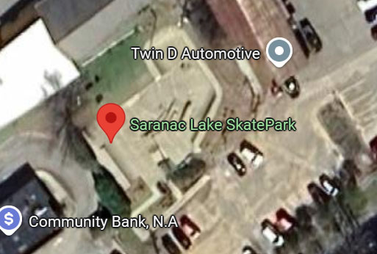
Summary: Since its opening in July 2015, the park has become a vibrant hub—not just for skateboarding, but for social interaction, mentorship, and inclusive community energy. The park covers approximately 5,000–5,200 square feet of all-concrete surface, and blends Street and Flow elements, including ramps, rails, quarter-pipes, ledges, banks, stairs, walls, manual pads, and other street-style obstacles.
The switchback concrete ramp is ADA/ABA compliant, with a maximum slope of 4.9% (see, Saranac Lake Skate Park (12) and (13). However, there is a lack of ADA/ABA/IBC compliant handrails on the ramp leading up to the skating area.

Priority: Medium
Feature: Handrails and lack of continuous handrails.
Location on Property: Concrete slope ramp on left side of park (GPS”: 44.32842487359002, -74.1317163575429).
Reference Image(s): Saranac Lake Skate Park (5)
ABA Reference: Handrails required on ramp runs with rise > 6 in and must comply with (§505), Handrails on both sides of ramps (§505.2), handrail heights must be 34–38 in above ramp surface with a this being a consistent height (§505.4), and handrails must be continuous along full length of each ramp run; inside handrail on switchback ramps must be continuous between runs (§505.3).
IBC Reference: Handrails on both sides of ramps. (§1012.8), height of 34–38 in above walking surface / nosing; uniform. (§1014.2), Gripping surfaces continuous without interruption by newel posts/obstructions. (§1014.4).
Remediation: Install ADA/ABA/INC compliant handrails on both sides of the ramp.

Priority: Medium
Feature: Primary park sign.
Location on Property: Any location at the entrance to the park.
Reference Image(s): N/A Multiple entrances and opportunities to provide signage.
ABA Reference: Chapter 7: Signs F216.2 “interior and exterior signs identifying permanent rooms and spaces, where provided”.
IBC Reference: ANSI 703 Signs.
Remediation: Add signage at the start of the red paver walkway that conforms with ABA Chapter 7, Signs. Note, Visual and tactile requirements apply to both interior and exterior signs labeling permanent rooms and spaces. However, exterior signs not located at the door to the space they serve (there is no ‘door’ to the park) do not have to be tactile but must meet visual requirements (F216.2, Ex. 1).

Ward Plumadore Park
Location: Intersection of Broadway and Bloomindale Avenue
Address: 65 Broadway, Saranac Lake, NY 12983
GPS”: 44.32894143269885, -74.13301287209372
Google Maps Plus Code: 8VH8+HQ Saranac Lake, New York
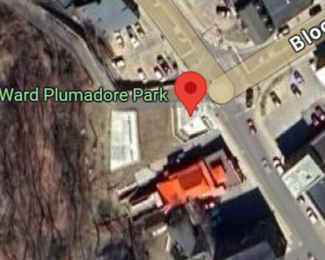
Summary: Nestled at the bustling intersection of Broadway and Bloomingdale Avenue, Ward Plumadore Park offers a charming respite amid Saranac Lake’s vibrant downtown. Built as part of the Village’s broader Downtown Revitalization Initiative (DRI), the park was reimagined to weave art, accessibility, and community gathering into its design. Thanks to DRI funding, the park now features terraced plazas, decorative paving, enhanced landscaping, and foundational elements for public art.
The bottom terrace of the park is roomy, and easily accessible by people with mobility impairments.
Important: As this was new construction, the park was required to provide accessibility to all spaces, including the top terrace. As a point of observation, prior to the new construction, access to the top of the park appears to be of a lesser grade than following construction (see, Ward-Plumadore-Pre-Renovation-(01), and (02), and Ward Plumadore Park (12)).
Notably, certain outdoor routes (trails, Outdoor Recreation Access Routes within campgrounds/picnic areas, beach access routes) may be exempt where complying would: (1) cause substantial harm to cultural, historic, religious or significant natural features; (2) substantially alter intended challenge/experience; (3) require construction methods prohibited by law; or (4) be not feasible due to terrain/other constraints.
“Not feasible due to terrain/other constraints” is not a convenience clause, it is meant for extraordinary site conditions like steep cliffs, wetlands, ravines, narrow ledges, unstable soils, or environmental restrictions that make it physically or legally impossible to build a compliant ramped route. Agencies must document which condition applies (terrain, legal limits, historic/cultural impact, etc.) whenever they invoke an exception, and the exception must be made part of the public record. The assessors attempted to access such documentation but could not find such a study within the Village website.
Moreover, satellite image of the park, when combined with the zoning map (see, Ward-Plumadore-Park---Zoning-Map (1)), provide that there may have been ample room to construct an accessible switchback ramp up the slope utilizing the south side of the property (the grassy road on the north side, named Terrace Street within the development plans is not, per the zoning map, the property of the Village and so would not be made use of in the redevelopment plans, although they were placed within the Contract Limit Line as being part of the project scope (see, Ward Plumadore Park Grading Plan (1)), but to our knowledge an accessible route (or any other safe access route) to the top terrace did not appear in the original plans - despite the top terrace being otherwise ADA/ABA/IBC compliant.

Priority: Medium
Feature: Access to top terrace.
Location on Property: Lawn area between bottom terrace and top terrace.
Reference Image(s): Ward Plumadore Park (2a), (11), (12), and (25)
ABA Reference: Access Board guidance: Chapter 4 — Ramps and curb ramps; §303.4: “Ramps and curb ramps are required along accessible routes to span changes in level greater than ½ in.”; see Access Board ADA guidance and ABA standards.
IBC Reference: Requires at least one accessible route to accessible entrances/site features; where an accessible route includes a change in level, ramp or other approved means is required. The technical ramp parameters (when a ramp is used) are specified by ICC A117.1 (maximum slope, landings, handrails). Providing the required accessible route therefore triggers the ramp requirement when level change exceeds ½".
Remediation: Construct accessible ramp to top terrace.

Priority: Medium
Feature: Primary park sign.
Location on Property: Any location at the entrance to the park.
Reference Image(s): N/A Multiple entrances and opportunities to provide signage.
ABA Reference: Chapter 7: Signs F216.2 “interior and exterior signs identifying permanent rooms and spaces, where provided”.
IBC Reference: ANSI 703 Signs.
Remediation: Add signage at the park entrance that conforms with ABA Chapter 7, Signs. Note, Visual and tactile requirements apply to both interior and exterior signs labeling permanent rooms and spaces. However, exterior signs not located at the door to the space they serve (there is no ‘door’ to the park) do not have to be tactile but must meet visual requirements (F216.2, Ex. 1).

William Morris Park
Location: Intersection of Bloomingdale Avenue, and Church Street to the south, and Depot Street to the North, adjacent to Adirondack Carousel
Address: 24 Depot St, Saranac Lake, NY 12983
GPS”: 44.32992855787785, -74.13133924177194
Google Maps Plus Code: 8VH9+XC Saranac Lake, New York
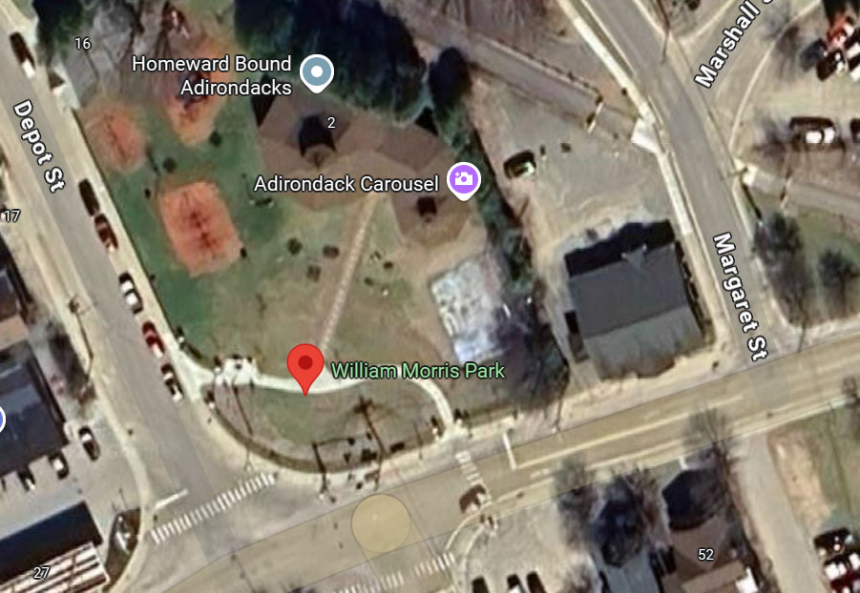
Summary: Situated at Depot Street, Saranac Lake, NY, William Morris Park is a family-friendly playground offering grassy lawns, shaded seating areas, and playground. It is the access point to the Adirondack Carousel—a unique indoor carousel directly adjacent and often considered part of the park experience. In 2022, as part of the Downtown Revitalization Initiative (DRI), redevelopment began at William Morris Park. Upgrades include a winding sidewalk connecting Bloomingdale Avenue and Depot Street, new fencing, expanded lawn space, landscaping, and site-specific accessible playground features that incorporate accessible musical elements and improved stormwater infrastructure.
The Adirondack Carousel was not assessed as it is not owned by the Village.
Approach slopes, pathways, and playground areas are all ADA/ABA compliant.

Priority: Medium
Feature: Primary park sign.
Location on Property: Any location at the entrance to the park.
Reference Image(s): N/A Multiple entrances and opportunities to provide signage.
ABA Reference: Chapter 7: Signs F216.2 “interior and exterior signs identifying permanent rooms and spaces, where provided”.
IBC Reference: ANSI 703 Signs.
Remediation: Add signage at the park entrance that conforms with ABA Chapter 7, Signs. Note, Visual and tactile requirements apply to both interior and exterior signs labeling permanent rooms and spaces. However, exterior signs not located at the door to the space they serve (there is no ‘door’ to the park) do not have to be tactile but must meet visual requirements (F216.2, Ex. 1).

William Wallace Park/Lake Colby Beach/Saranac Lake Village Beach
Location: Intersection of Broadway and Moir Road
Address: Moir Road, Saranac Lake, NY 12983
GPS”: 44.34195613653049, -74.14396706996644
Google Maps Plus Code: 8VR4+P8 Saranac Lake, New York
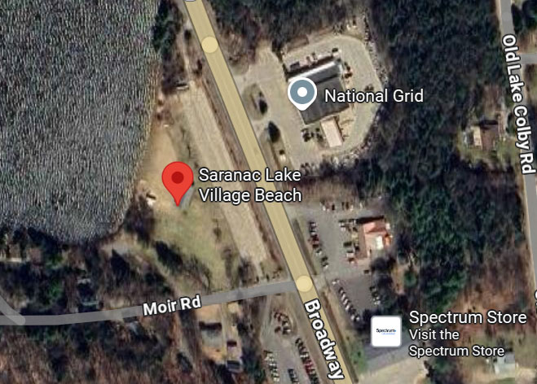
Summary: This site is known interchangeably as William Wallace Park, Lake Colby Beach, and Saranac Lake Village Beach, located just north of downtown Saranac Lake, at the corner of Route 86 and Moir Road. It’s a long-standing community staple, serving thousands of visitors during the summer season. Features include, but are not limited to, a sandy beach, changing rooms, restrooms, a volleyball court, picnic area, and off-street parking.

Important: There are numerous trip and fall hazards in this area, including but not limited to the picnic table patio, sidewalk to the main building, and large steps into the restroom areas. These present concerns not just for people with disabilities with mobility challenges, but those with low vision, equilibrium concerns, and small children. There are some structural concerns at the main building as well (see, William-Wallace-Park-Lake-Colby-Beach (24),
Remediation Notes: After the initial assessment period, the Village has installed two accessible portable restrooms, an ADA compliant hand washing station, an ADA compliant changing room, an additional two accessible parking spaces, an ADA compliant path to the beach, and an ADA compliant beach wheelchair. Major structural changes are planned for implementation by the Village for the spring of 2026. This will result in the demolition of the current main building, including the restroom and lifeguard facilities, and replacement with an ADA/ABA/IBC compliant structure. As such, and in the interest of brevity, only major safety concerns, and accessibility barriers that overtly deny access to primary restroom functions are presented herein. We applaud the efforts of the Village of Saranac Lake in making these important accommodations.

Priority: HIGH
Feature: Wheelchair accessible table entry barrier of lack of stable, firm, and slip-resistant surface. The pavers are misaligned and disjointed providing trip and fall hazards to users.
Location on Property: Paver patio area southeast of main building (GPS”: 44.34152165349831, -74.14375922331391).
Reference Image(s): William-Wallace-Park-Lake-Colby-Beach (8)
ABA Reference: “Floor and ground surfaces shall be stable, firm, and slip resistant.” — ADA 2010 Standards §302.1 / A117.1 (same language used by Access Board guidance). Access Board guidance: “Stable surfaces resist movement; firm surfaces resist deformation by indentations. Hardened materials (concrete, asphalt, wood, tile) are sufficiently firm and stable; some trail surfaces may be permitted but must meet the performance definitions.” (Access Board / Outdoor Developed Areas; ADA guidance §302 explainer).
IBC Reference: IBC (means of egress / ramps / stairs): IBC requires slip-resistant walking surfaces for circulation/means-of-egress and requires ramp surfaces to be of slip-resistant materials securely attached; stairway treads/landings must be solid and not excessively sloped. (IBC §1003.4; §1012.7.1; §1011.7.1). IBC does not use “stable, firm” phrasing for all ground surfaces the way ADA/ABA does.
Remediation: Reconstruct or replace the patio to ensure surface is stable, firm and slip resistant. Areas of concern should be cordoned off immediately to prevent injury to visitors until repairs can be made.

Priority: HIGH
Feature: Trip hazard with cable connecting two picnic tables.
Location on Property: Paver patio area southeast of main building (GPS”: 44.34152165349831, -74.14375922331391).
Reference Image(s): William-Wallace-Park-Lake-Colby-Beach (36)
ABA Reference: Key trip-hazard controls appear in §302 Floor or Ground Surfaces, §303 Changes in Level, §304 Turning Space, §302.3 Openings, and related outdoor-areas supplements (ORAR / Outdoor Developed Areas).
IBC Reference: Chapter 10 (Means of Egress — elevation change §1003.5 / §1003.4), §1011.7 stair walking surfaces (openings, slope), and references to A117.1 for accessibility where required.
Remediation: Install cables and locks so that they are not a trip hazard. Areas of concern should be cordoned off immediately to prevent injury to visitors until repairs can be made.

Priority: HIGH
Feature: Asphalt sidewalk to main building.
Location on Property: East side of main building (GPS” 44.34184088742833, -74.14397012268321).
Reference Image(s): William-Wallace-Park-Lake-Colby-Beach (17)
ABA Reference: 302.1 – Surface must be firm, stable, and slip-resistant. Concrete/asphalt/pavers allowed if installed properly. 403.3 - ≤ 1:20 (5%) is allowed as a walking surface.
IBC Reference: 1104.2 referencing ANSI A117.1 section 302.1. Same as ABA: walking surfaces must be firm, stable, and slip-resistant. 1104.2; ANSI 403.3 – Same as ABA: 1:20 max (5%) for walking surface.
Remediation: Trip hazard present in sidewalk. Repair and/or replace the sidewalk with an ADA/ABA/IBC compliant entrance to the main building. Areas of concern should be cordoned off immediately to prevent injury to visitors until repairs can be made.

Priority: HIGH
Feature: Restroom and lifeguard room entrances
Location on Property: West side of main building (GPS” 44.34210297062502, -74.14421849325346).
Reference Image(s): William Wallace Park Lake Colby Beach (45), (59), (66)
ABA Reference: ABAAS §303.3 Changes in Level “Changes in level between 1/4 inch (6.4 mm) high maximum shall be permitted to be vertical. Changes in level between 1/4 inch (6.4 mm) high minimum and 1/2 inch (13 mm) high maximum shall be beveled with a slope not steeper than 1:2.” No step is permitted at restroom entrances. Any vertical rise > 1/2 inch must be provided by a ramp or lift.
IBC Reference: IBC 1010.1 Stairways, ramps, and escalators. “Stairways shall not be used as part of an accessible route.” Steps cannot be used to access required toilet rooms. All accessible toilet rooms must be connected by an accessible route.
Remediation: Steps are 9” high for the men’s, women’s and lifeguard rooms, presenting multiple risks of trip and fall injuries on entering and exiting. Lifeguards may be at risk when rapidly exiting to effect a rescue. Steps are not permitted for access to restrooms. Replace the steps with a ramp or ramps in compliance with ADA/ABA/IBC standards, above. Areas of concern should be cordoned off immediately to prevent injury to visitors until repairs can be made.

Priority: Medium
Feature: Wheelchair accessible table entry barrier of lack of stable, firm, and slip-resistant surface during either fair or foul weather.
Location on Property: Paver patio area southeast of main building (GPS”: 44.34152165349831, -74.14375922331391).
Reference Image(s): William-Wallace-Park-Lake-Colby-Beach (8), (34)
ABA Reference: ABA/ADA accessible route requirements require routes to be stable, firm, and slip-resistant, with minimum clear widths (often 48 in for outdoor access routes; 36 in minimum in some contexts) and maximum slopes. Outdoor guide references these route performance requirements where an ORAR (Outdoor Recreation Access Route) is required. These surfaces are required to allow wheelchair access to picnic areas where scoping requires it.
IBC Reference: IBC does not specify “firm/stable” access route surface design for accessibility; IBC addresses structural design, but flood guidance requires consideration of site grading and drainage so floodwaters are directed away, and design may require raising or flood-proofing features to avoid performance loss during floods (see ASCE 24 and IBC Appx G). Flood guidance may require that critical access (egress) be maintained or remediated post-flood per local floodplain regulations.
Remediation: Reconstruction of patio area to allow for flood water drainage.

Priority: Medium
Feature: Approach to main building restrooms.
Location on Property: Northeast side of main building (GPS” 44.341927449252104, -74.14403214871975).
Reference Image(s): William-Wallace-Park-Lake-Colby-Beach (21), (23)
ABA Reference: ABA Accessible Route (Ch. 4), Outdoor Developed Areas (Ch. 10), ORAR §1016 requires a minimum of 36 inches continuous.
IBC Reference: IBC §1104 requires at least one accessible route from site arrival points to accessible building/feature entrances and across sites; technical criteria come from ICC A117.1 Ch. 4.
Remediation: No meaningful clearance for wheelchair users on asphalt approach. Provide at least one accessible route from site arrival points to the memorial of at least 36 inches in width.

Priority: Medium
Feature: Approach to main building restrooms.
Location on Property: West side of main building (GPS” 44.341937950461684, -74.14420242036226).
Reference Image(s): William-Wallace-Park-Lake-Colby-Beach (26)
ABA Reference: ABA Accessible Route (Ch. 4), Outdoor Developed Areas (Ch. 10), ORAR §1016 requires a minimum of 36 inches continuous.
IBC Reference: IBC §1104 requires at least one accessible route from site arrival points to accessible building/feature entrances and across sites; technical criteria come from ICC A117.1 Ch. 4.
Remediation: No meaningful clearance for wheelchair users on asphalt approach. Provide at least one accessible route from site arrival points to the memorial of at least 36 inches in width.

Priority: Medium
Feature: Doors for toilet rooms and changing rooms.
Location on Property: Men’s and women’s restrooms.
Reference Image(s): William-Wallace-Park-Lake-Colby-Beach (44)
ABA Reference: 604.8.1.2 Doors. Toilet compartment doors, including door hardware, shall comply with 404 … The door shall be self-closing. A door pull complying with 404.2.7 shall be placed on both sides of the door near the latch. Toilet compartment doors shall not swing into the minimum required compartment area.
IBC Reference: A117.1 relationship: IBC Chapter 11 enforces accessibility technical provisions by reference to A117.1; where the ADA/ABA standard requires compartment doors to be self-closing, A117.1 figures and the AHJ will enforce the same (IBC does not typically restate the ADA compartment-self-closing sentence but defers to A117.1/ADA technical text via Chapter 11). (See IBC Ch.11 scoping + A117.1 §404/related language.)
Remediation: Many of the doors are spring-loaded do not have door pulls on both sides of the door. Install door pulls on both sides of all toilet and changing rooms.

Priority: Medium
Feature: Toilet rooms – grab bars.
Location on Property: Men’s and women’s restrooms.
Reference Image(s): William Wallace Park Lake Colby Beach (43), (79)
ABA Reference: 604.5 Grab Bars. Grab bars for water closets shall comply with 609. Grab bars shall be provided on the side wall closest to the water closet and on the rear wall.
IBC Reference: A117.1 / Chapter 6 (Plumbing Elements) — equivalent scoping language: A117.1 requires that grab bars in accessible toilet compartments comply with Section 609 (Grab Bars) and be provided per the compartment requirements (side and rear wall locations shown in the compartment figures). (See A117.1 §604.8.1.5 and §604.8.2.3 for compartment requirements.)
Remediation: Install grab bars as required in accordance with the above standards.

Priority: Medium
Feature: Primary park sign
Location on Property: Any location at the entrance to the park.
Reference Image(s): N/A Multiple entrances and opportunities to provide signage.
ABA Reference: Chapter 7: Signs F216.2 “interior and exterior signs identifying permanent rooms and spaces, where provided”.
IBC Reference: ANSI 703 Signs
Remediation: Add signage at the park entrance that conforms with ABA Chapter 7, Signs. Note, Visual and tactile requirements apply to both interior and exterior signs labeling permanent rooms and spaces. However, exterior signs not located at the door to the space they serve (there is no ‘door’ to the park) do not have to be tactile but must meet visual requirements (F216.2, Ex. 1).

World War 1 Memorial
Location: Southwest of Church Street, at its intersection with River Street
Address: 11 Church Street, Saranac Lake, NY 12983
GPS”: 44.3247226273773, -74.1272897773438
Google Maps Plus Code: 8VFF+V3 Saranac Lake, New York
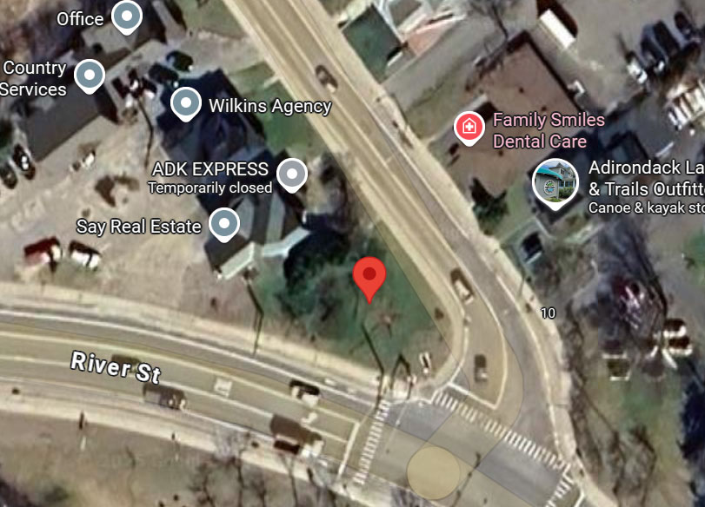
Summary: The memorial stands at the triangular junction of Church Street and River Street in Saranac Lake and is also known as Triangle Park. At its heart lies a granite bench, constructed by Master Mason Matthew Winderl, providing both a place to pause and a structural focal point of the memorial. The north-east entrance on Church Street consists of an accessible concrete pathway that enters the memorial, with enough room for a single wheelchair, but no passing space.

Priority: Medium
Feature: Path to Memorial.
Location on Property: From the Church Street entrance (44.32480915485401, -74.12727800601563). Current path width is 32 inches.
Reference Image(s): World War I Memorial (7), (8), (10), and (27
ABA Reference: ABA Accessible Route (Ch. 4), Outdoor Developed Areas (Ch. 10), ORAR §1016 requires a minimum of 36 inches continuous.
IBC Reference: IBC §1104 requires at least one accessible route from site arrival points to accessible building/feature entrances and across sites; technical criteria come from ICC A117.1 Ch. 4.
Remediation: Provide at least one accessible route from site arrival points to the memorial of at least 36 inches in width.

Priority: Medium
Feature: Park bench.
Location on Property: Next to tree in front of memorial. Bench seat is 16 inches from the ground (IBC standard is 17-19 inches), and seat depth is approximately 12 inches (IBC standard is 20-24 inches).
Reference Image(s): World War I Memorial (9), (16), (19), and (22)
ABA Reference: Benches are explicitly listed as outdoor constructed features at outdoor recreation facilities. (ABA Guide Ch.10 “Outdoor Constructed Features – Definition” [F106.5]. At trailheads, along trails, and within viewing areas/picnic & camping facilities, at least 20% (but not less than one) of each type of outdoor constructed feature provided (including benches) must comply with the technical rules. (F247.3.1, F247.5, F246.3; also F244) for picnic/camping). Not specified in ABA outdoor bench section; ABA focuses on space & route. (Ch. 10 “Outdoor Constructed Features – Benches” table)
IBC Reference: IBC Ch. 11 scopes accessibility and points to ICC A117.1 for the technical rules; it does not enumerate “park benches.” (IBC Ch. 11 overview). IBC does not have a numeric requirement for outdoor park benches. Where benches are required in certain interior rooms (e.g., dressing/locker rooms, holding cells), those benches must meet A117.1 §903. (ICC A117.1 is the tech standard referenced by IBC; see A117.1 2009 §903). Explicit specs in ICC A117.1 §903: clear floor space for parallel approach (§903.2); seat length ≥ 42 in; depth 20–24 in (§903.3); back support from ≤2 in above seat to ≥18 in above, within 2½ in of rear edge (§903.4); seat height 17–19 in above floor (§903.5; child exceptions).
Remediation: Install at least 20% of benches in the park, but not less than one.

Priority: Medium
Feature: Primary park sign.
Location on Property: Any location at the entrance to the park.
Reference Image(s): N/A Multiple entrances and opportunities to provide signage.
ABA Reference: Chapter 7: Signs F216.2 “interior and exterior signs identifying permanent rooms and spaces, where provided”.
IBC Reference: ANSI 703 Signs.
Remediation: Add signage at the park entrance that conforms with ABA Chapter 7, Signs. Note, Visual and tactile requirements apply to both interior and exterior signs labeling permanent rooms and spaces. However, exterior signs not located at the door to the space they serve (there is no ‘door’ to the park) do not have to be tactile but must meet visual requirements (F216.2, Ex. 1).

Appendix A. Images

Berkeley Green
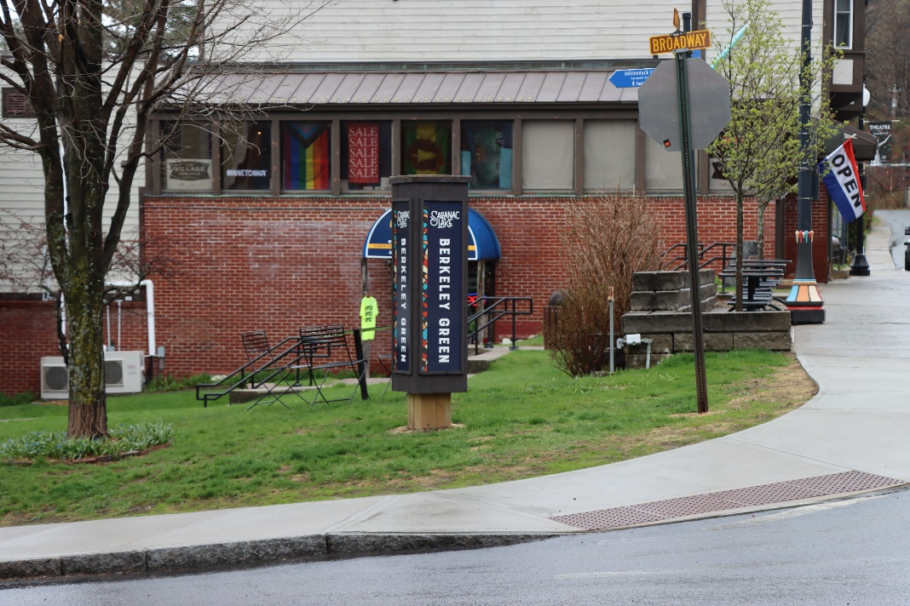
Berkeley Green (1)
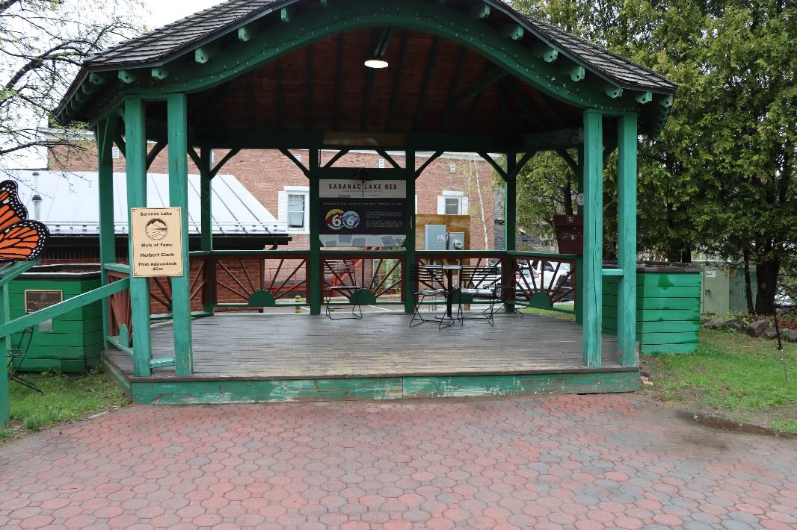
Berkeley Green (75)
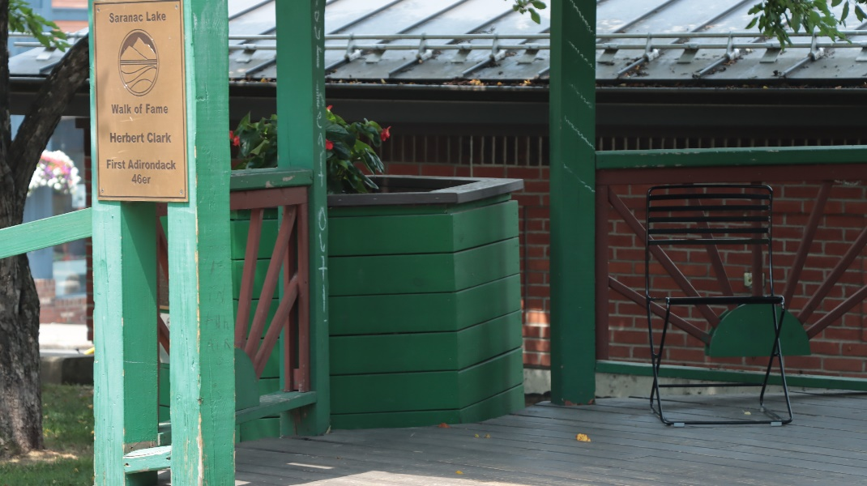
Berkeley Green (87)
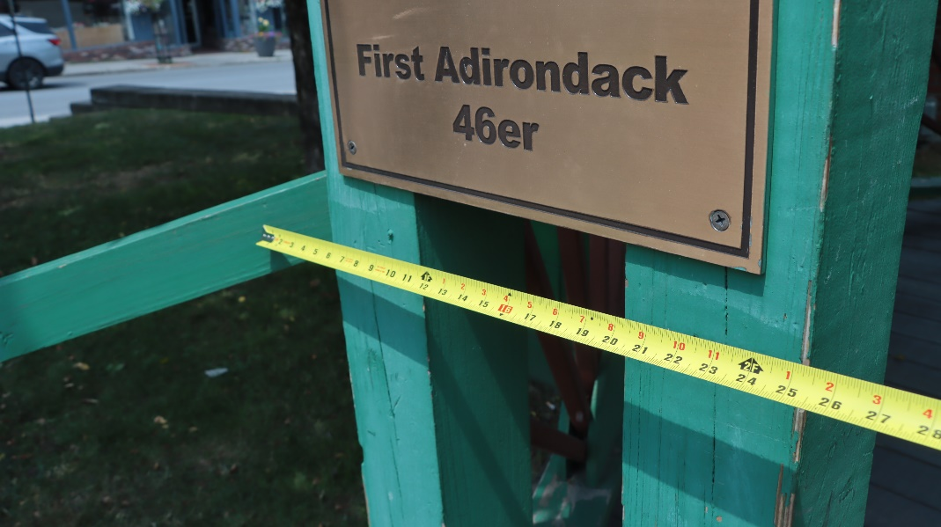
Berkeley Green (91)
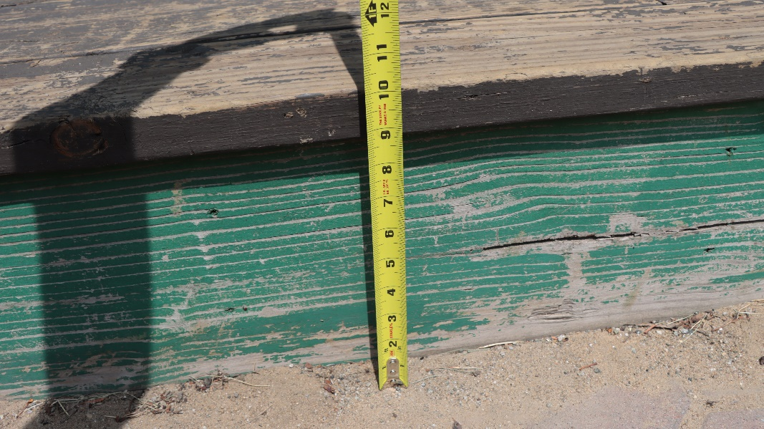
Berkeley Green (93)
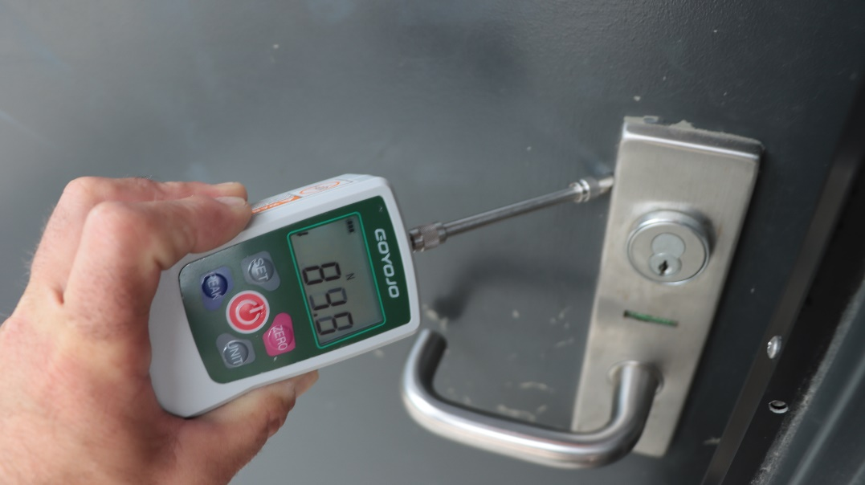
Berkeley Green (136)
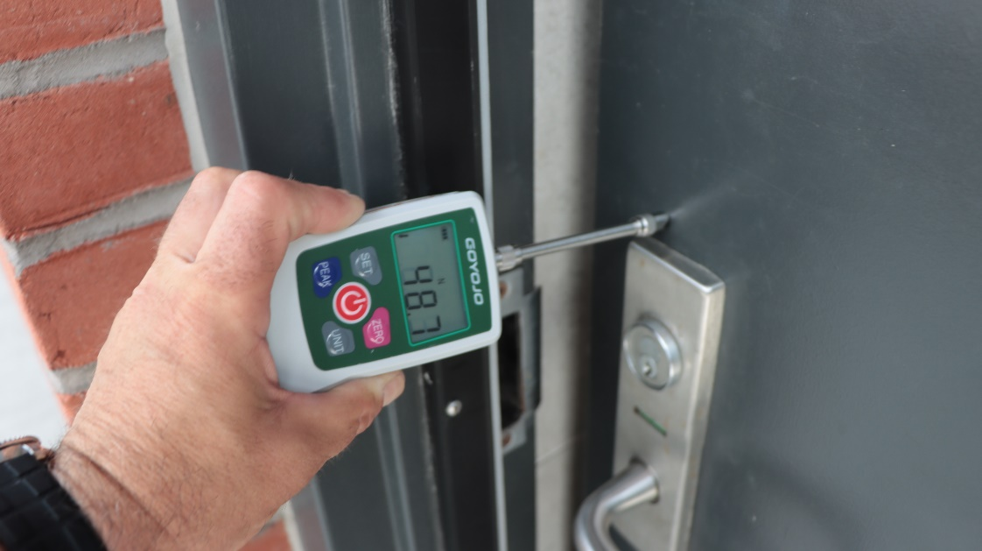
Berkeley Green (138)
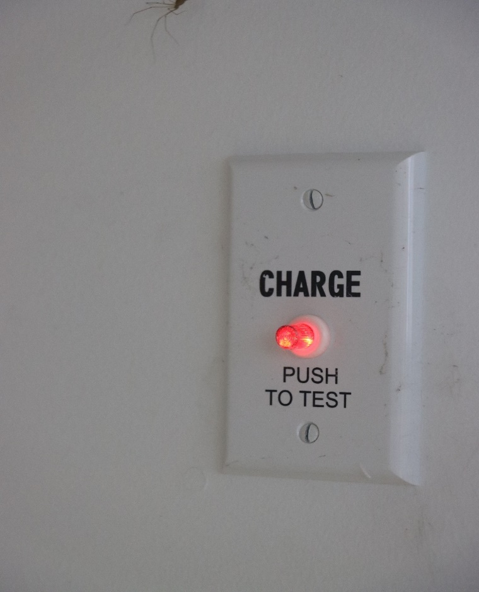
Berkeley-Green-(142)

Hydro Point Park
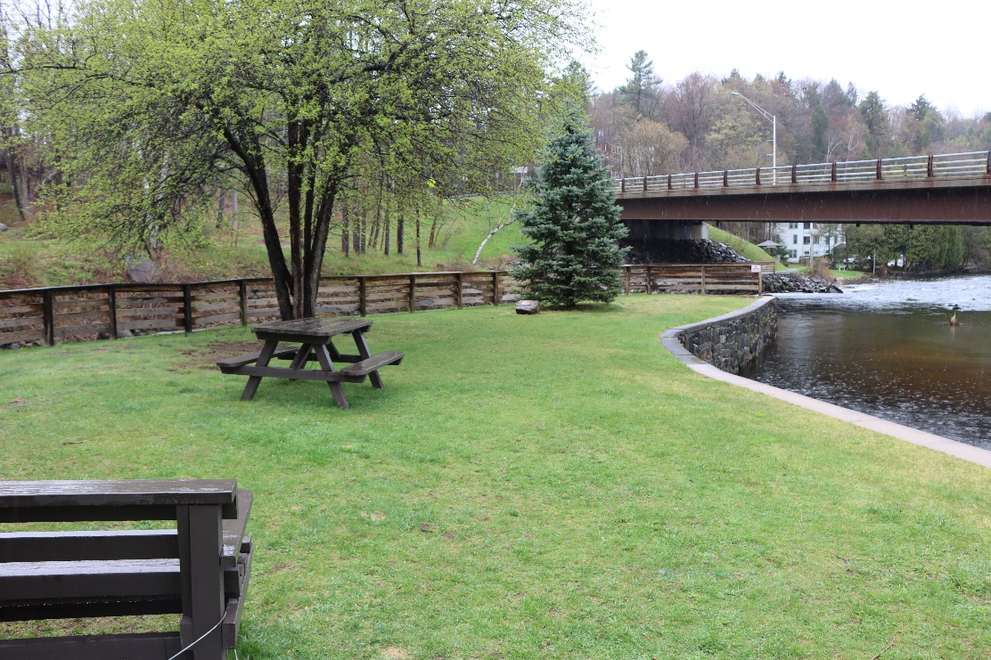
Hydro Point Park (16)
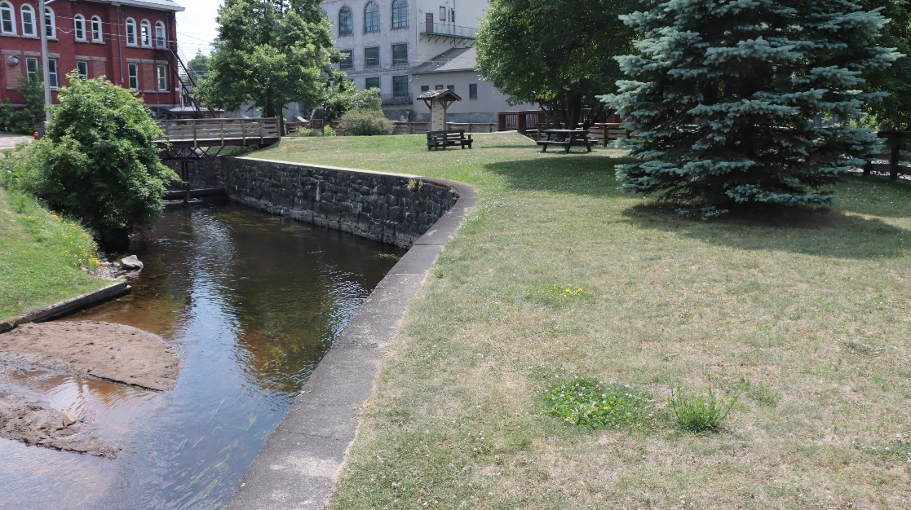
Hydro Point Park (17)
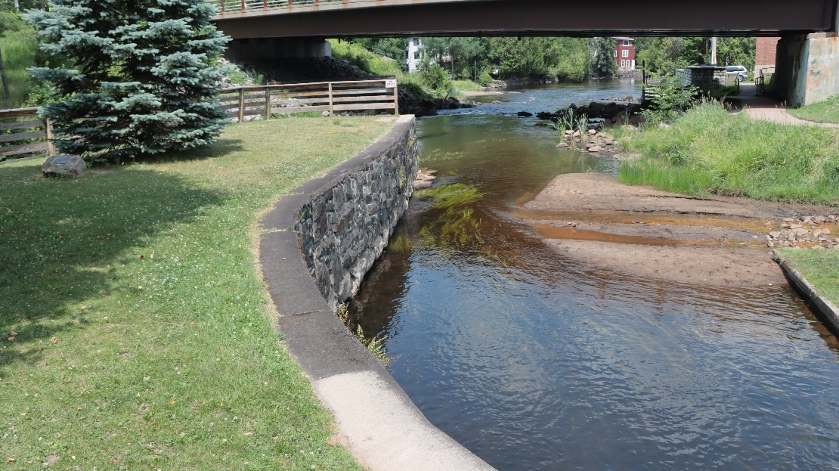
Hydro Point Park (18)
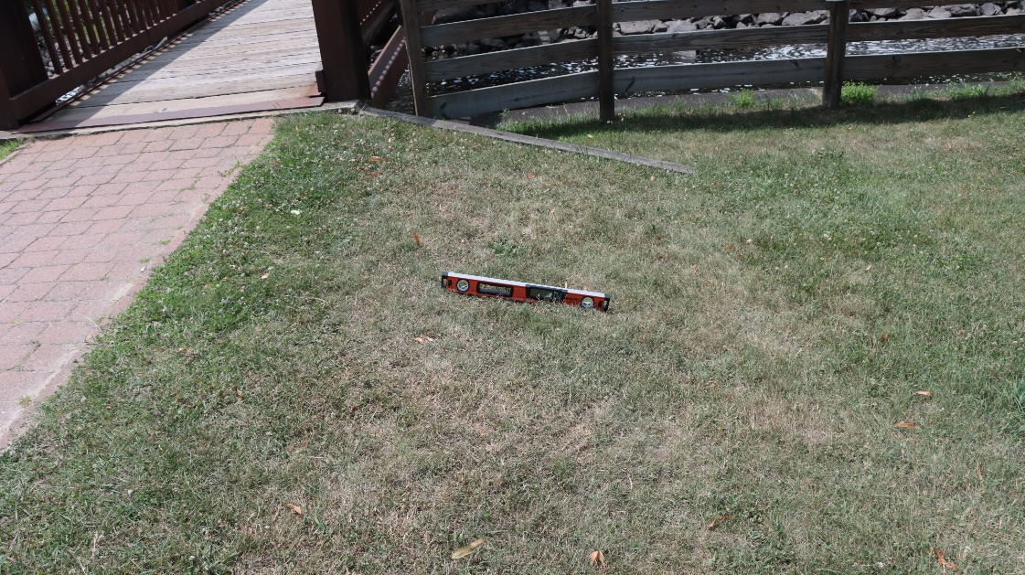
Hydro Point Park (19)
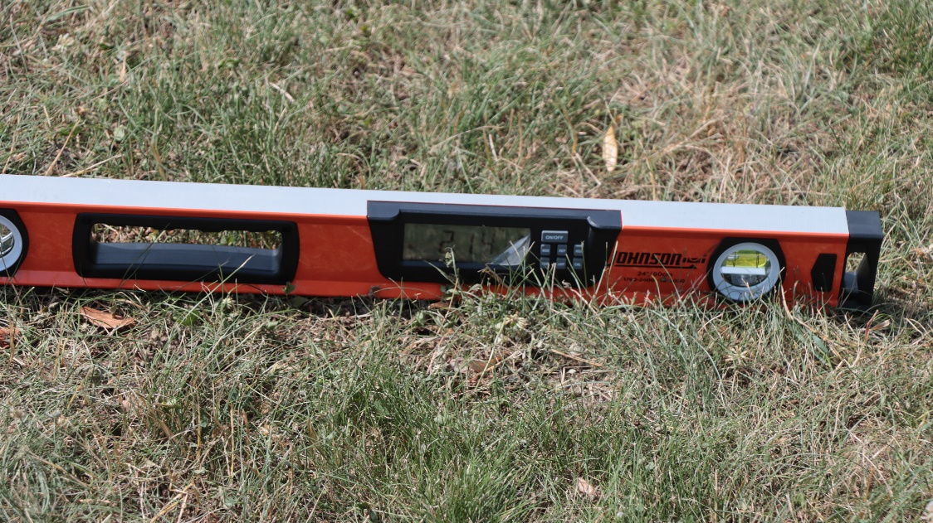
Hydro Point Park (20)
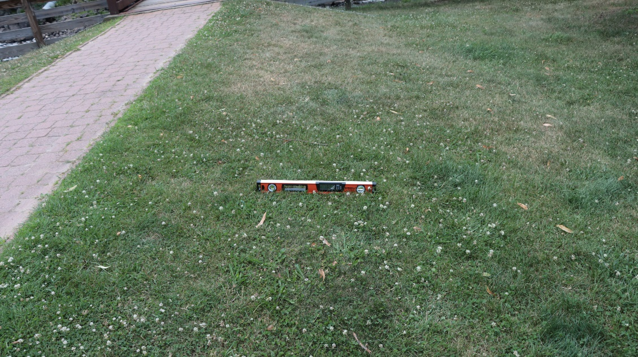
Hydro Point Park (21)
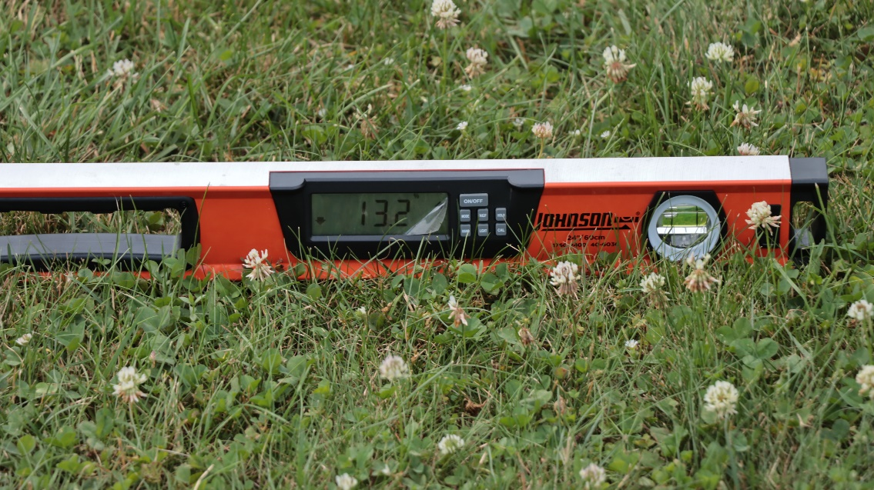
Hydro Point Park (22)
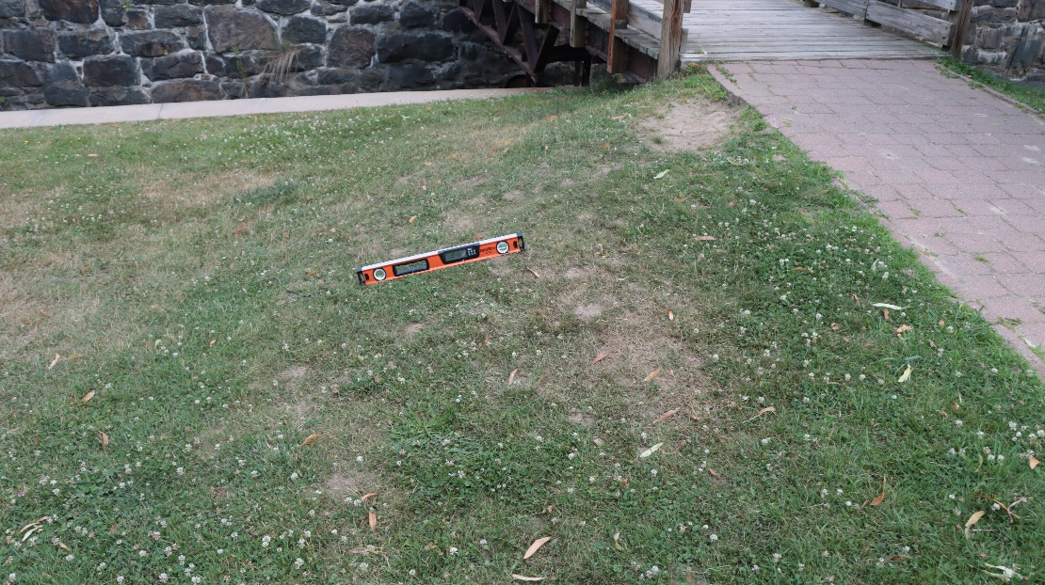
Hydro Point Park (23)
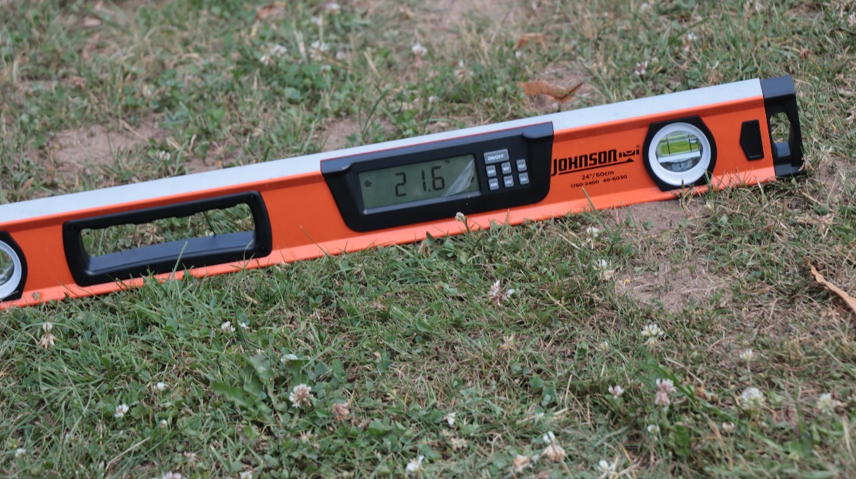
Hydro Point Park (24)
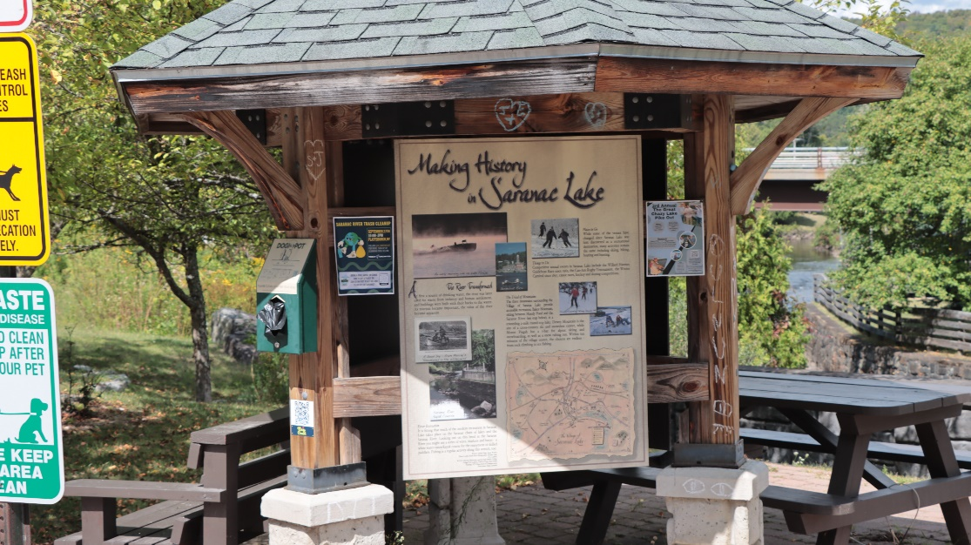
Hydro Point Park (26)

Mount Pisgah Recreation Center
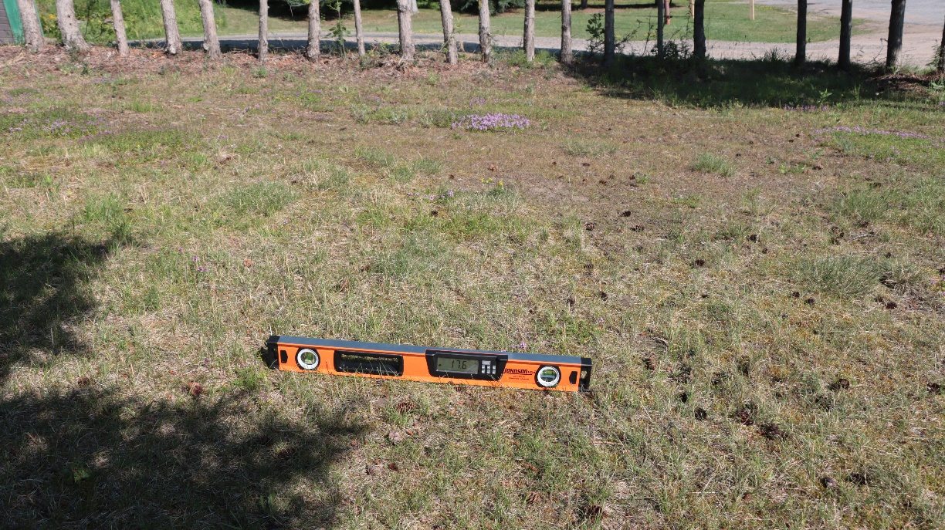
Mt. Pisgah Recreation Center (24)
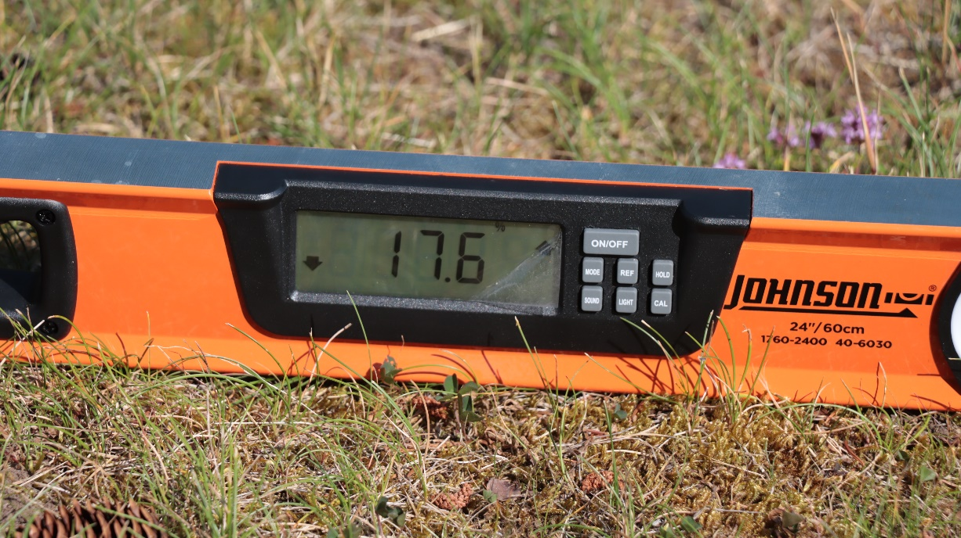
Mt. Pisgah Recreation Center (25)
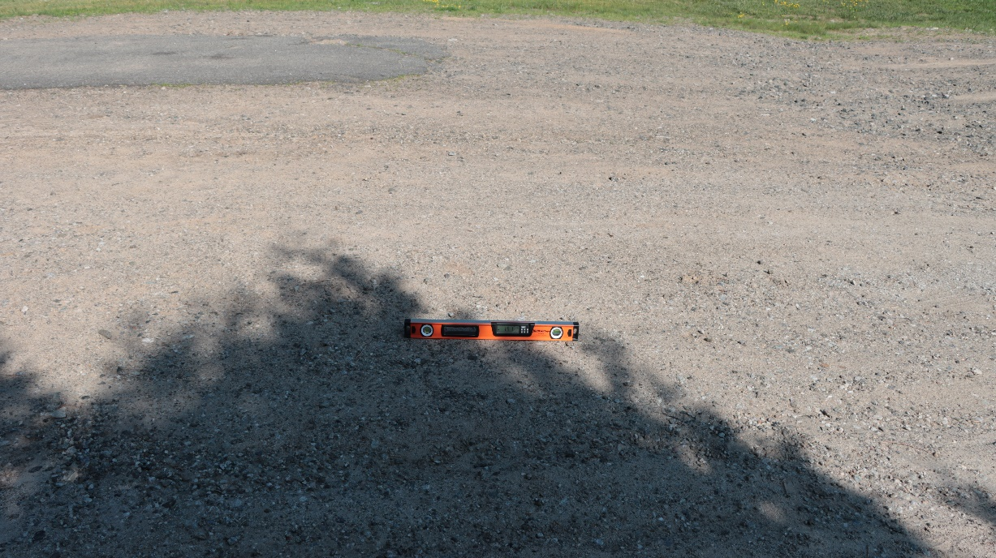
Mt. Pisgah Recreation Center (26)
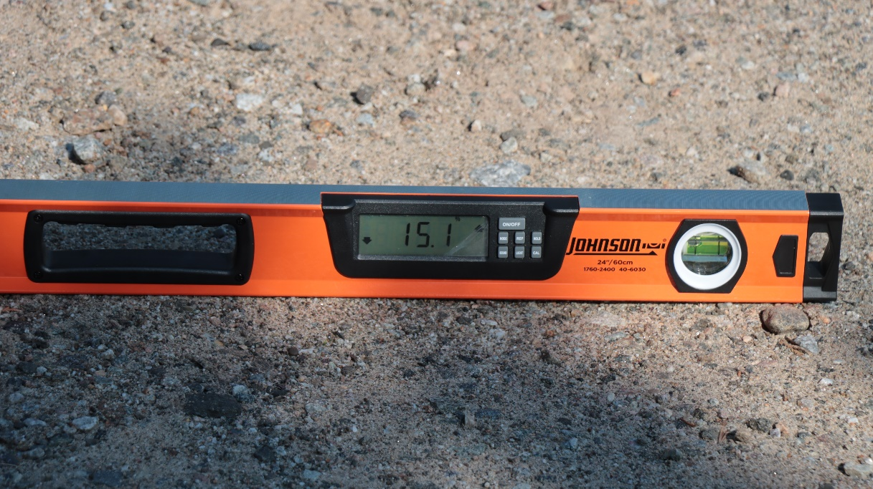
Mt. Pisgah Recreation Center (27)
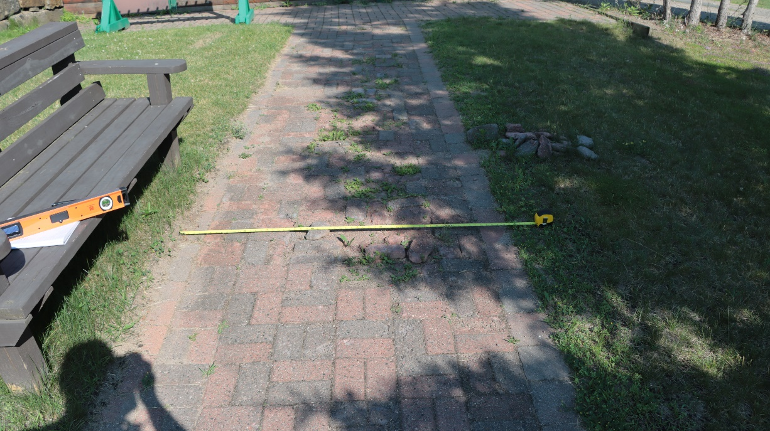
Mt. Pisgah Recreation Center (28)
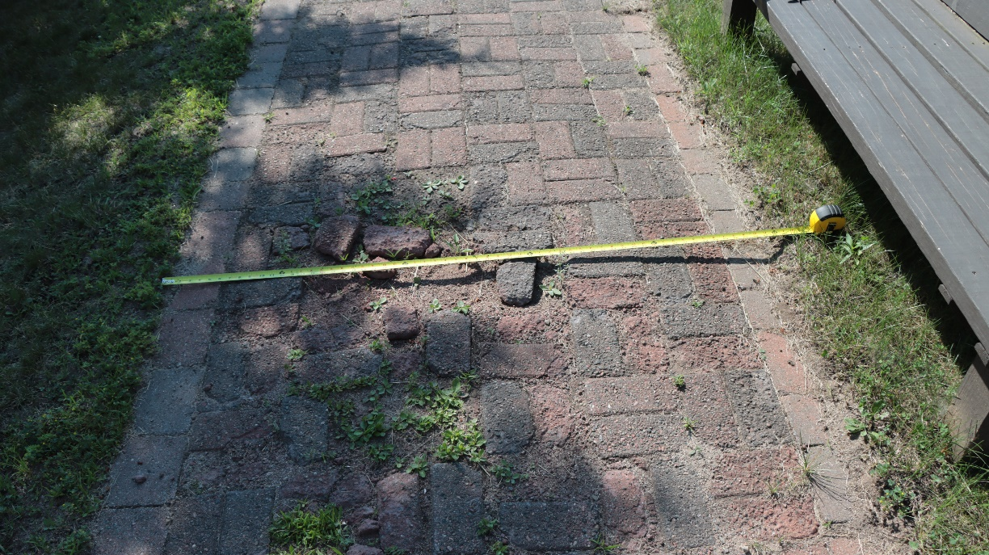
Mt. Pisgah Recreation Center (29)
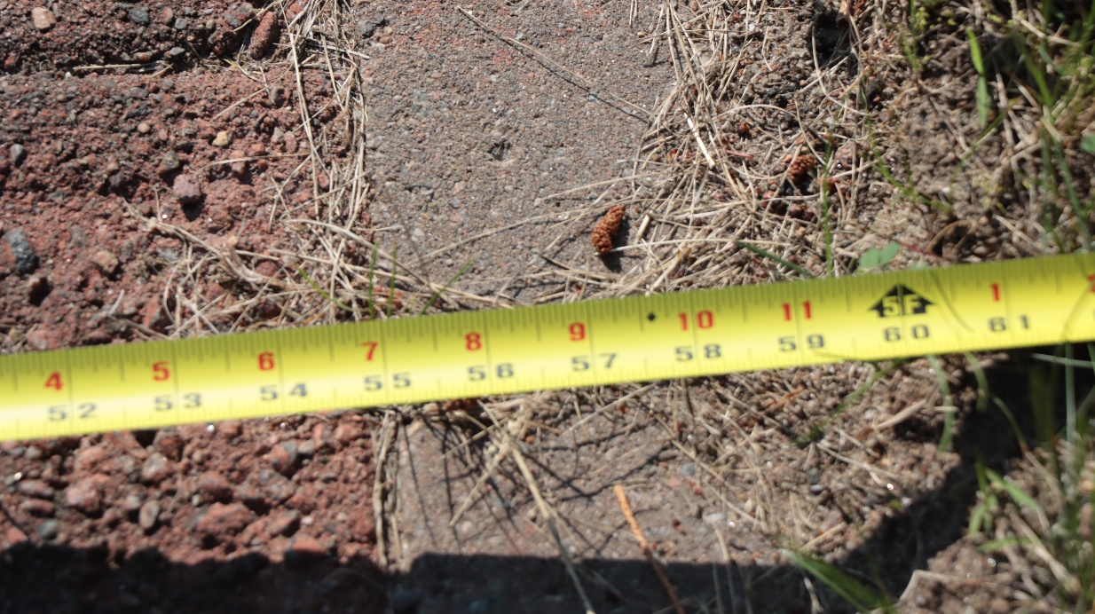
Mt. Pisgah Recreation Center (30)
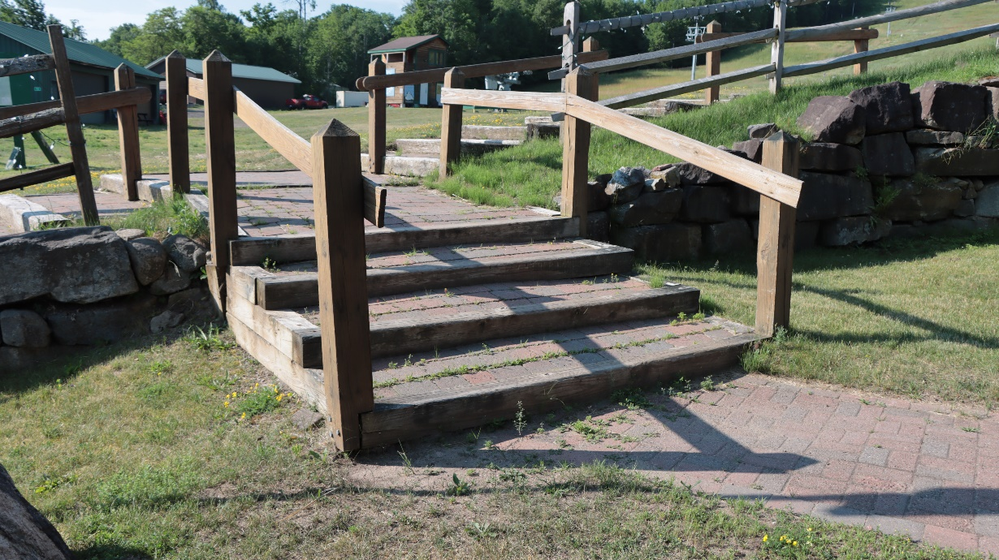
Mt. Pisgah Recreation Center (33)
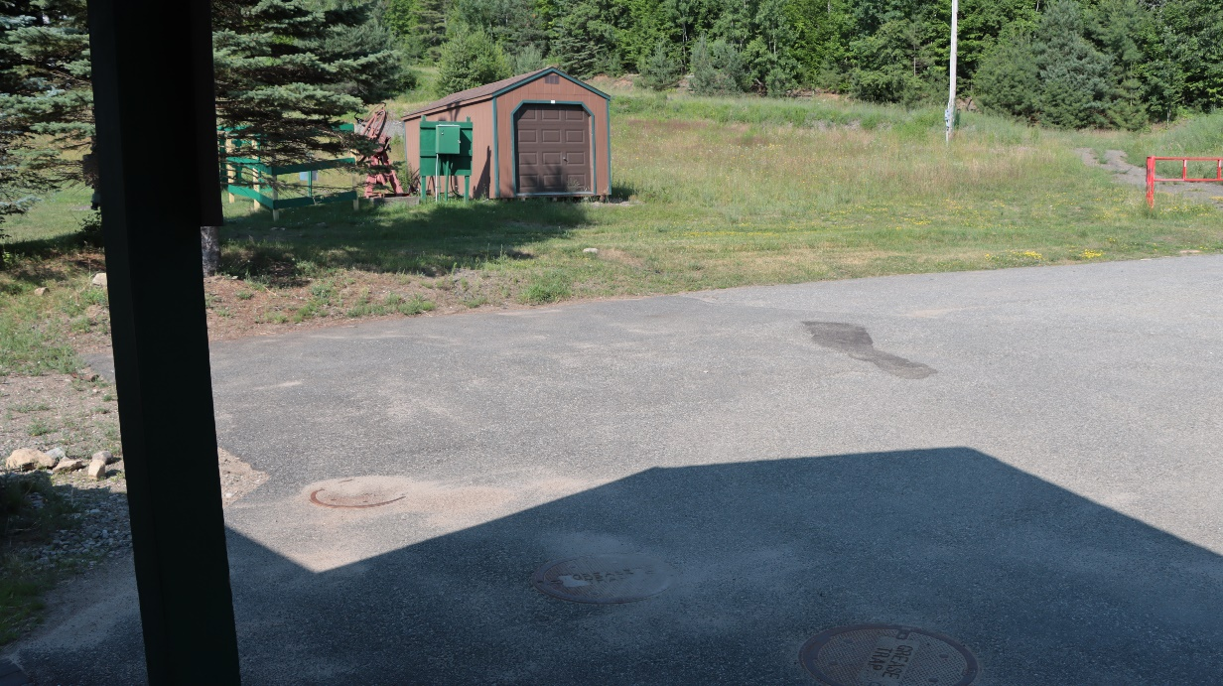
Mt. Pisgah Recreation Center (37)
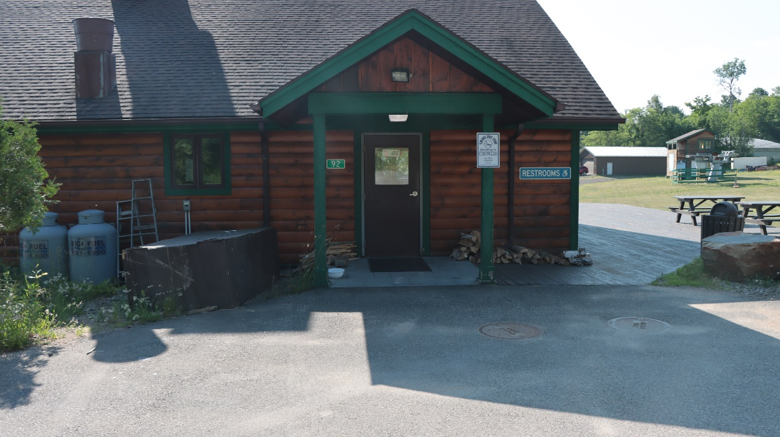
Mt. Pisgah Recreation Center (41)
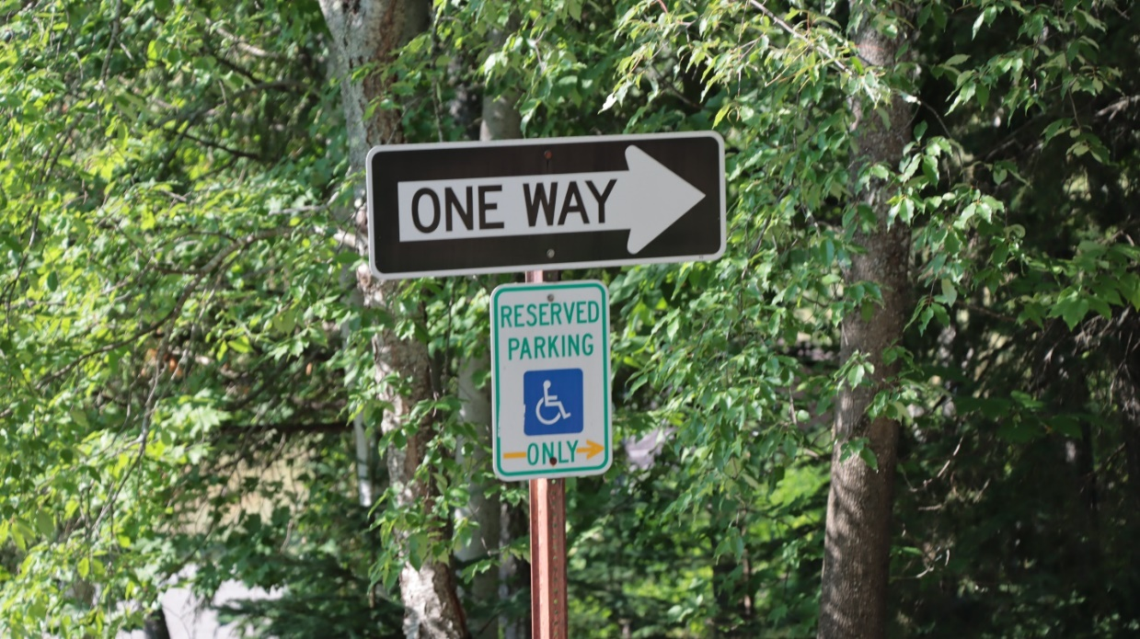
Mt. Pisgah Recreation Center (48)

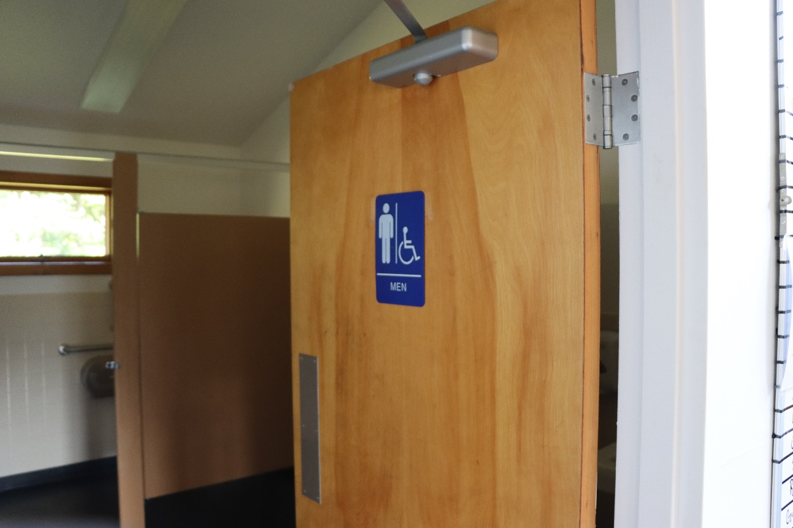
Mt. Pisgah Recreation Center (66)
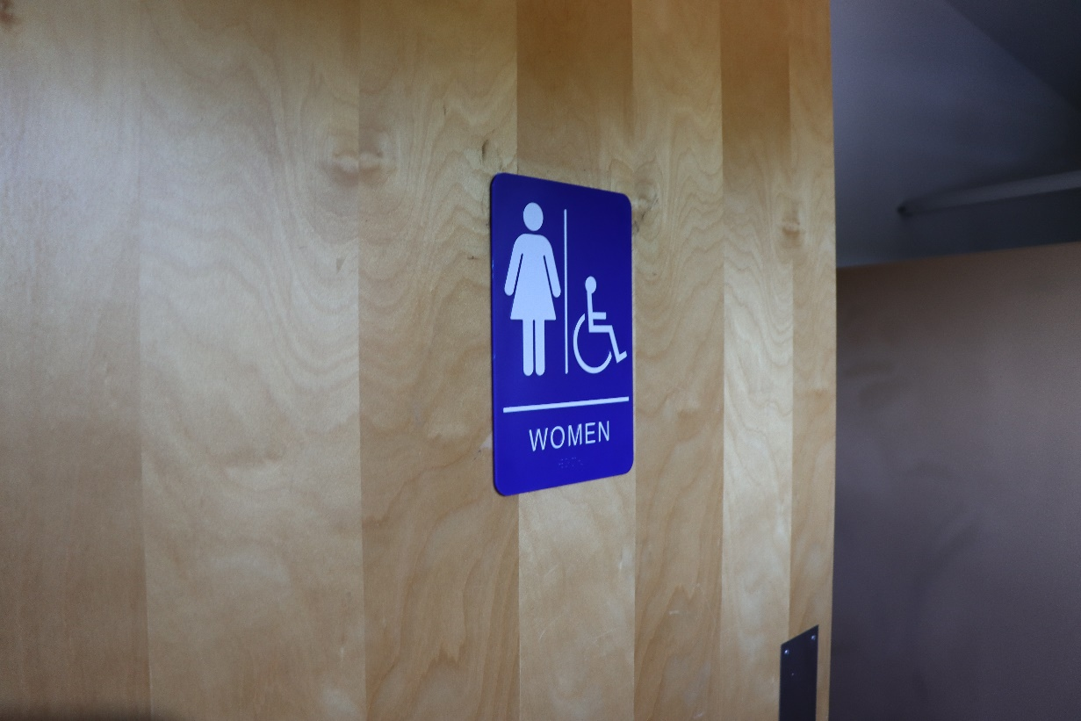
Mt. Pisgah Recreation Center (80)
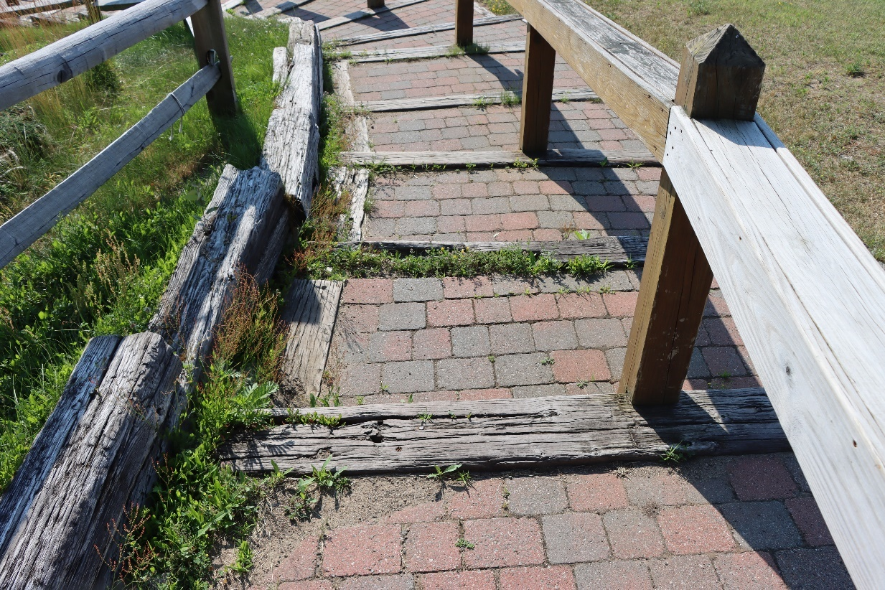
Mt. Pisgah Recreation Center (99)

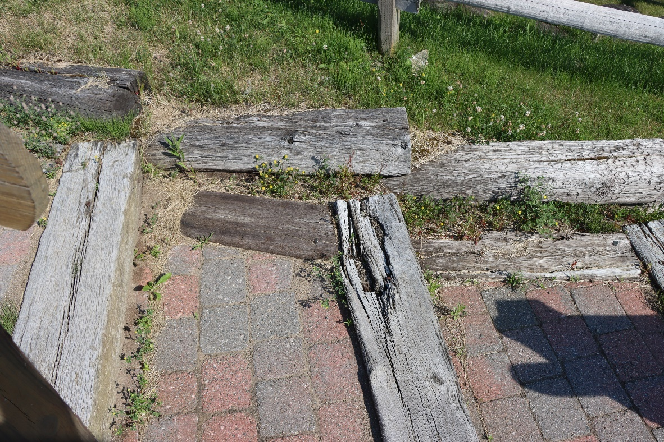
Mt. Pisgah Recreation Center (102)
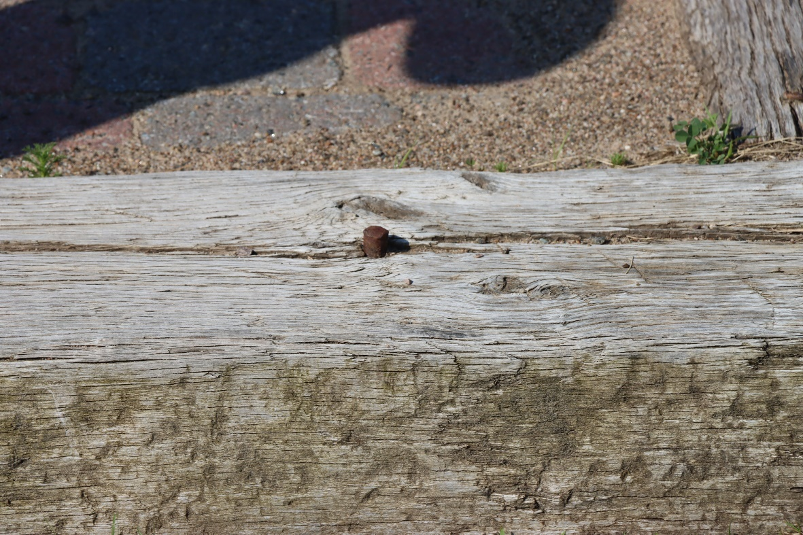
Mt. Pisgah Recreation Center (107)

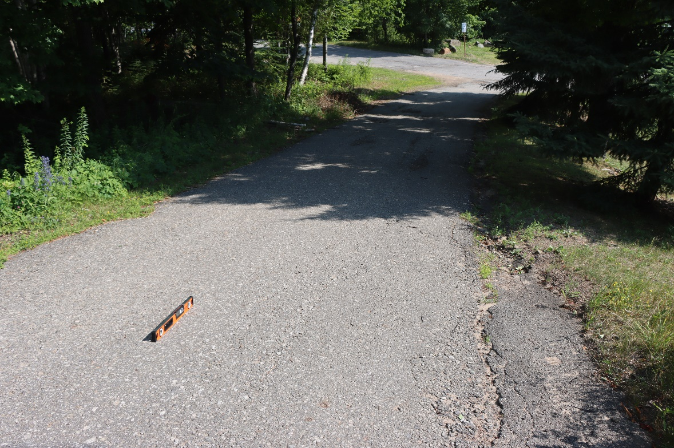
Mt. Pisgah Recreation Center (115)
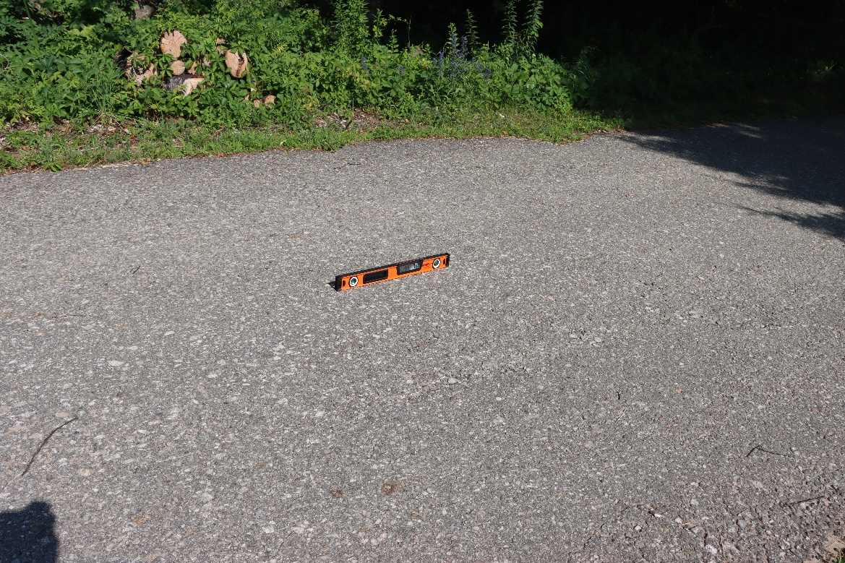
Mt. Pisgah Recreation Center (116)
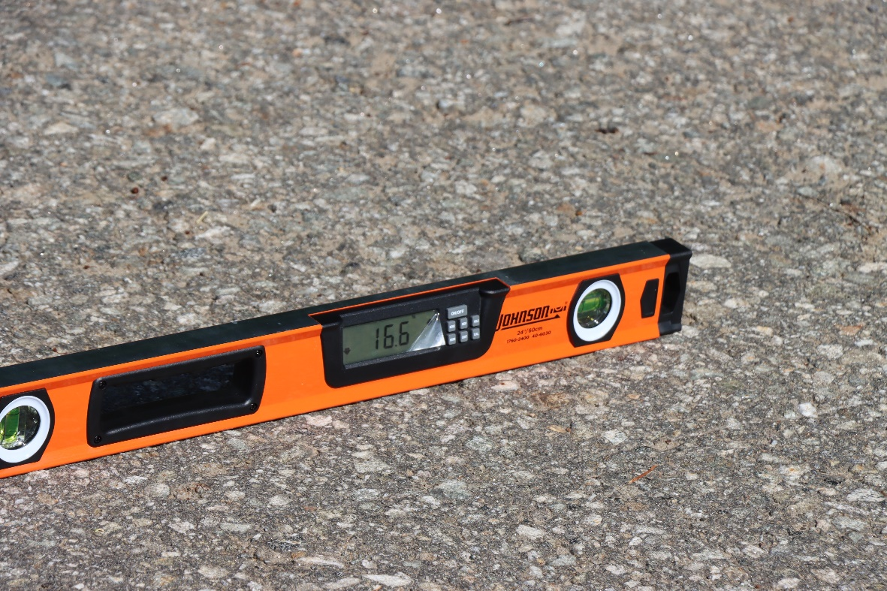
Mt. Pisgah Recreation Center (117)
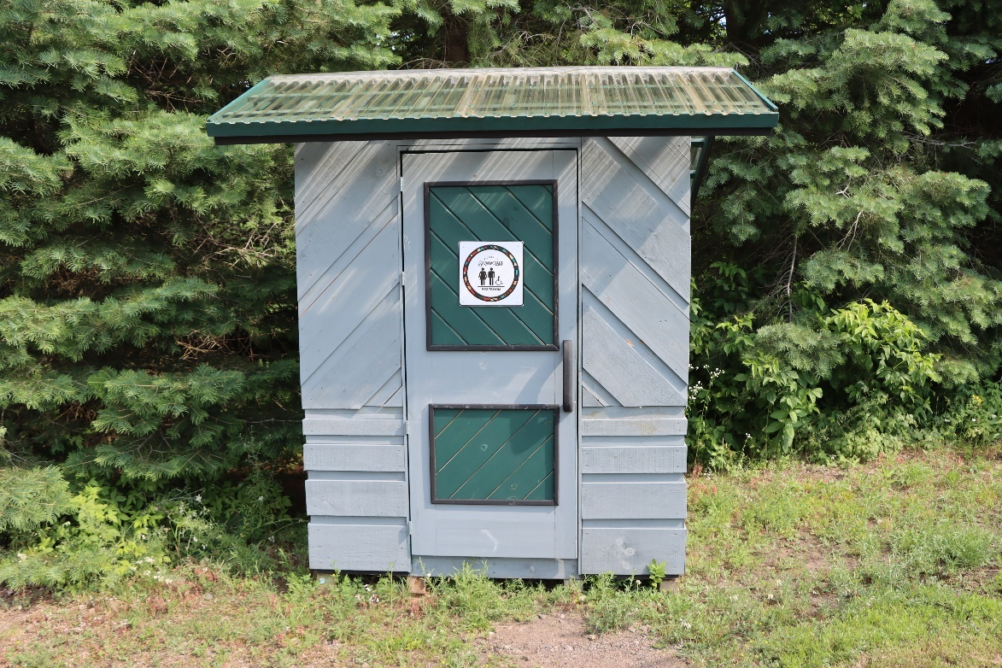
Mt. Pisgah Recreation Center (137)
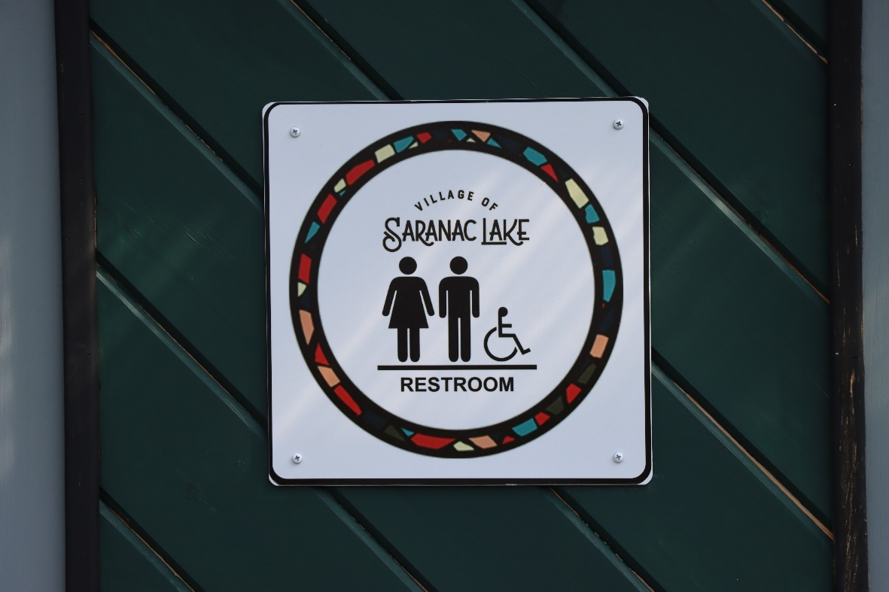
Mt. Pisgah Recreation Center (138)
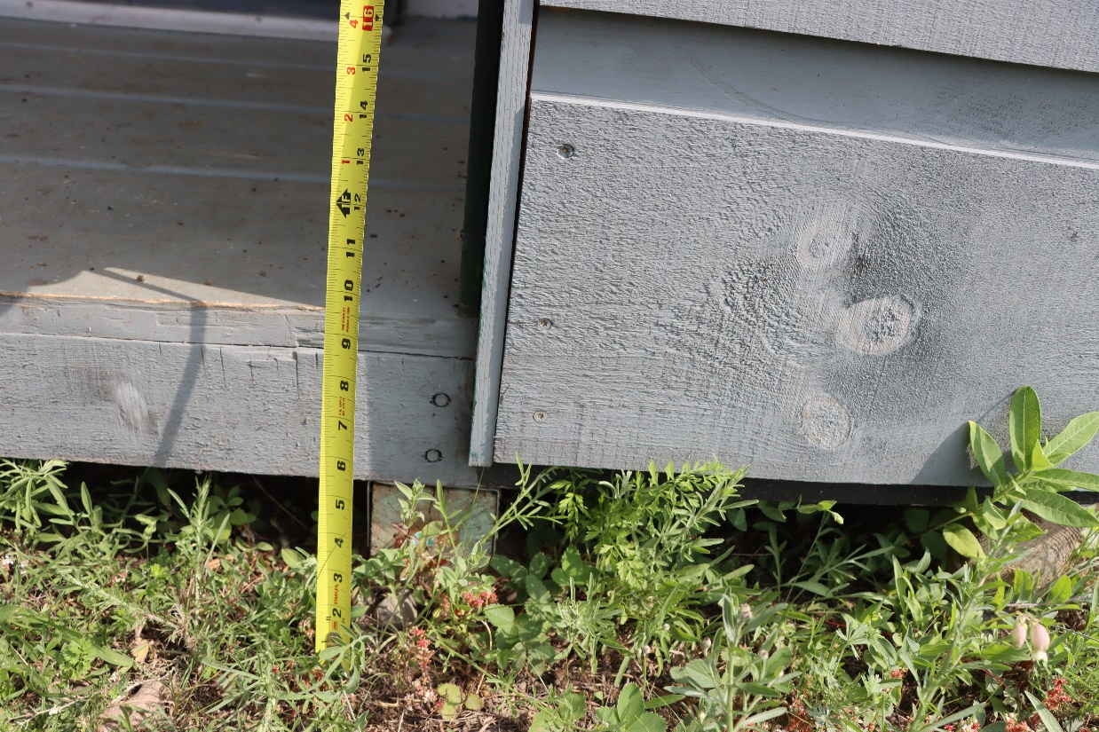
Mt. Pisgah Recreation Center (139)
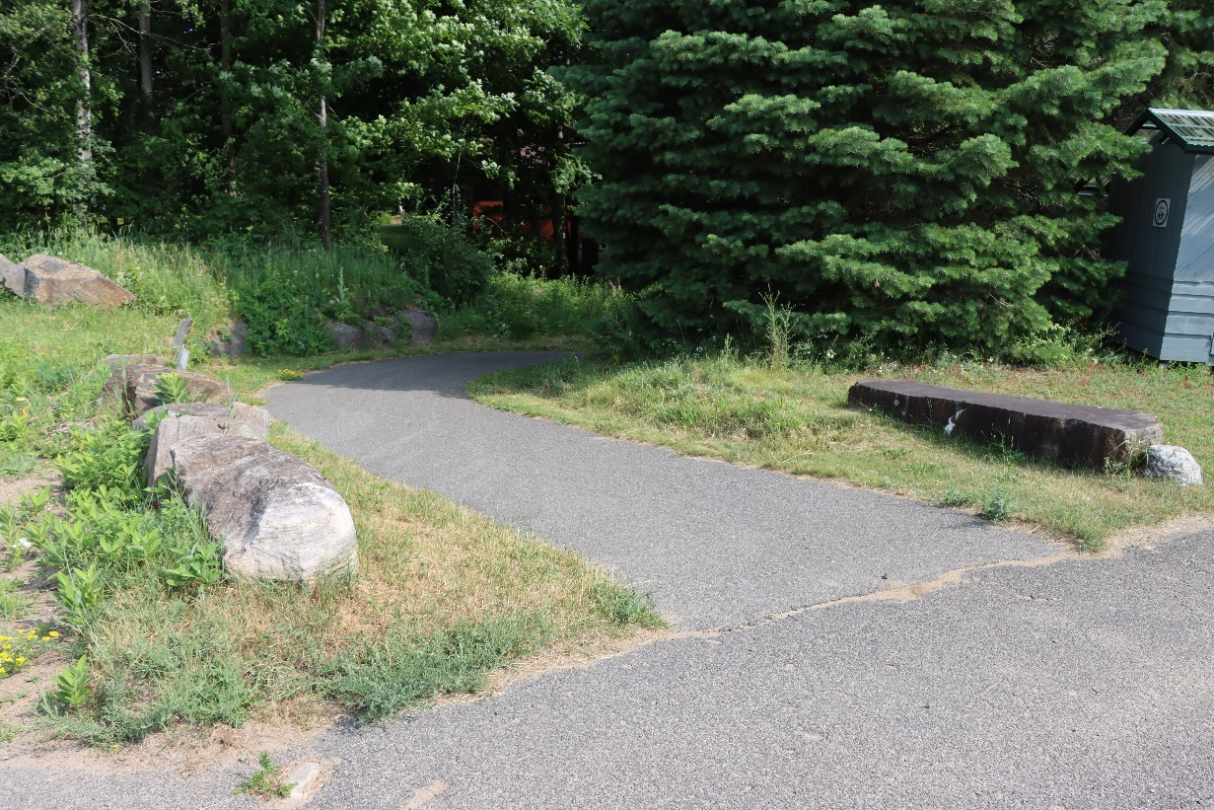
Mt. Pisgah Recreation Center (143)
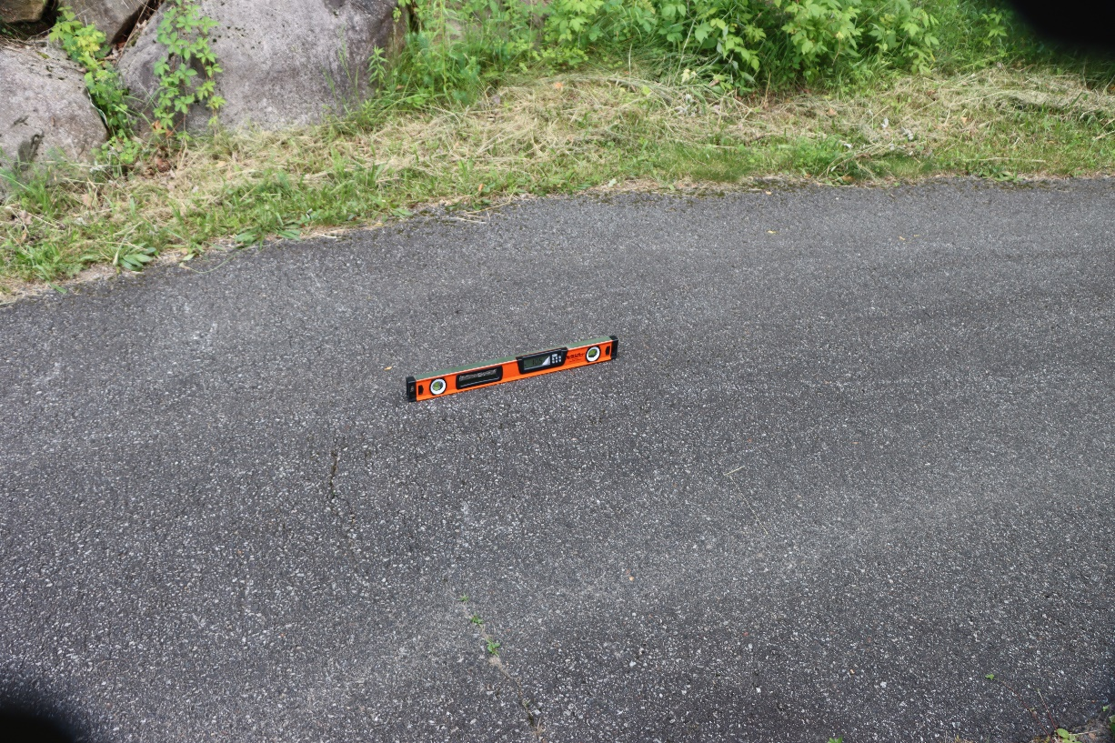
Mt. Pisgah Recreation Center (145)
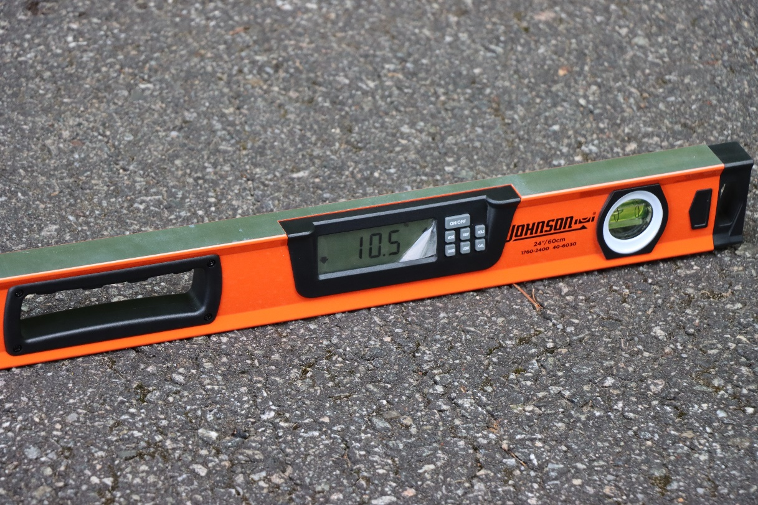
Mt. Pisgah Recreation Center (146)

Prescott IPW Park
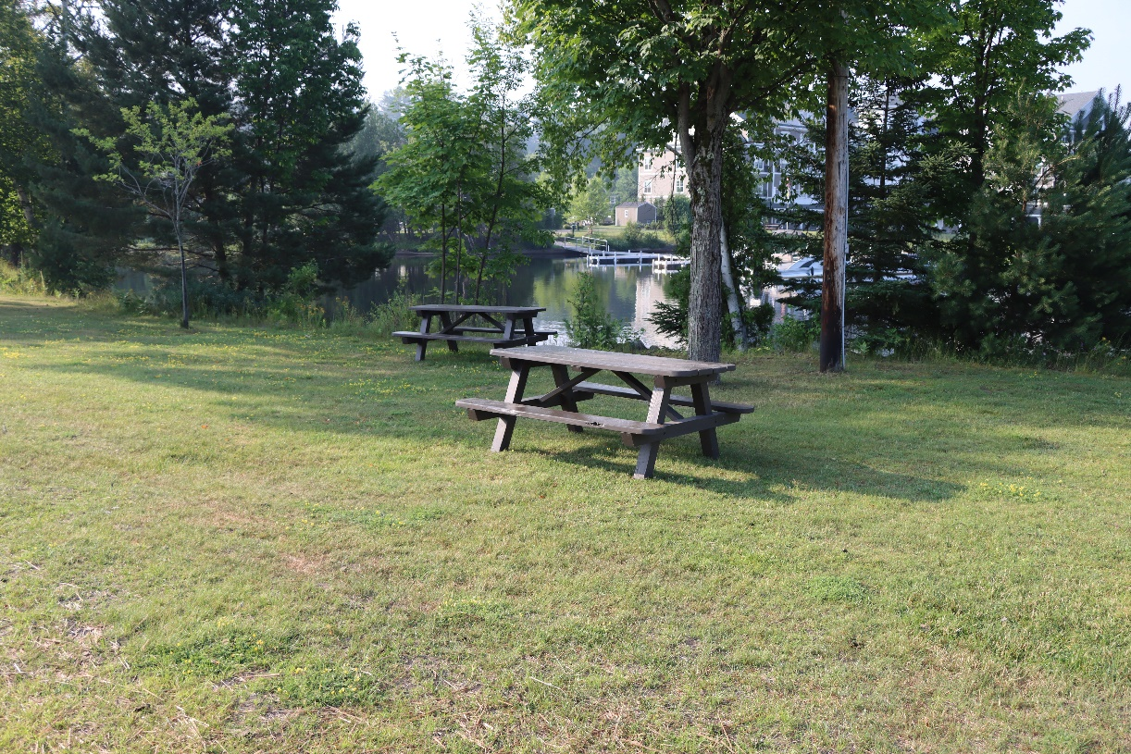
Prescott Park (4)

Riverfront Park

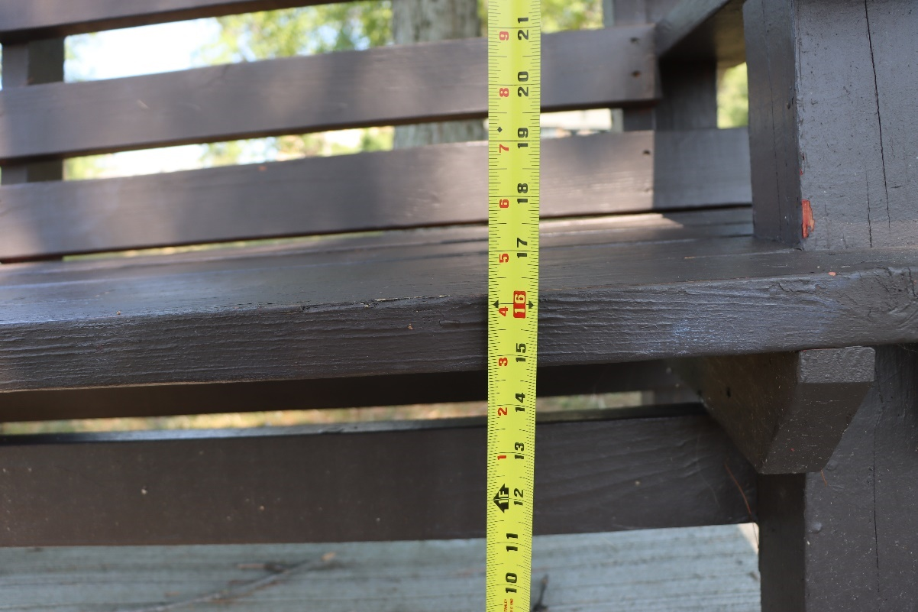
Riverfront Park (20)
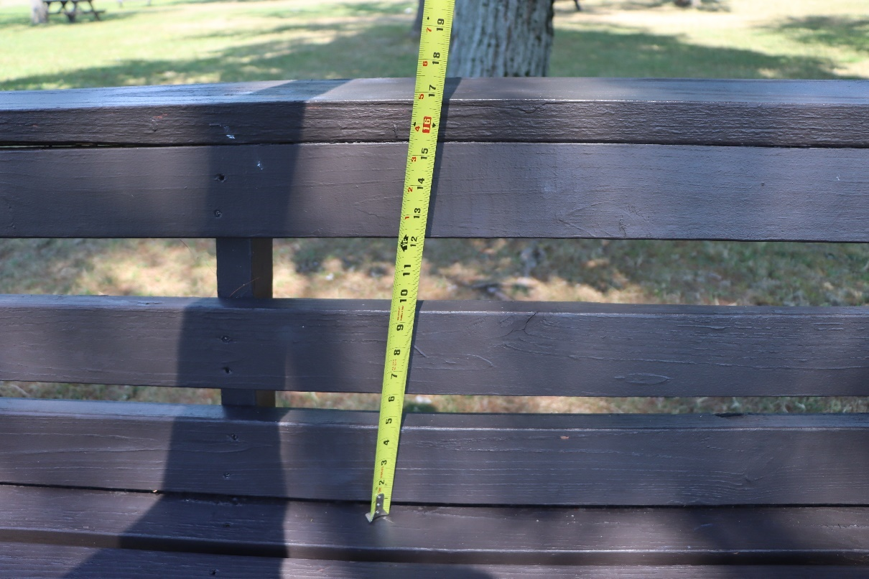
Riverfront Park (21)
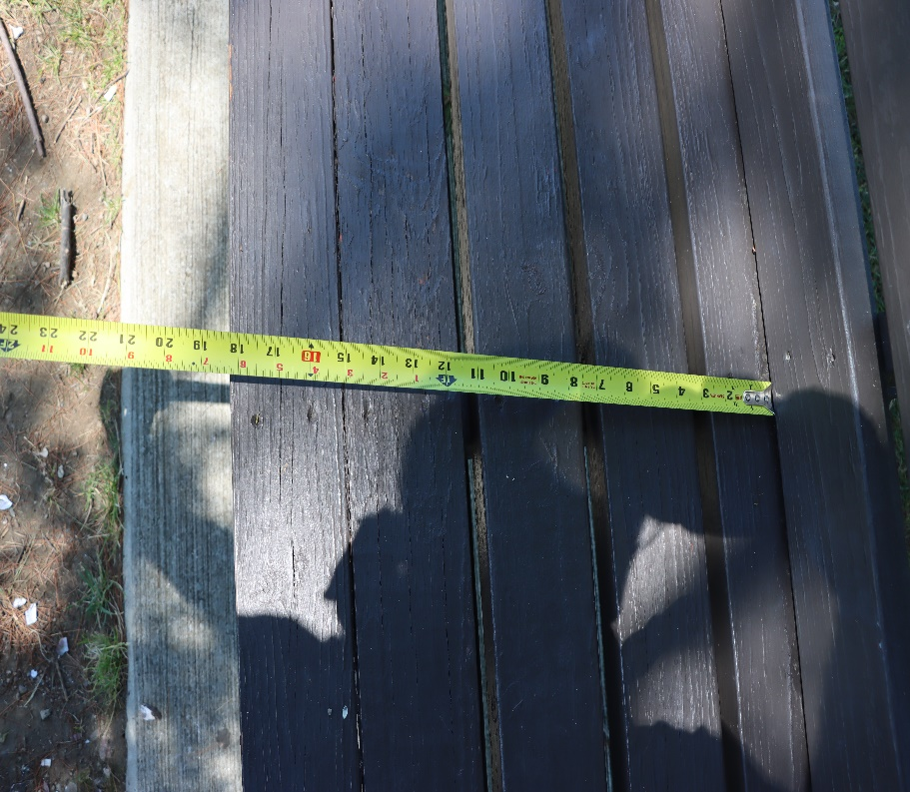
Riverfront Park (25)
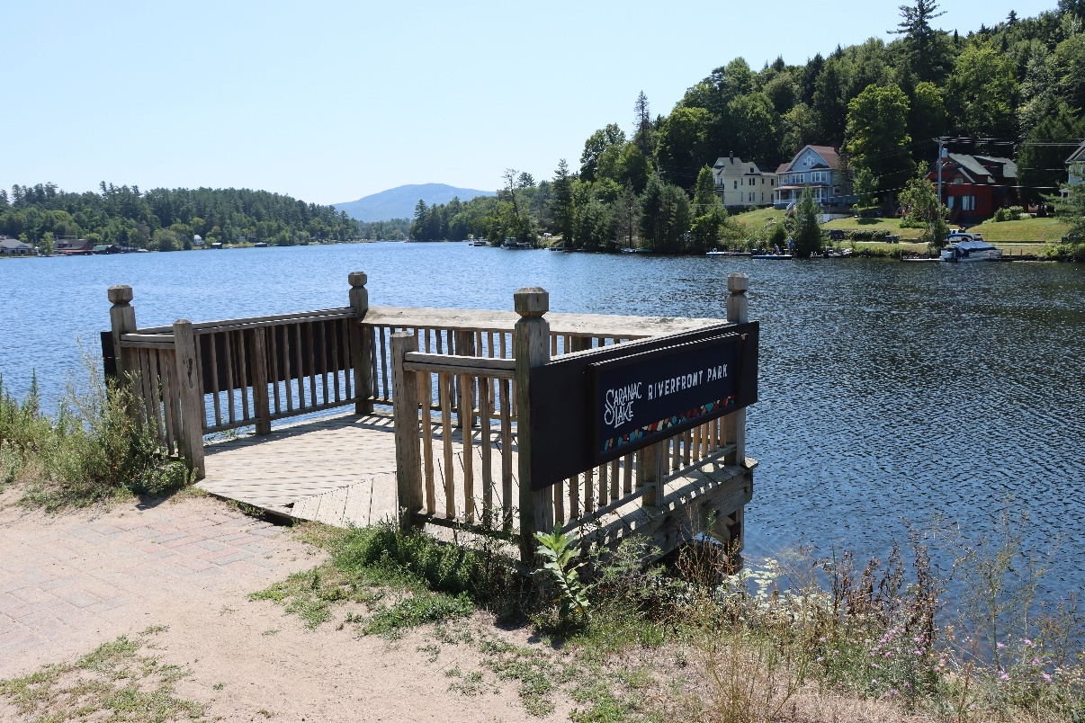
Riverfront Park (28)
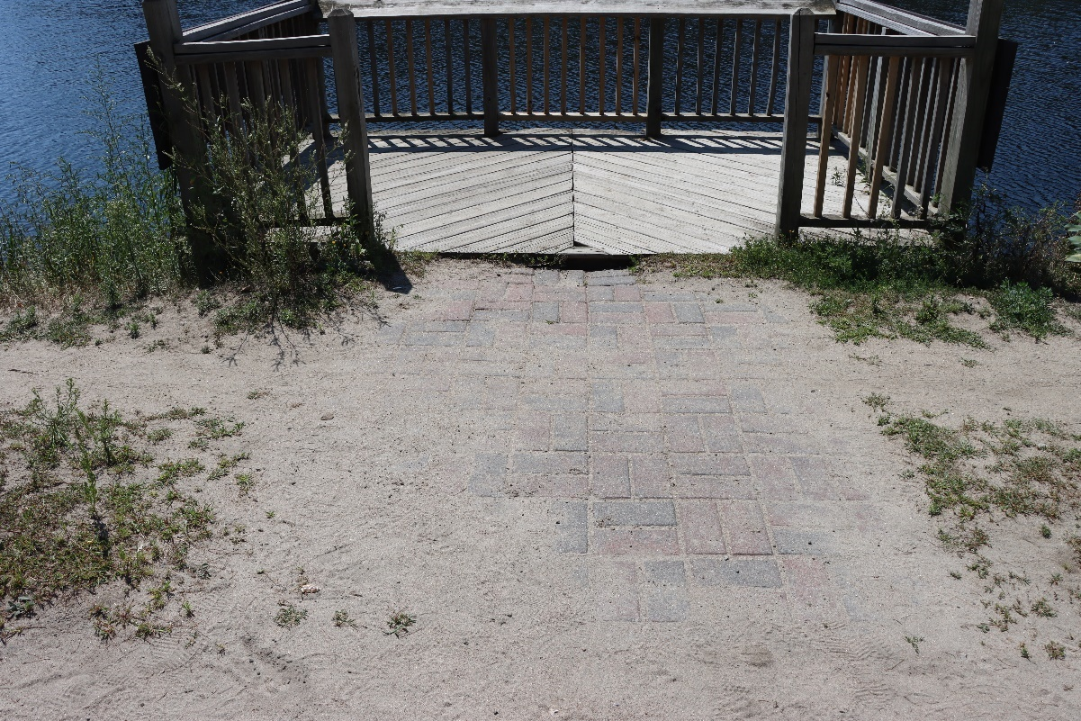
Riverfront Park (29)
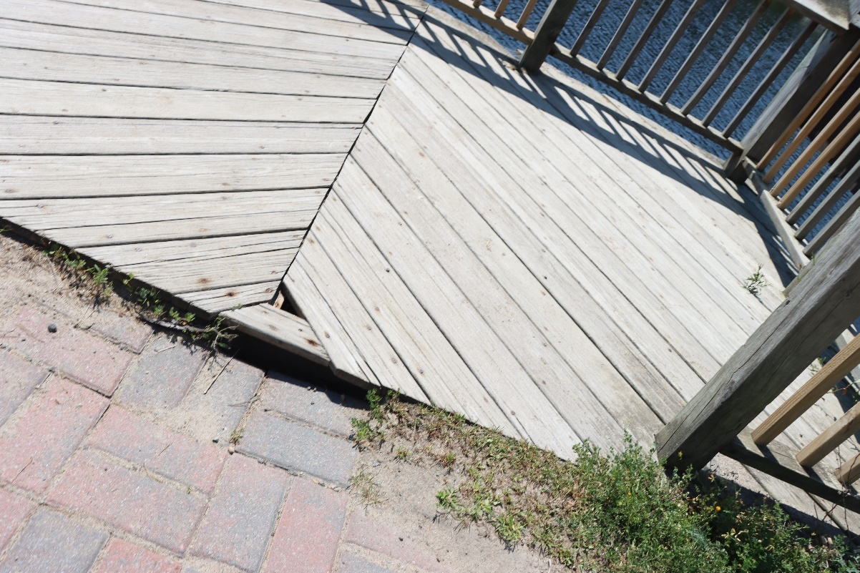
Riverfront Park (31)
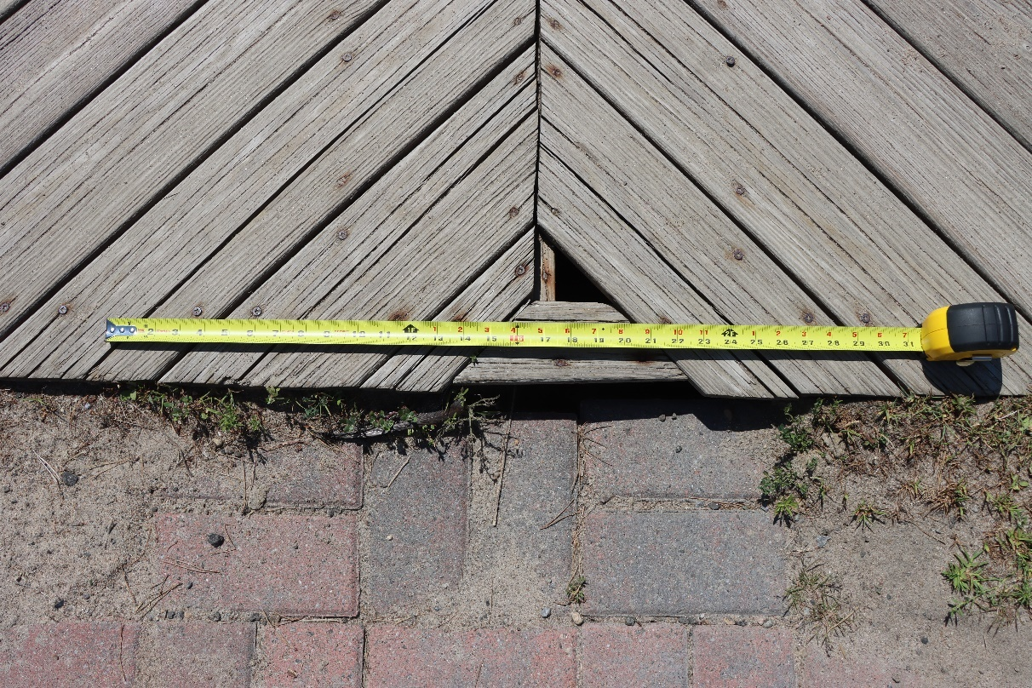
Riverfront Park (34)
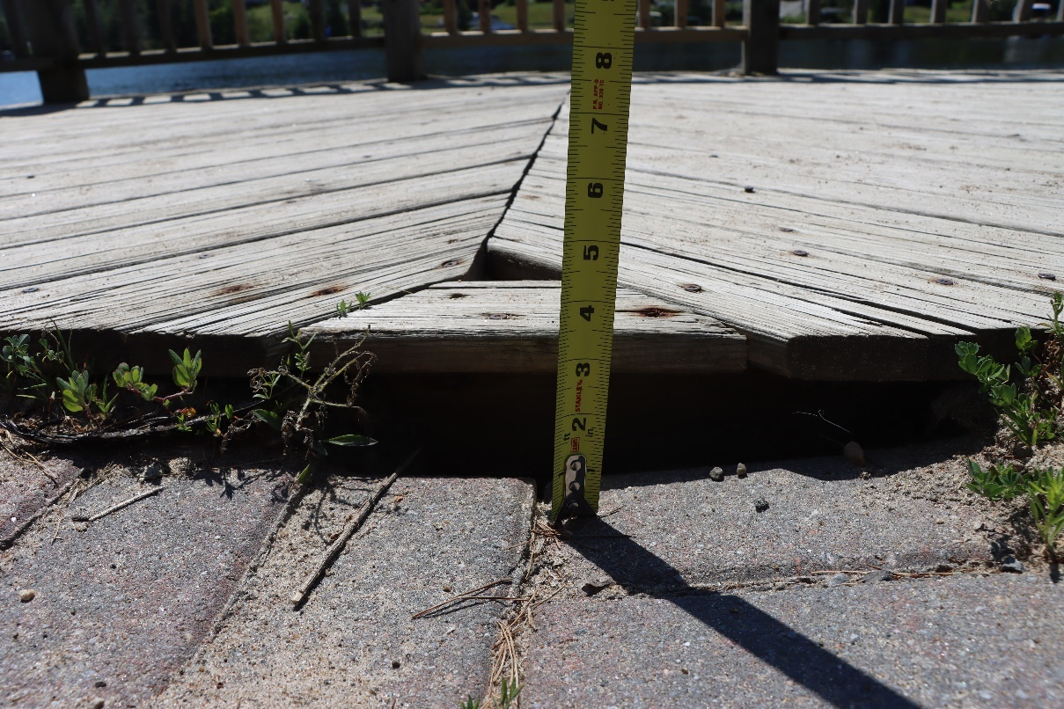
Riverfront Park (36)
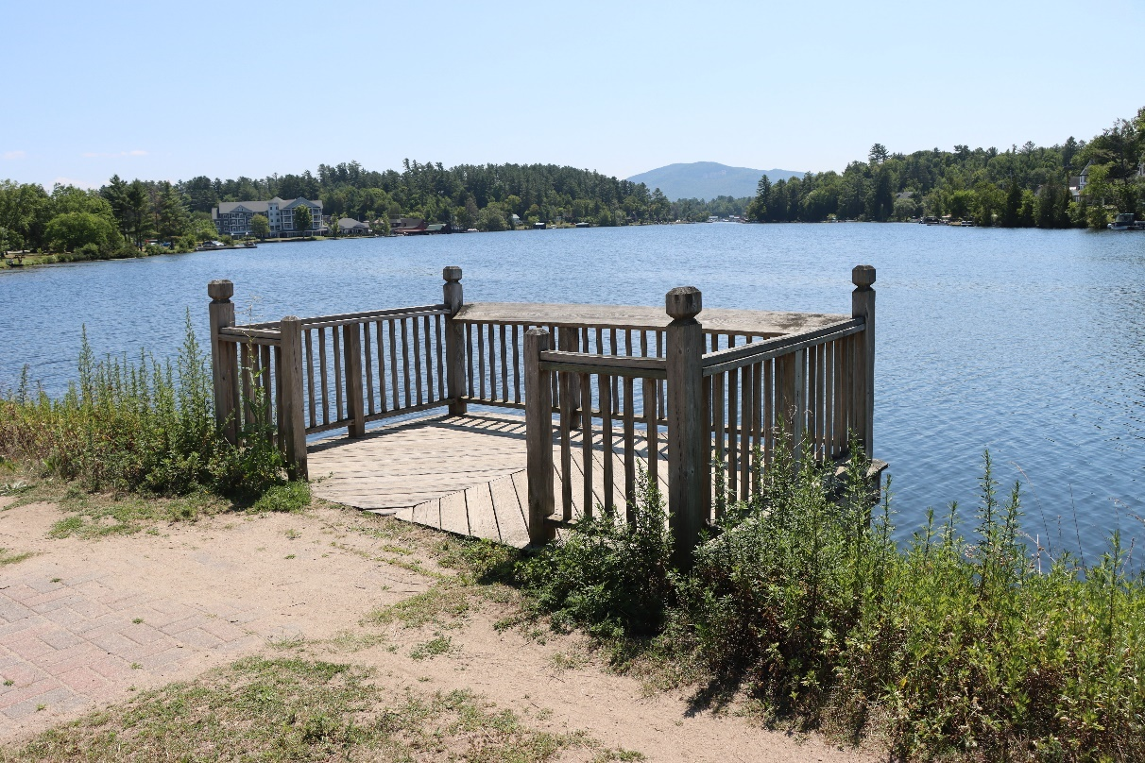
Riverfront Park (37)
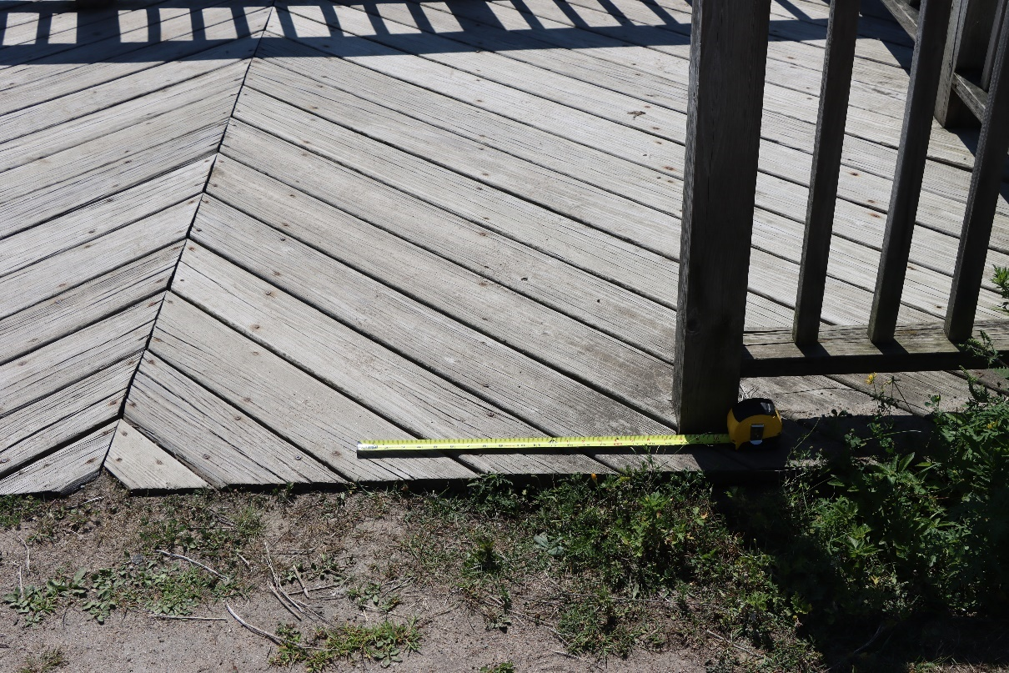
Riverfront Park (39)
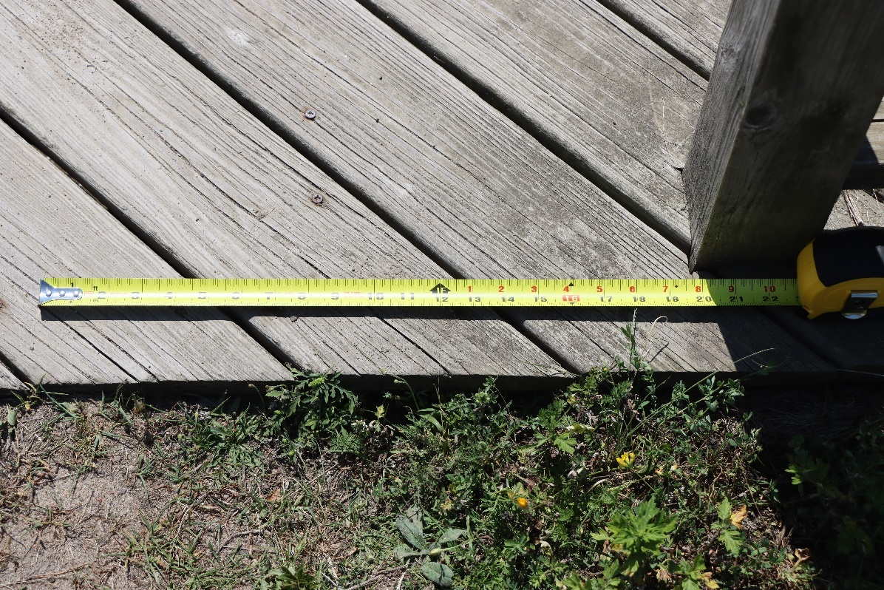
Riverfront Park (40)
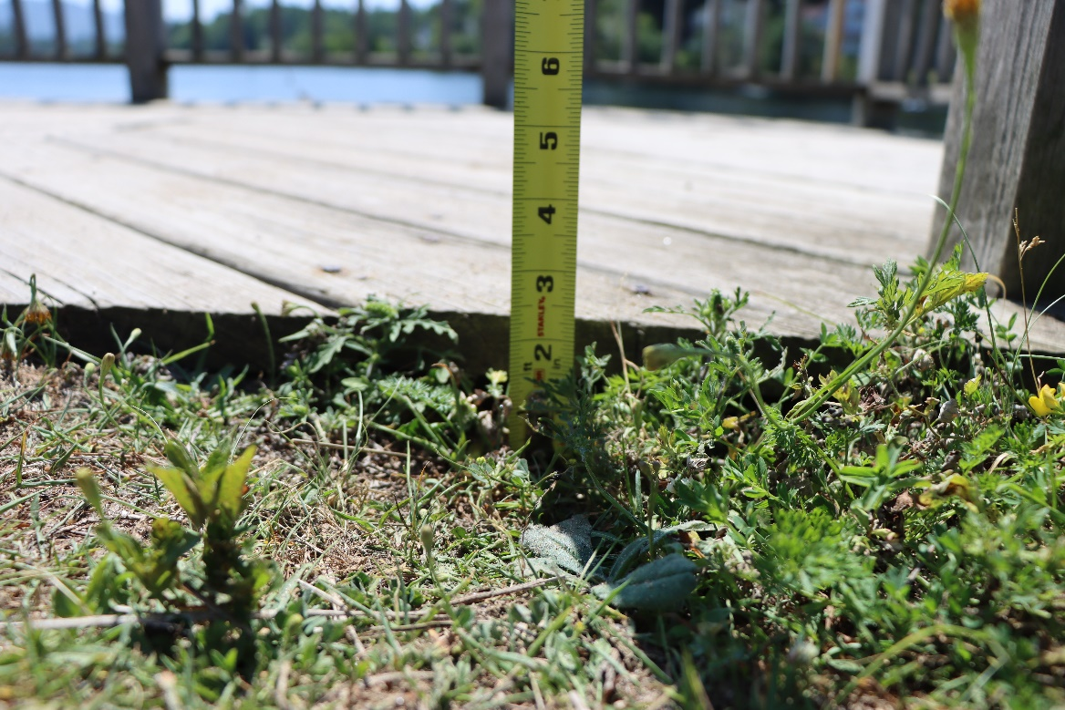
Riverfront Park (41)

Riverside Park
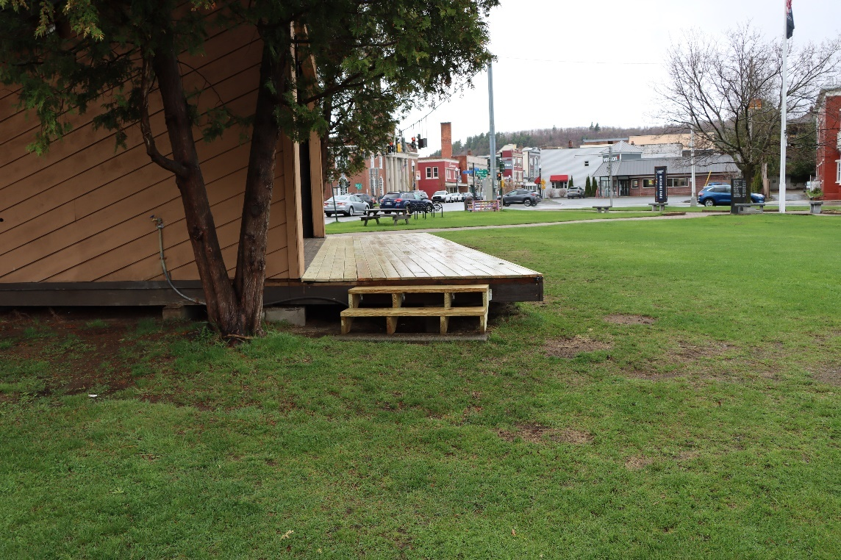
Riverside Park (3)
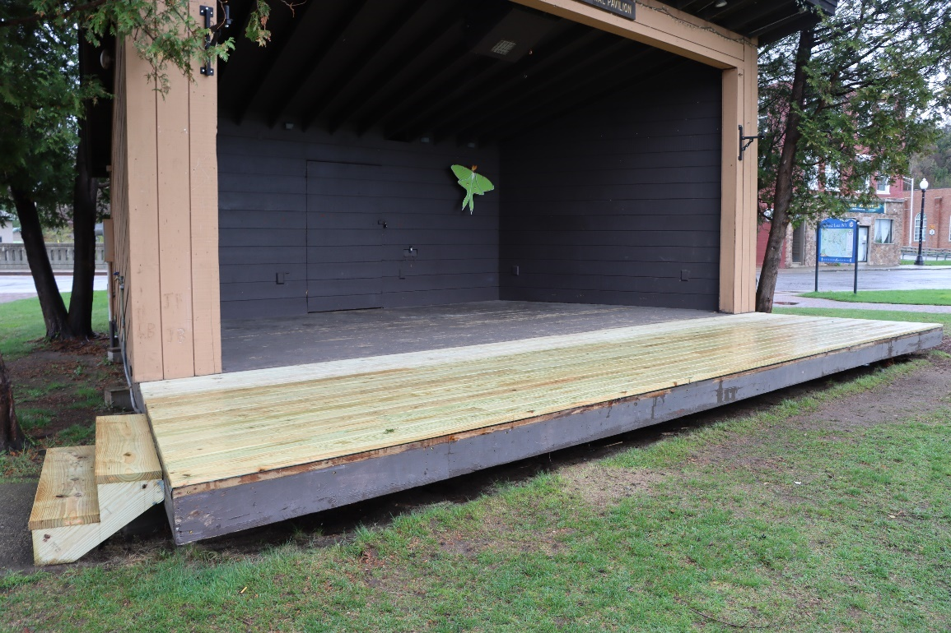
Riverside Park (4)
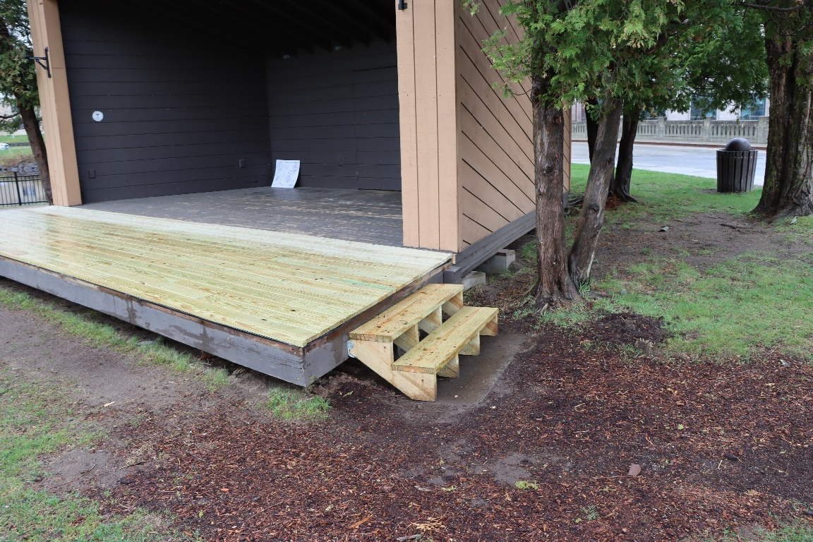
Riverside Park (5)
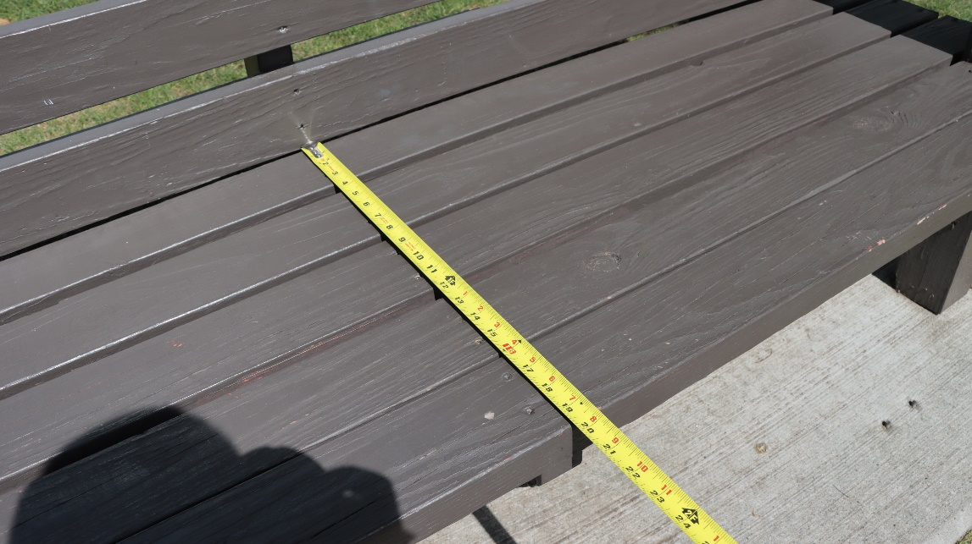
Riverside Park (24)
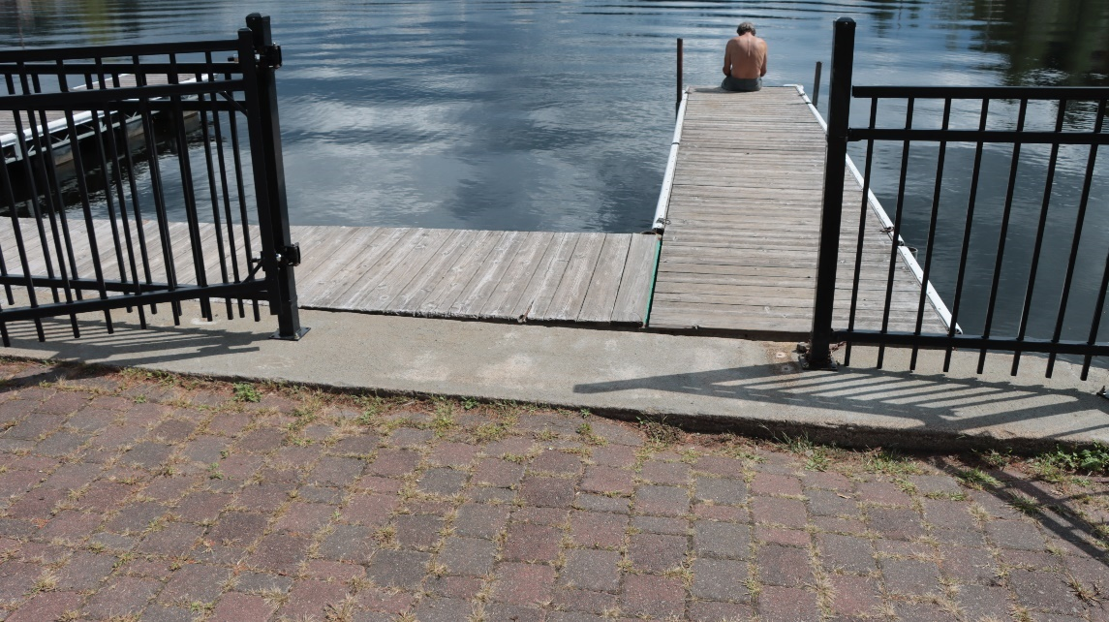
Riverside Park (30)
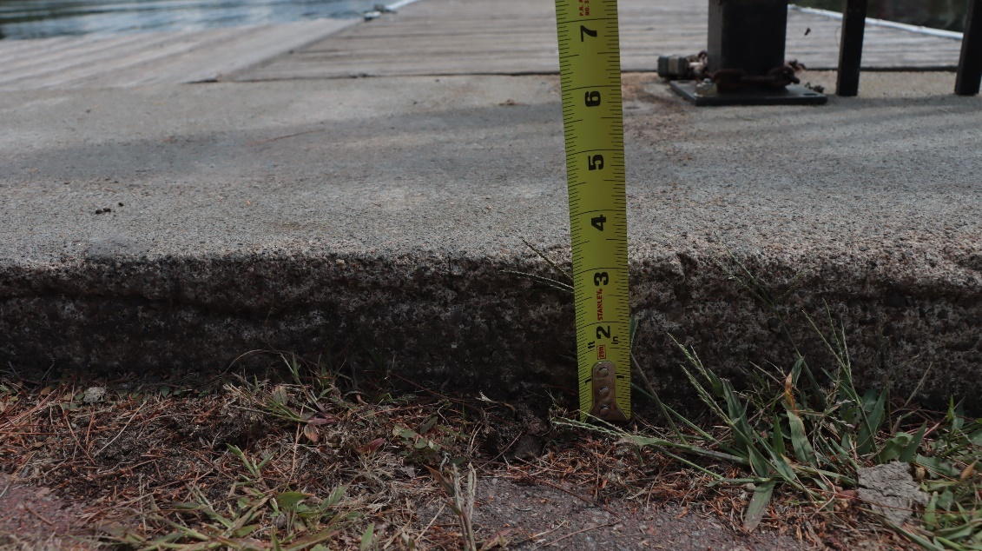
Riverside Park (31)
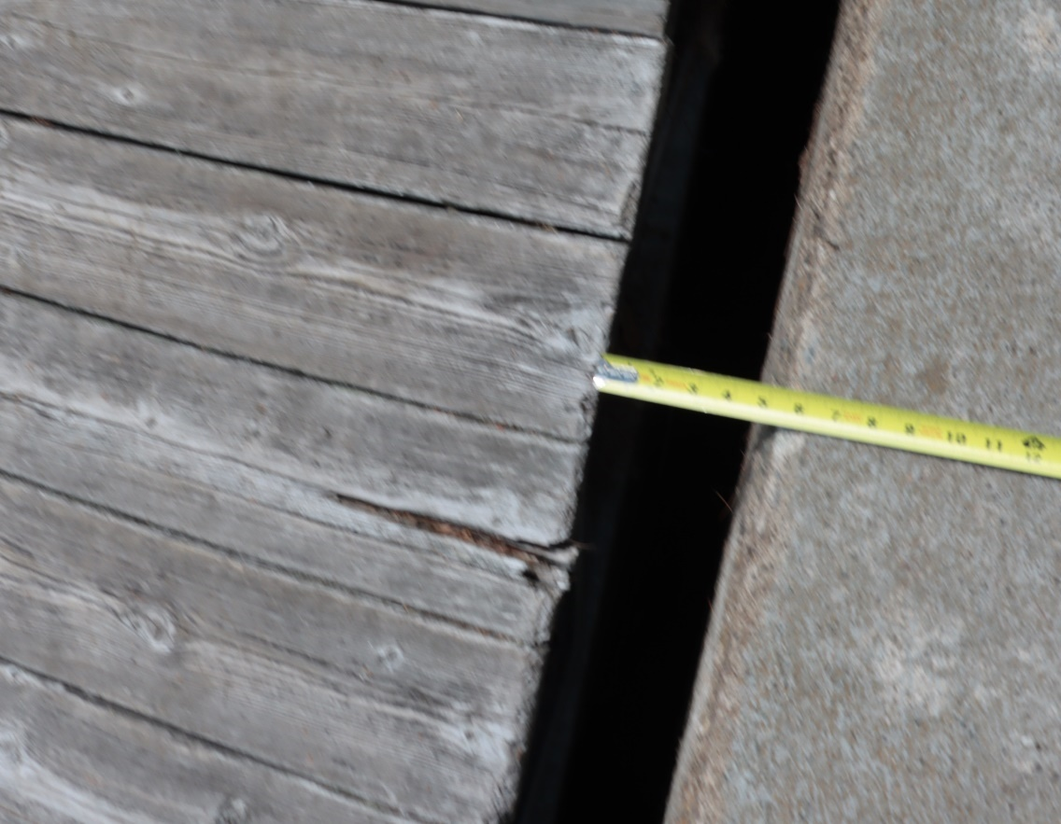
Riverside Park (33)
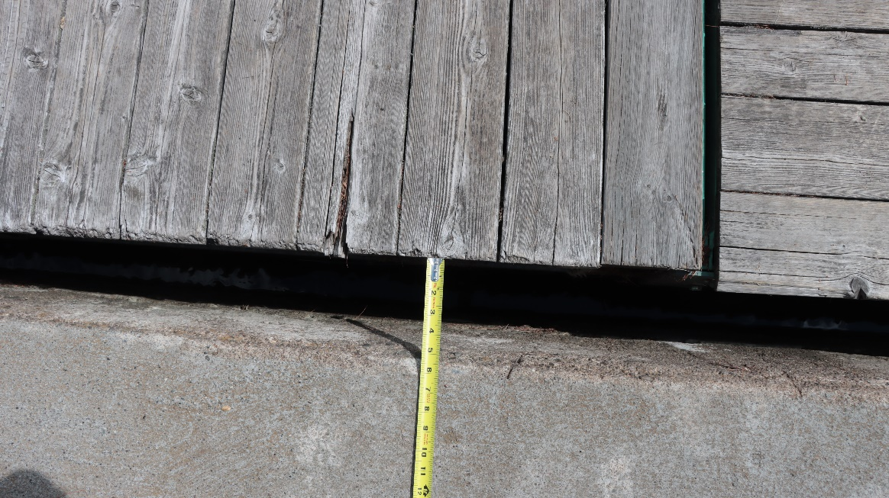
Riverside Park (34)
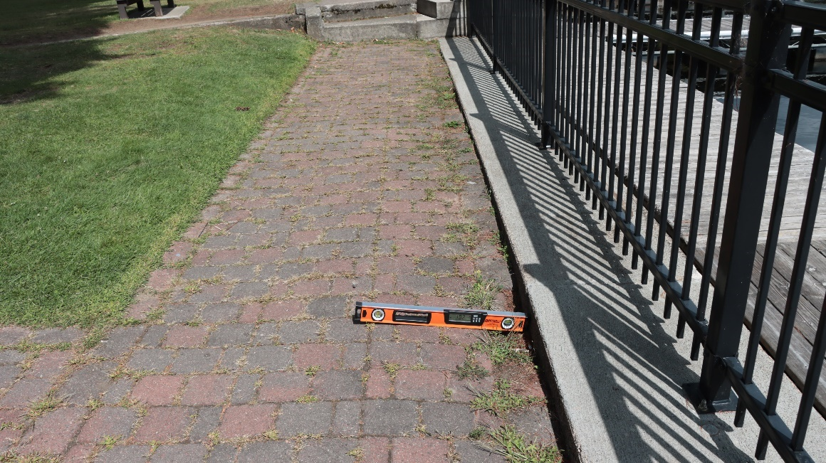
Riverside Park (36)
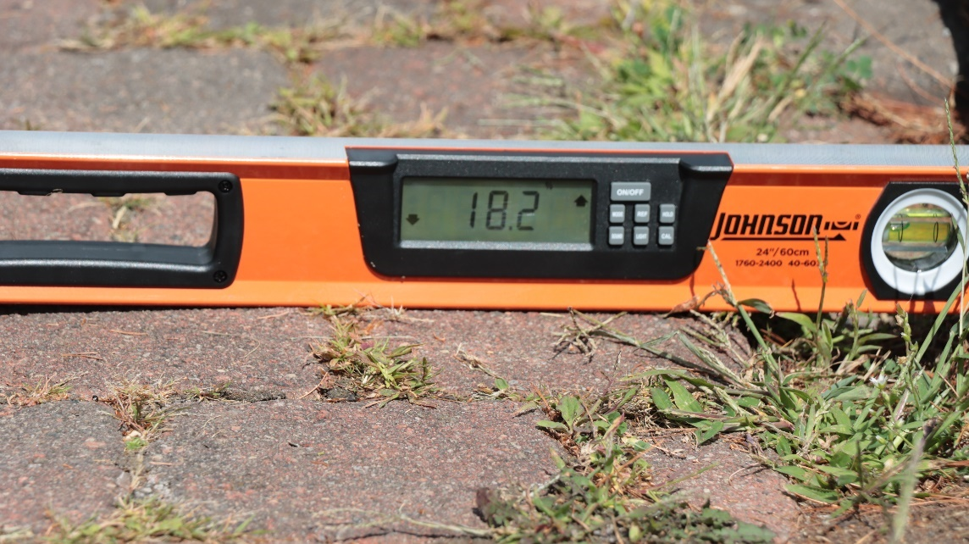
Riverside Park (37)

Saranac Lake Riverwalk
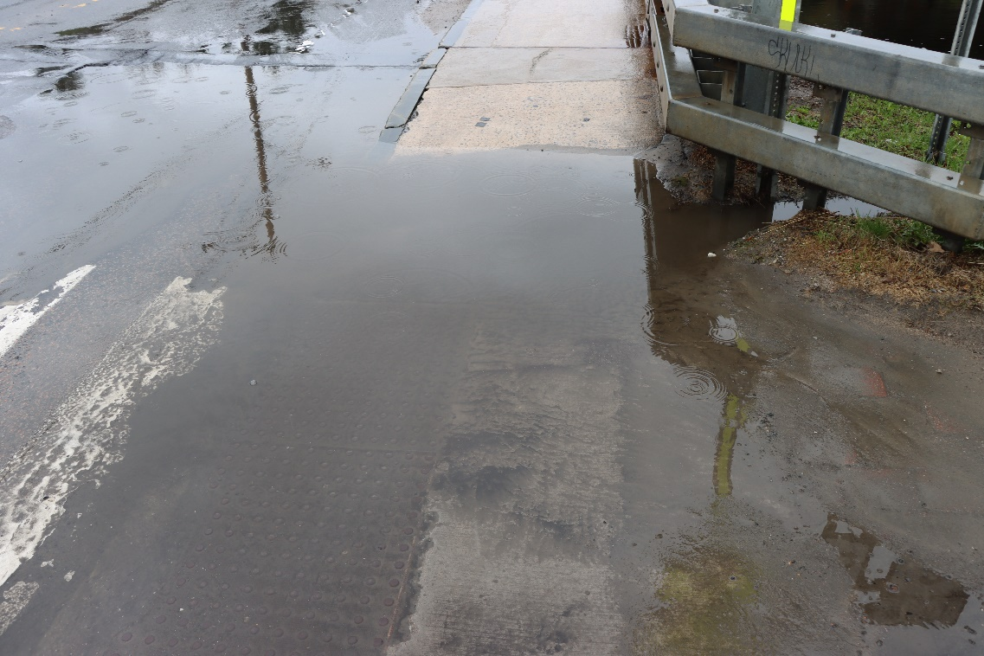
Saranac Lake Riverwalk (4)
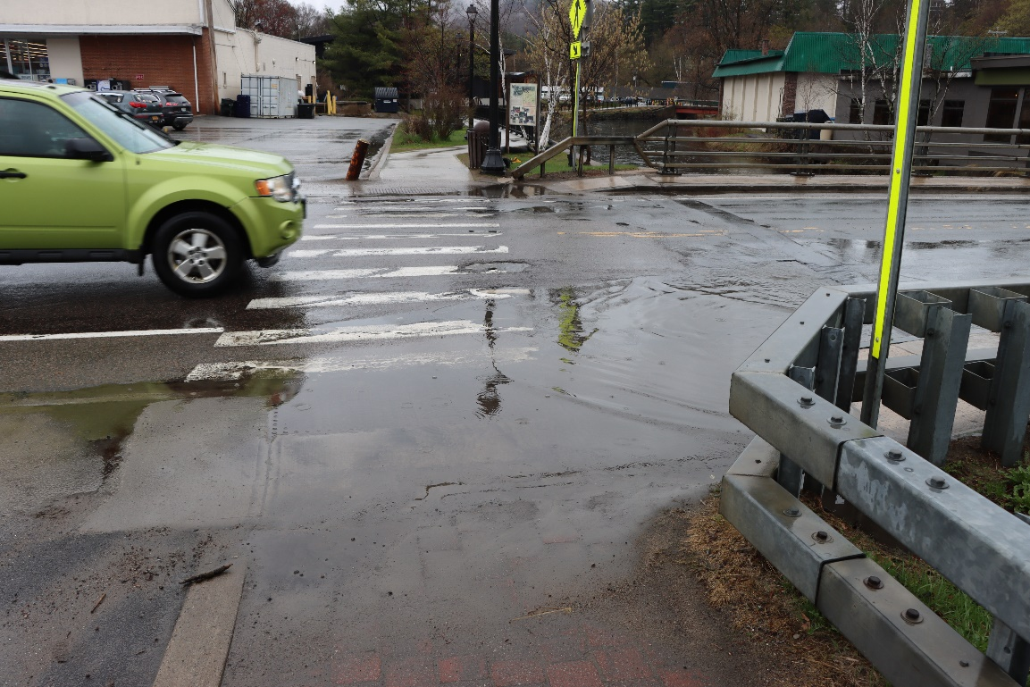
Saranac Lake Riverwalk (5)
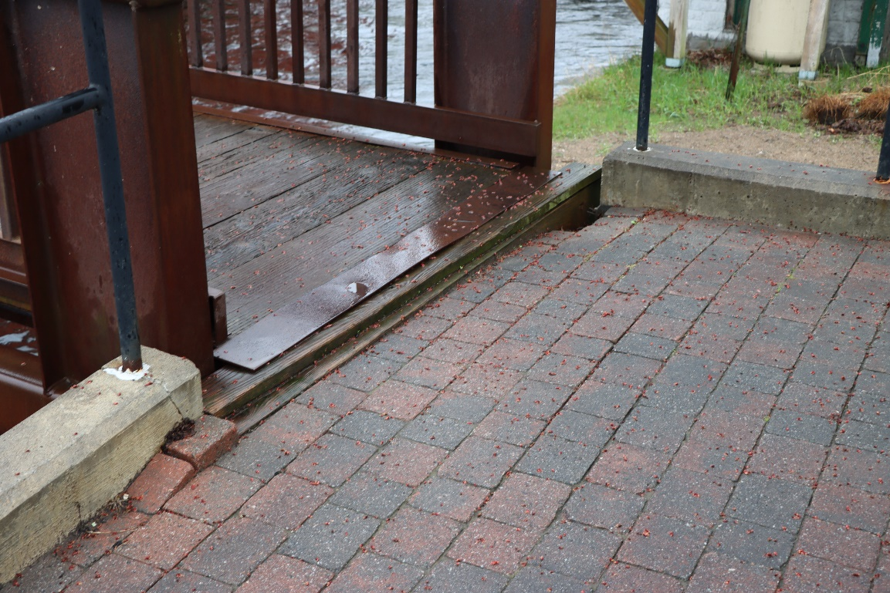
Saranac Lake Riverwalk (12)
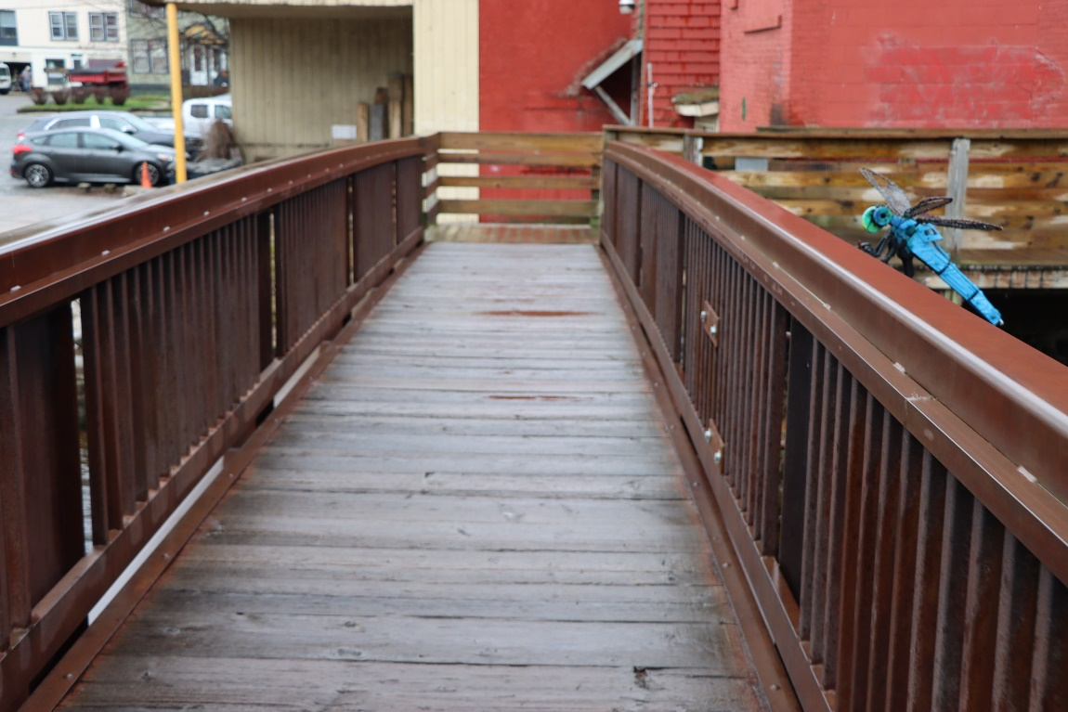
Saranac Lake Riverwalk (13)
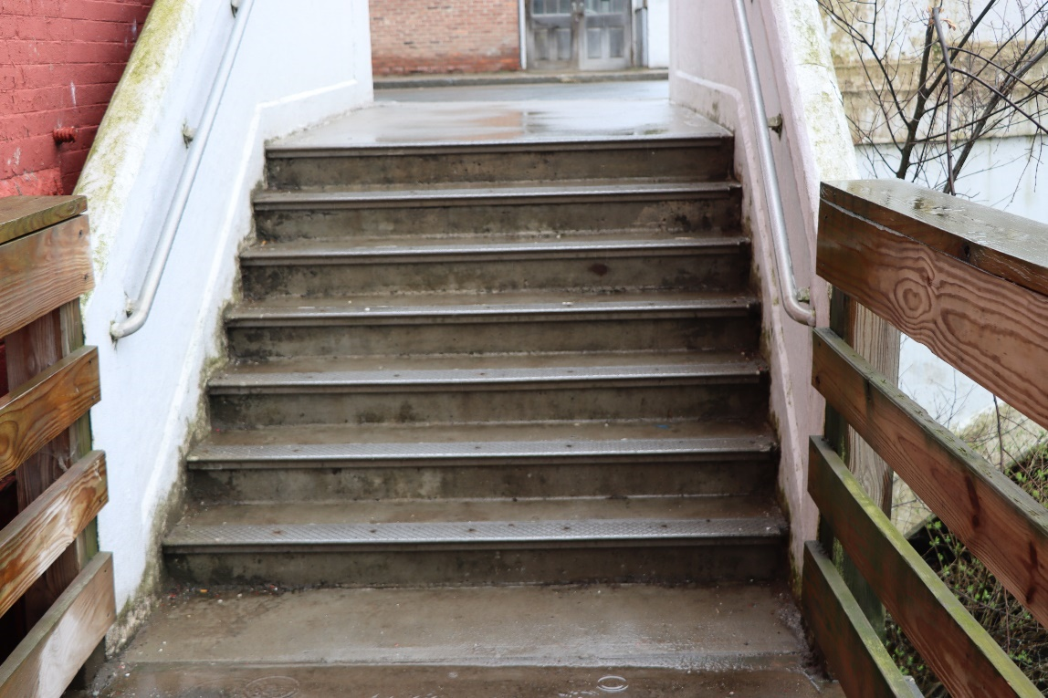
Saranac Lake Riverwalk (15)
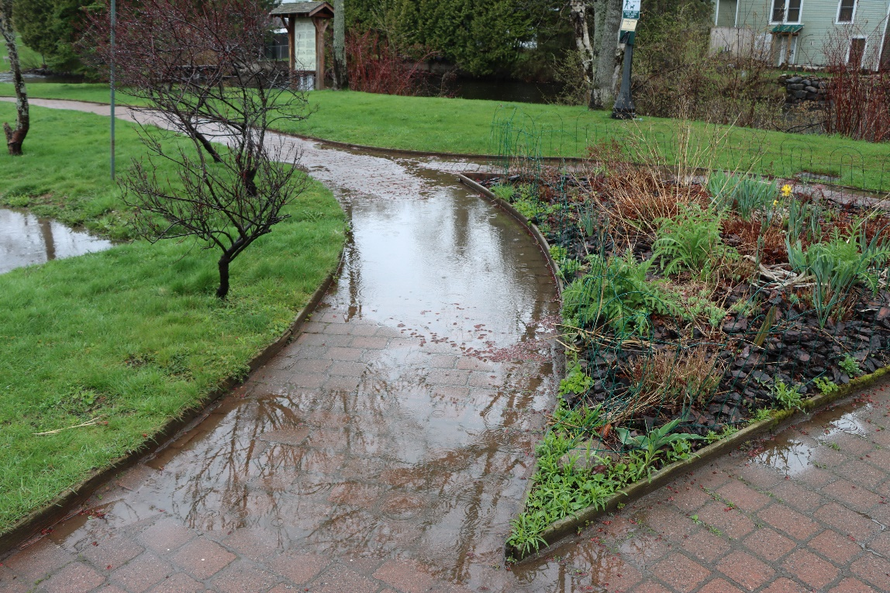
Saranac Lake Riverwalk (33)

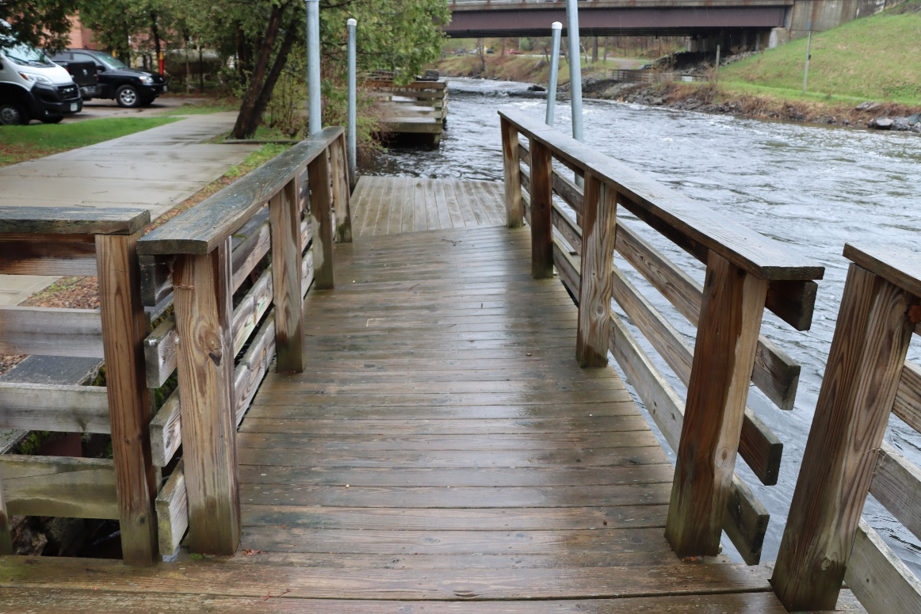
Saranac Lake Riverwalk (41)
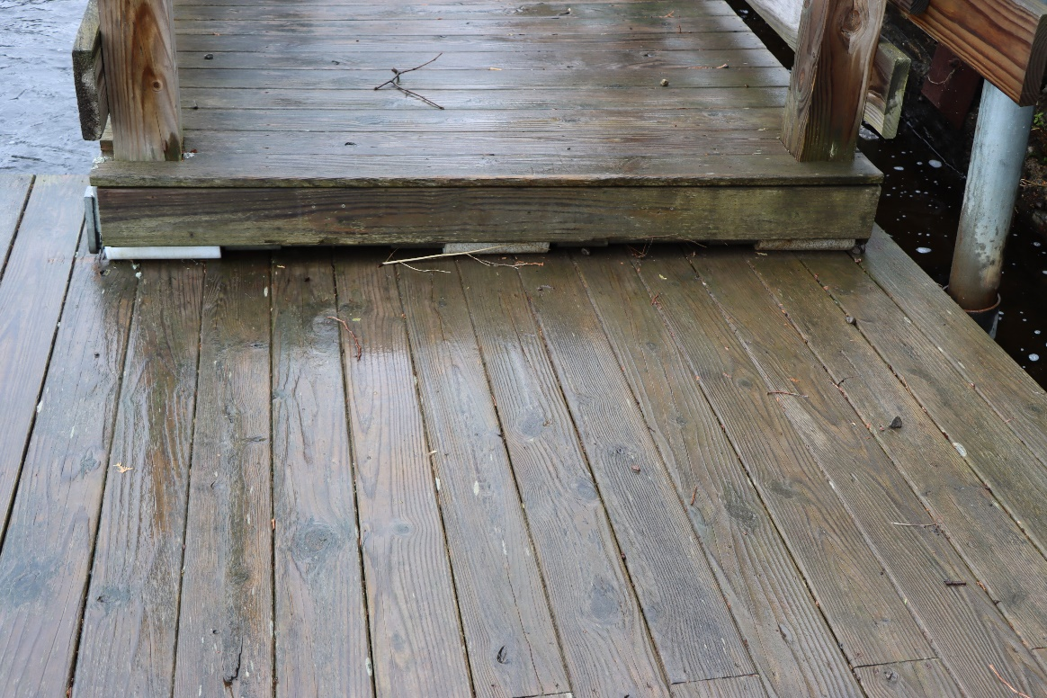
Saranac Lake Riverwalk (42)
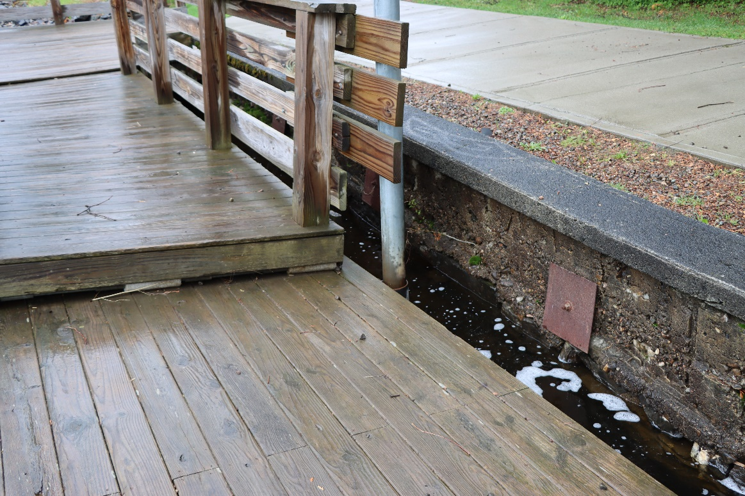
Saranac Lake Riverwalk (43)
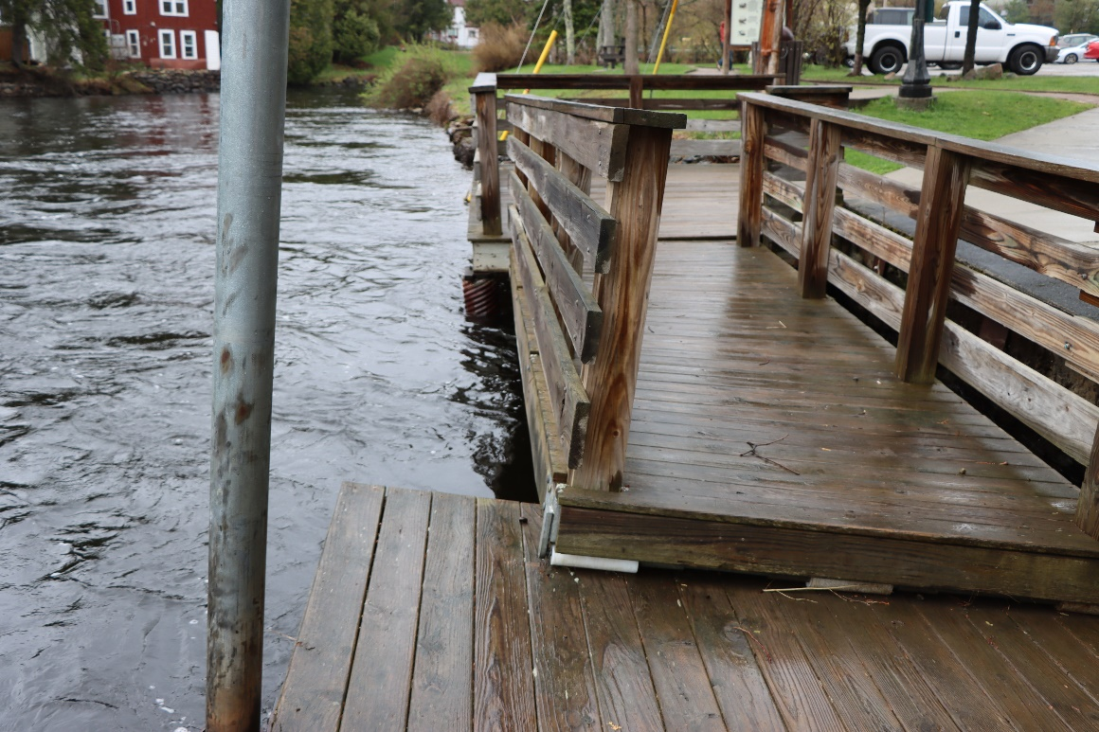
Saranac Lake Riverwalk (43)
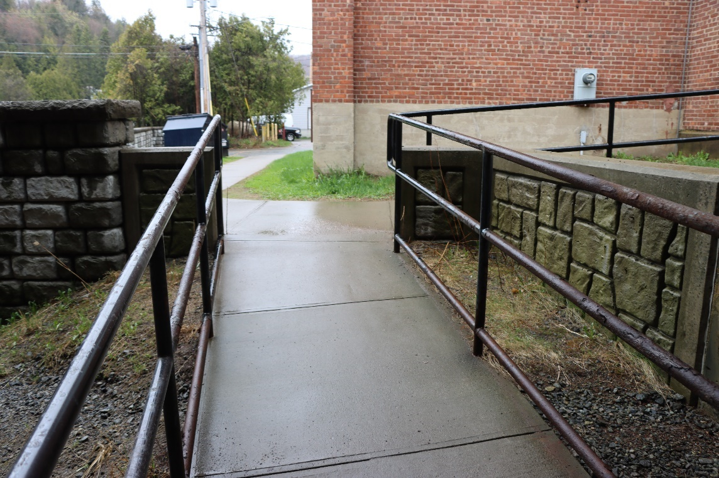
Saranac Lake Riverwalk (51)
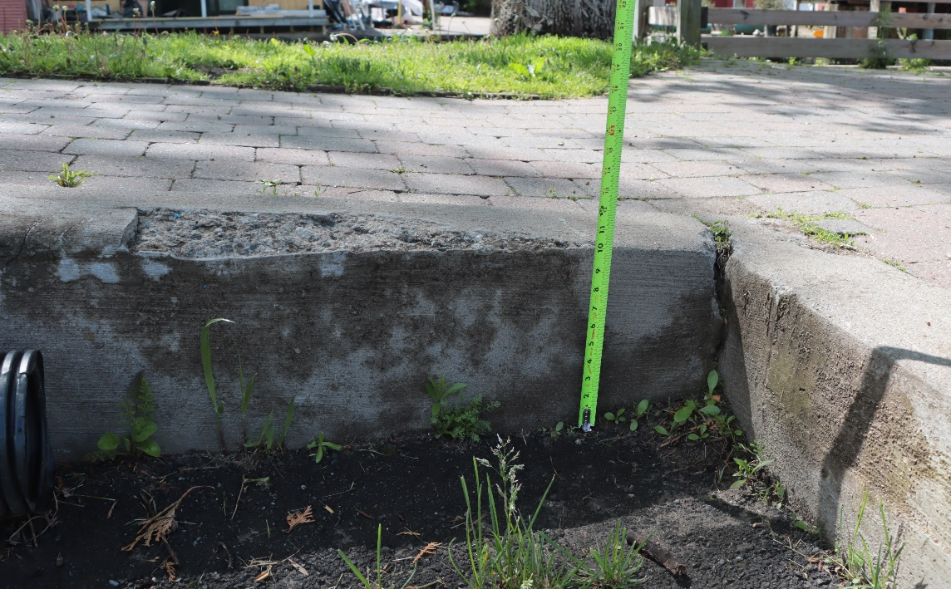
Saranac Lake Riverwalk (90)
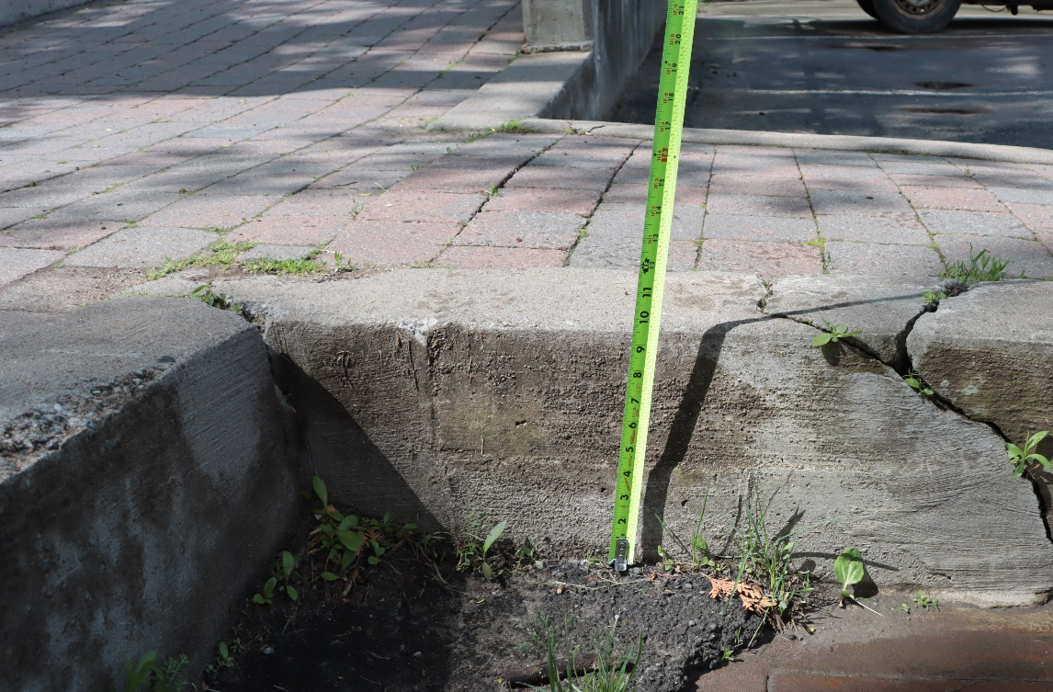
Saranac Lake Riverwalk (91)
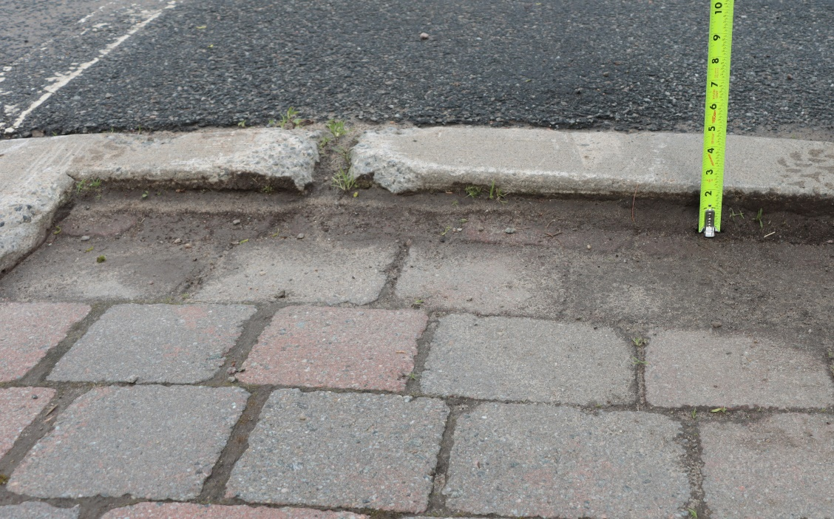
Saranac Lake Riverwalk (99)
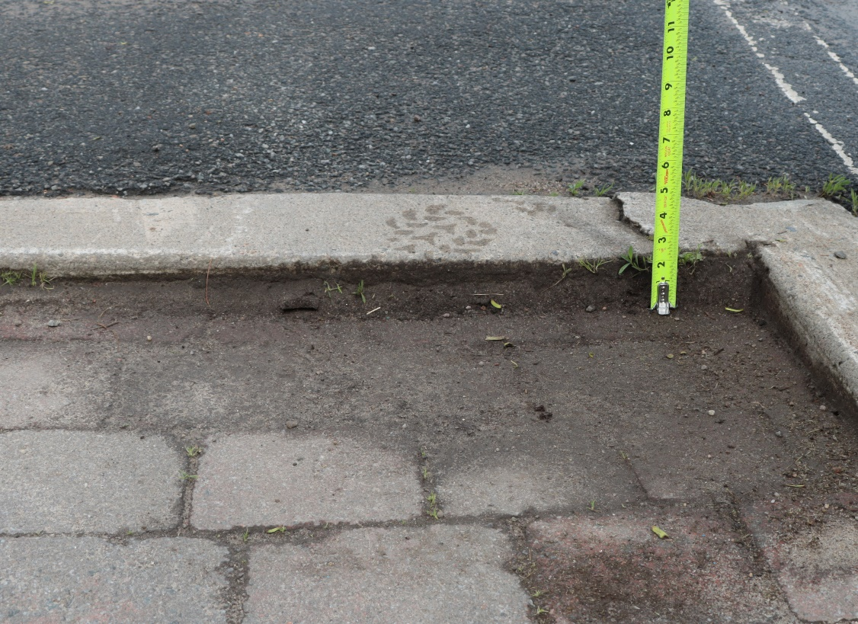
Saranac Lake Riverwalk (100)
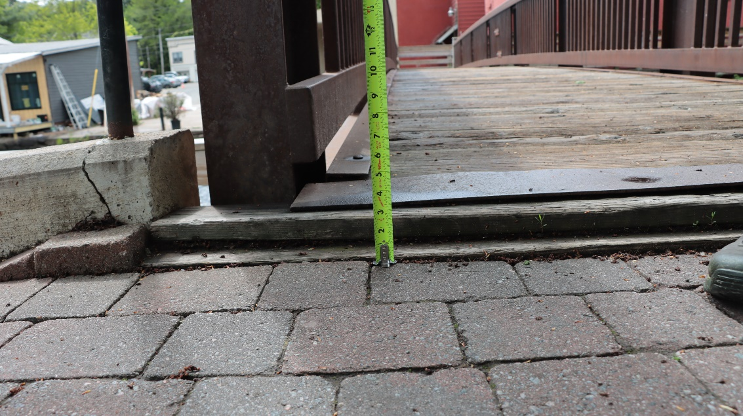
Saranac Lake Riverwalk (102)
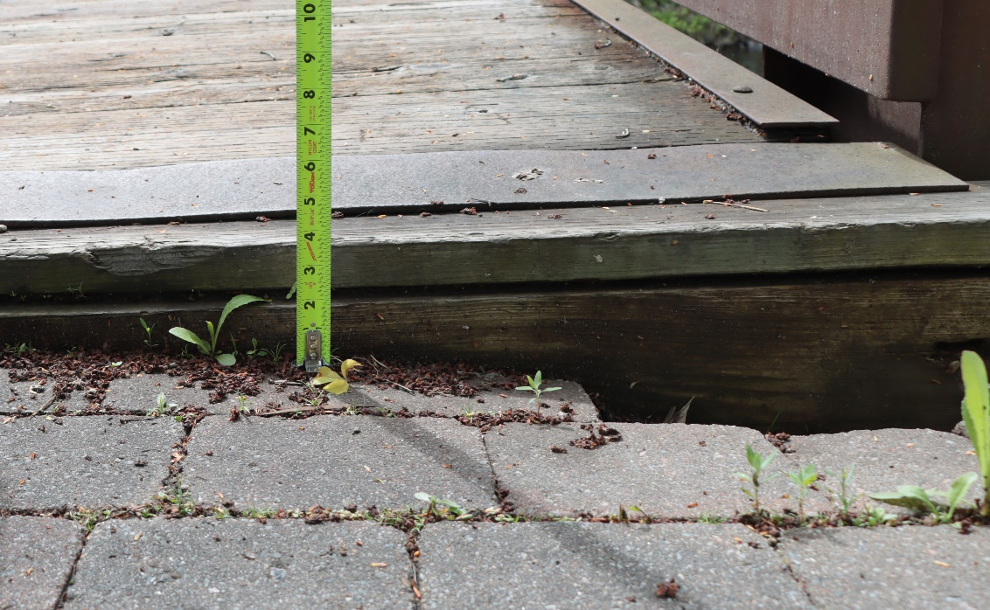
Saranac Lake Riverwalk (103)
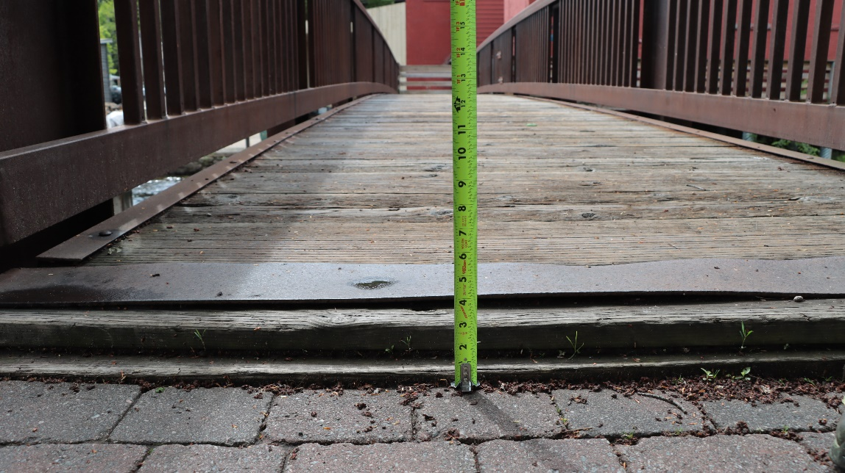
Saranac Lake Riverwalk (104)
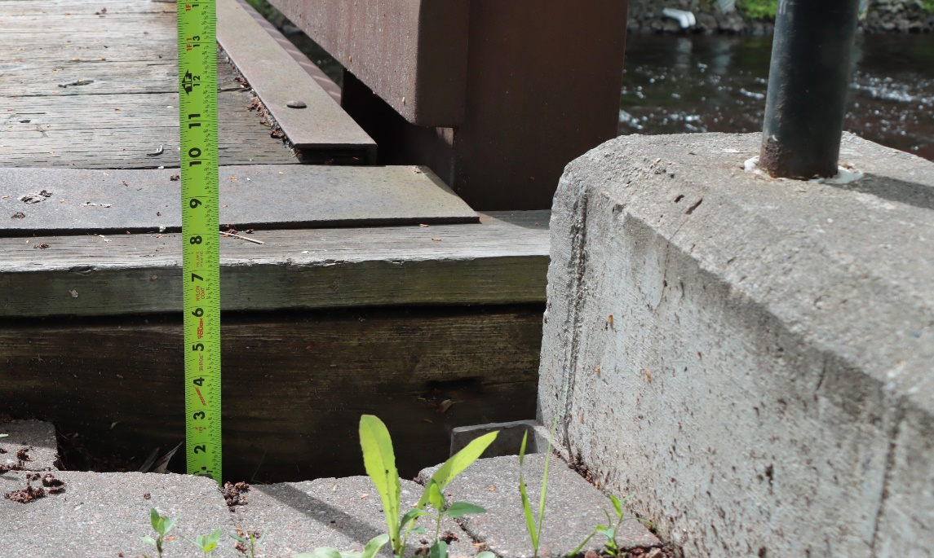
Saranac Lake Riverwalk (105)
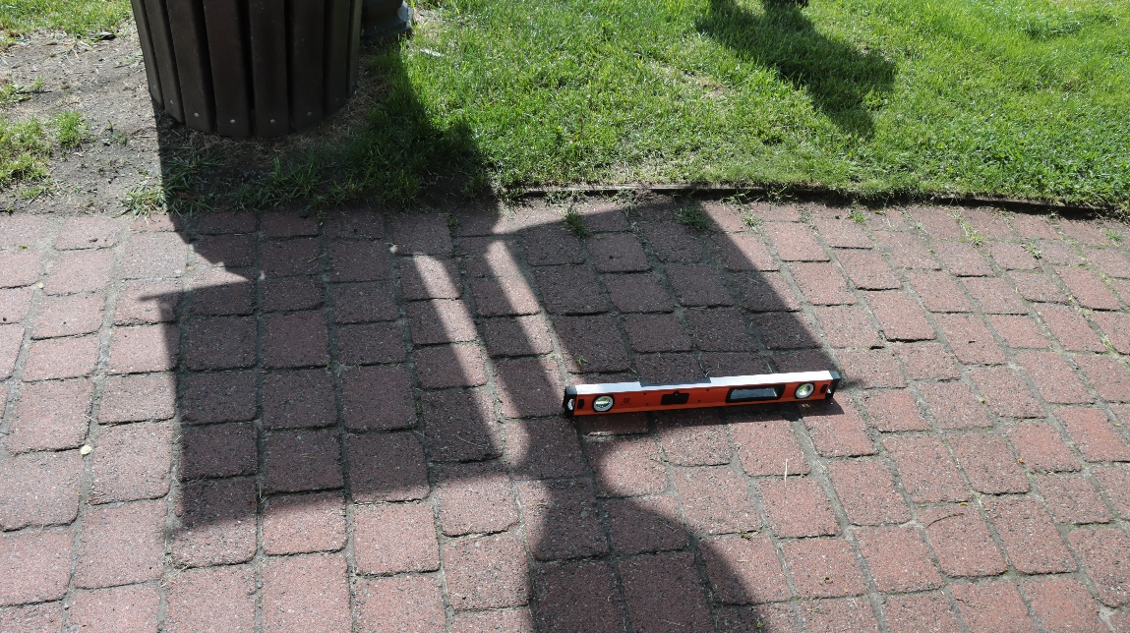
Saranac Lake Riverwalk (126)
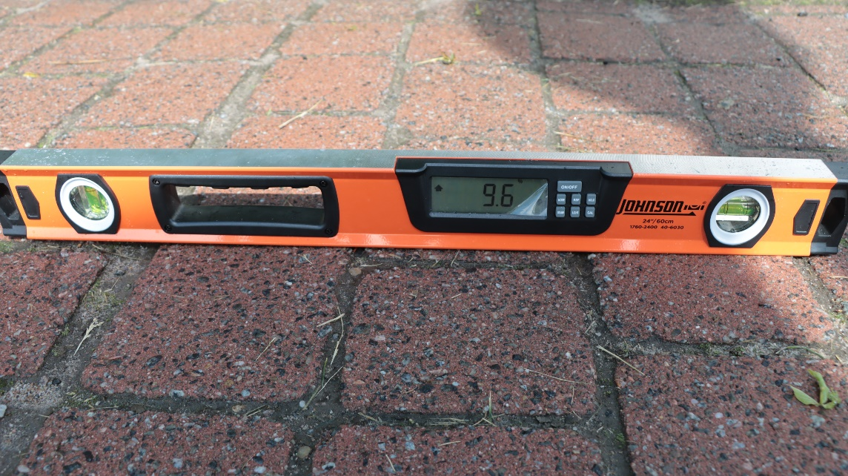
Saranac Lake Riverwalk (127)
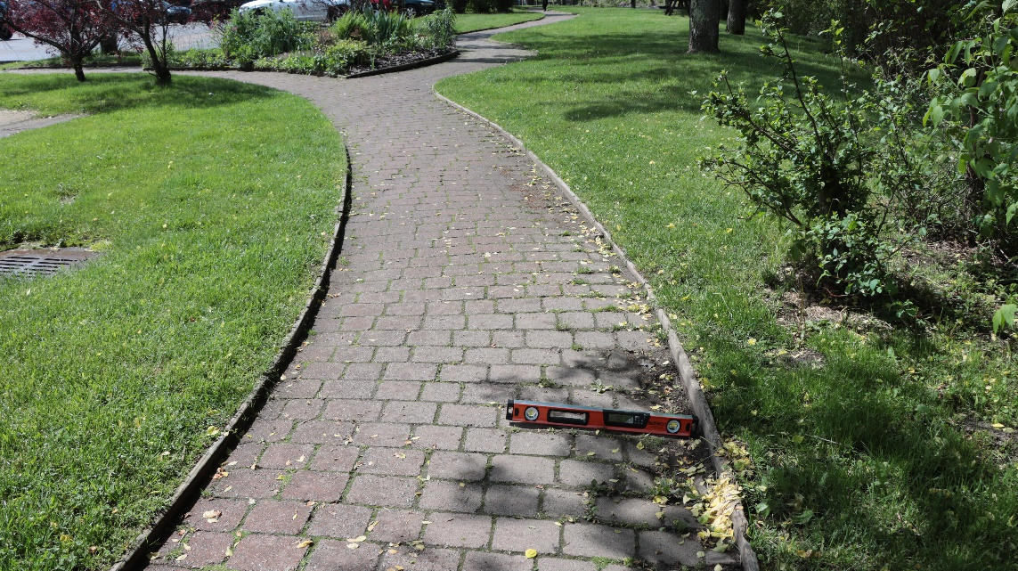
Saranac Lake Riverwalk (130)
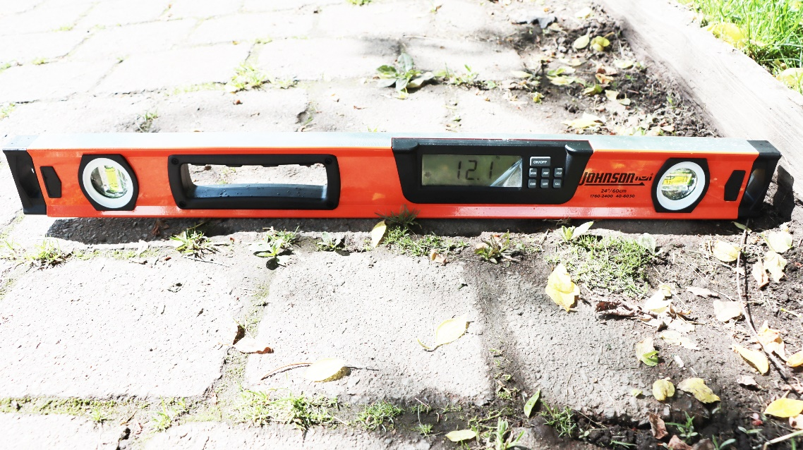
Saranac Lake Riverwalk (131)
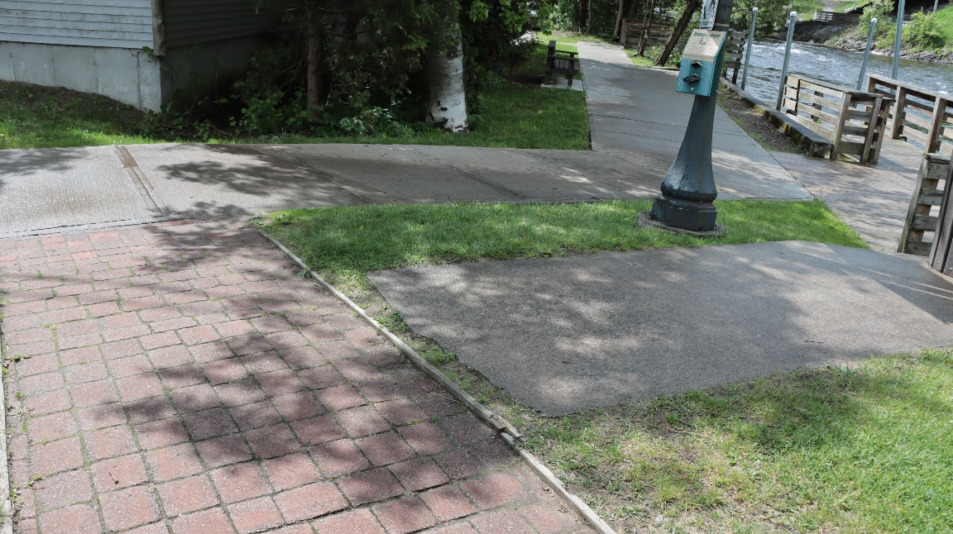
Saranac Lake Riverwalk (151)
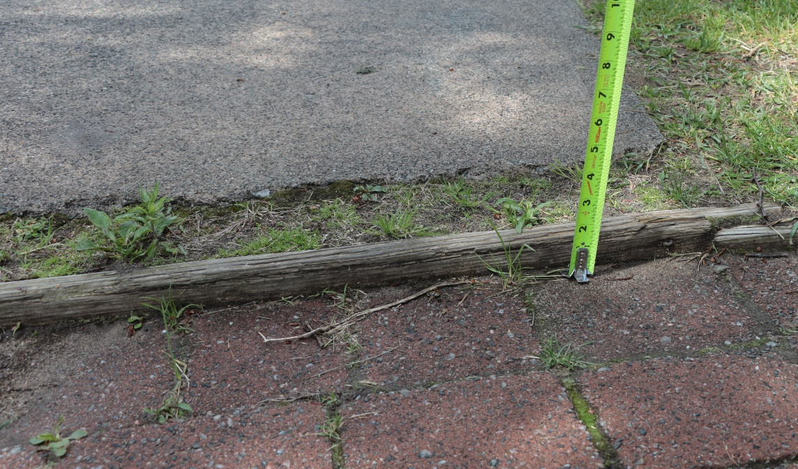
Saranac Lake Riverwalk (153)
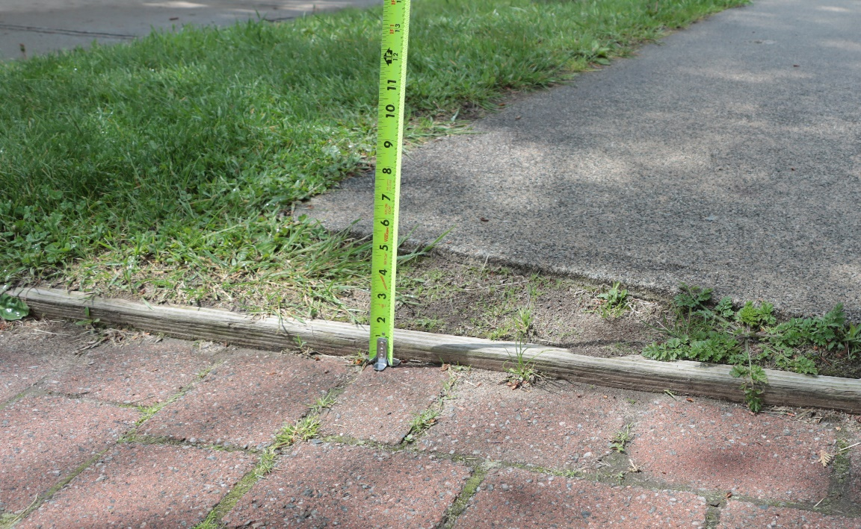
Saranac Lake Riverwalk (154)
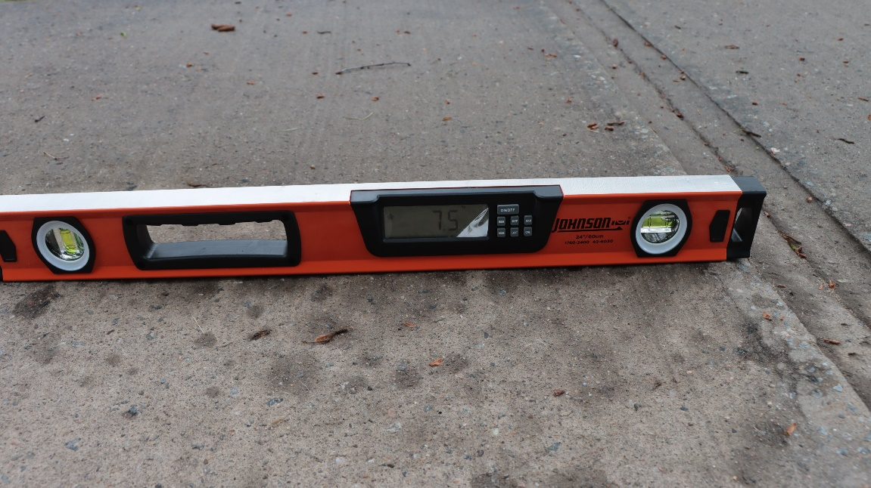
Saranac Lake Riverwalk (162)
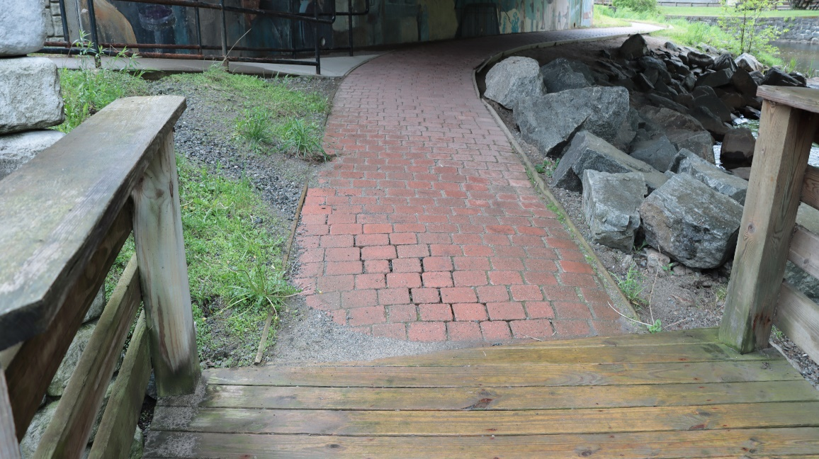
Saranac Lake Riverwalk (176)
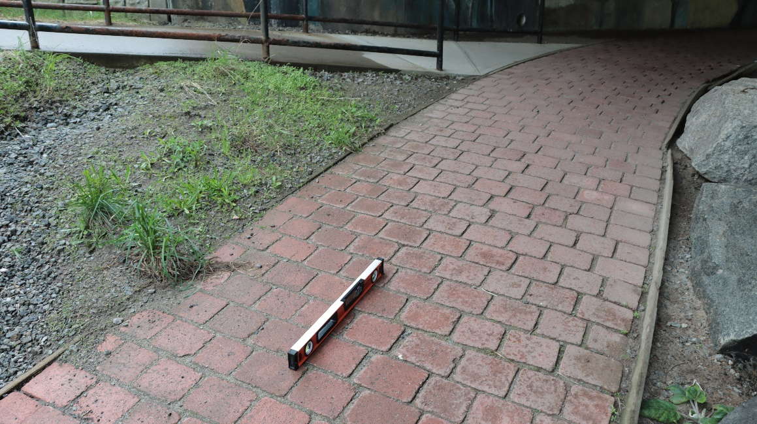
Saranac Lake Riverwalk (177)
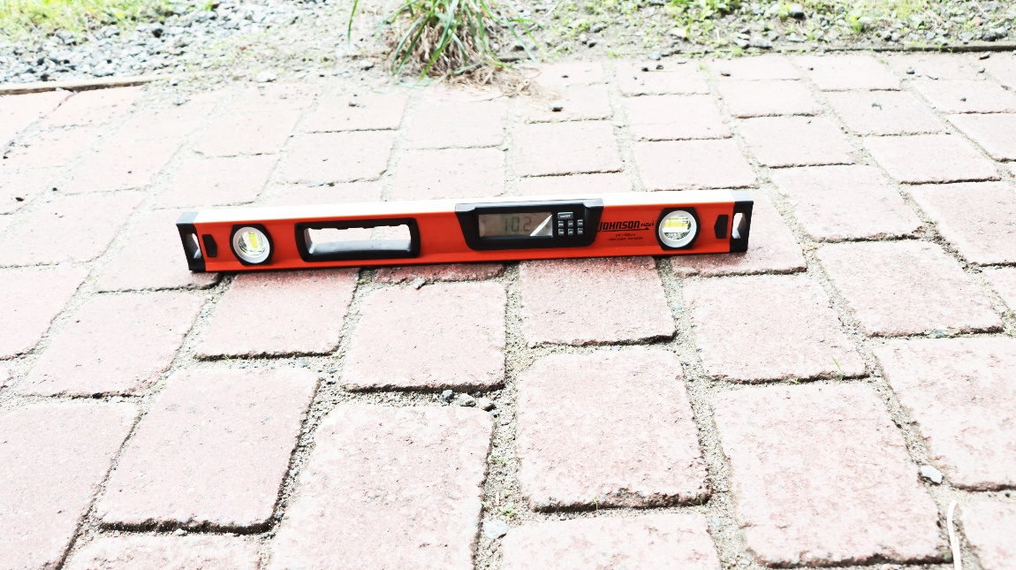
Saranac Lake Riverwalk (178)
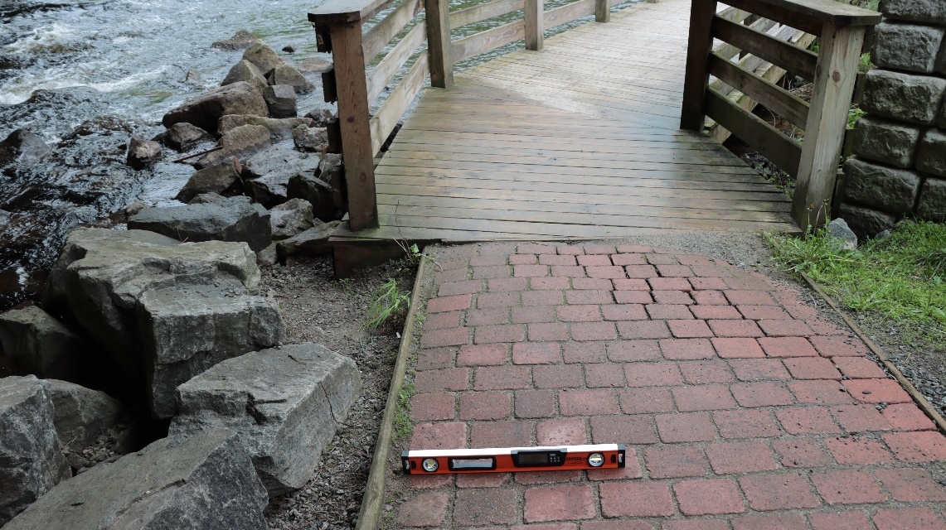
Saranac Lake Riverwalk (179)
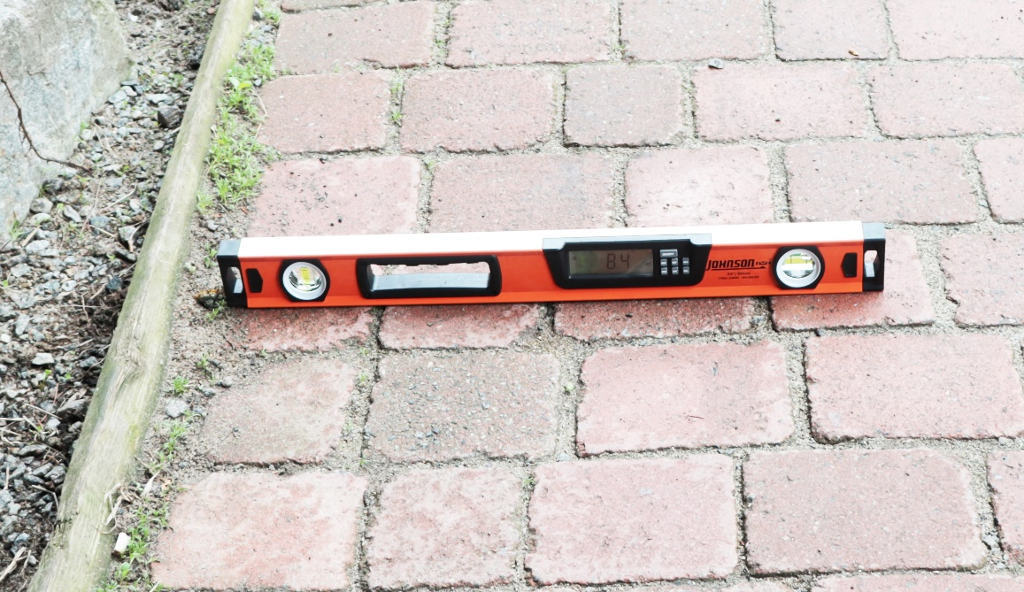
Saranac Lake Riverwalk (180)
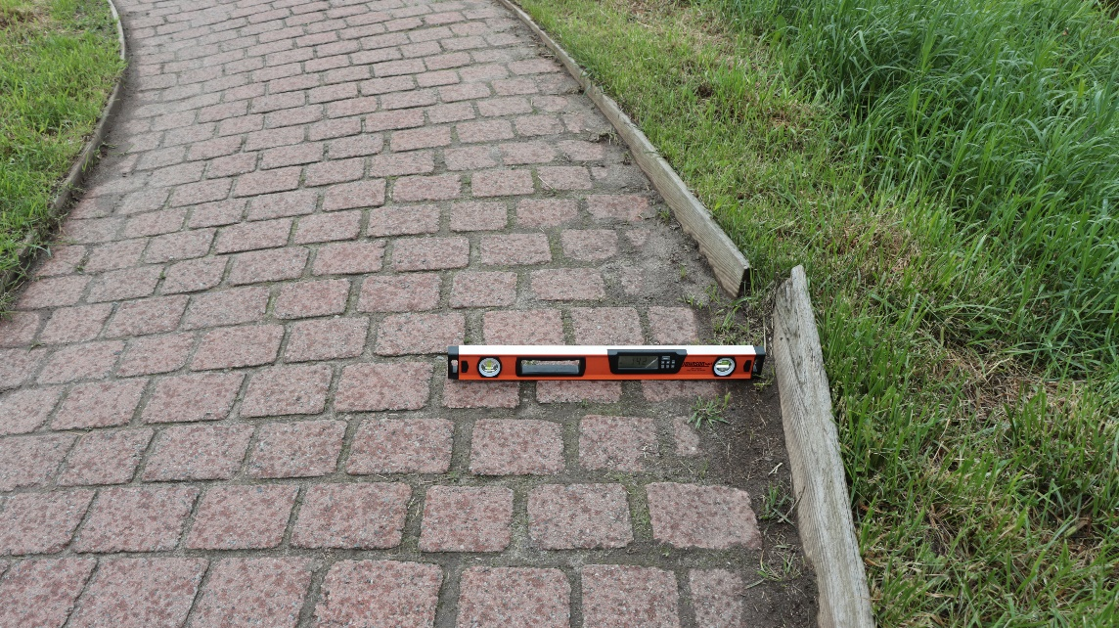
Saranac Lake Riverwalk (182)
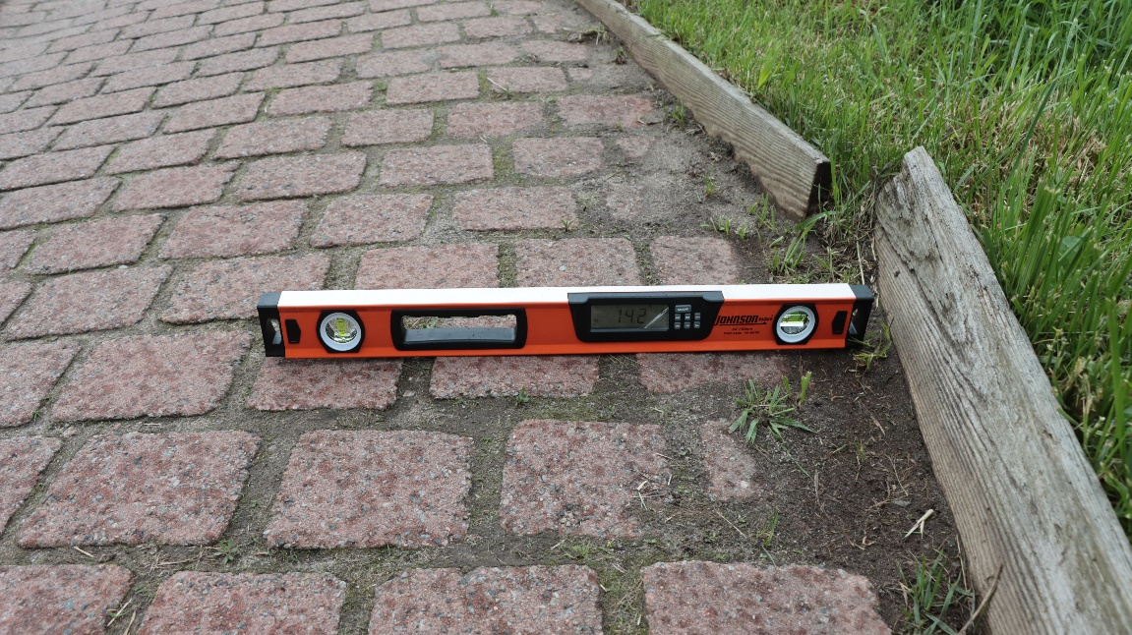
Saranac Lake Riverwalk (183)
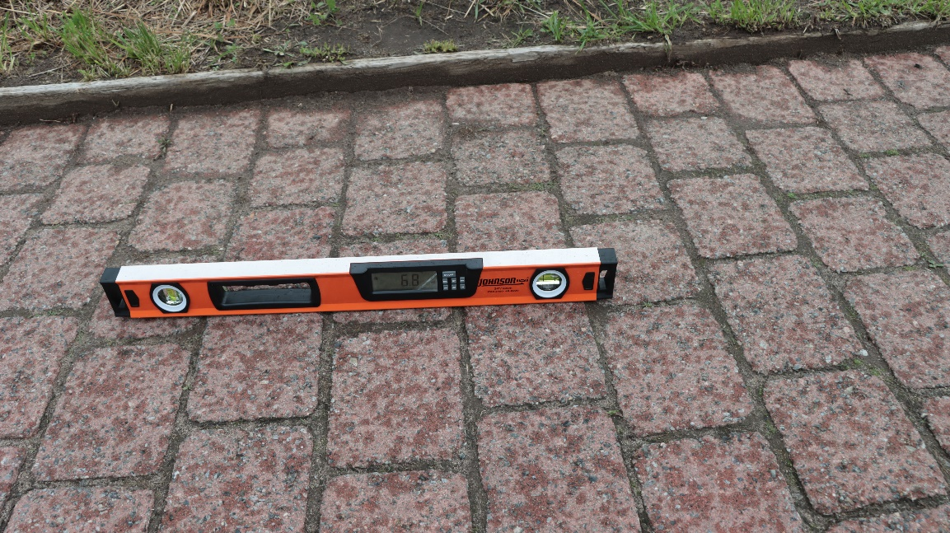
Saranac Lake Riverwalk (184)
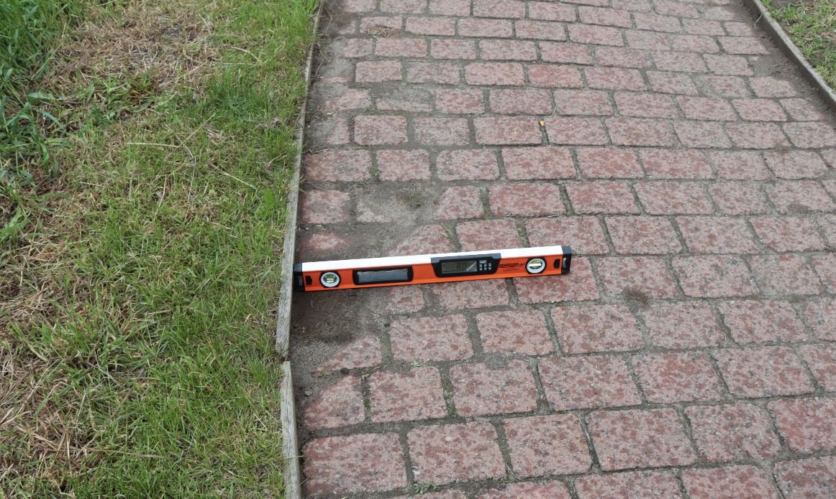
Saranac Lake Riverwalk (185)
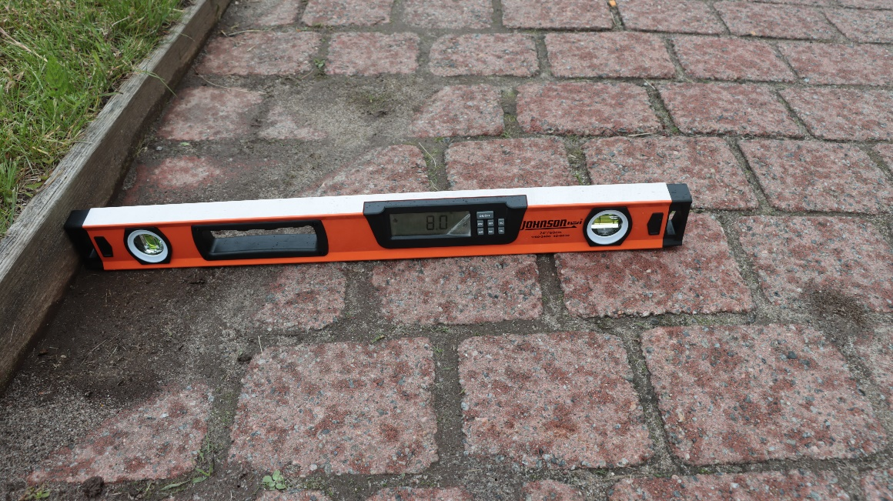
Saranac Lake Riverwalk (186)
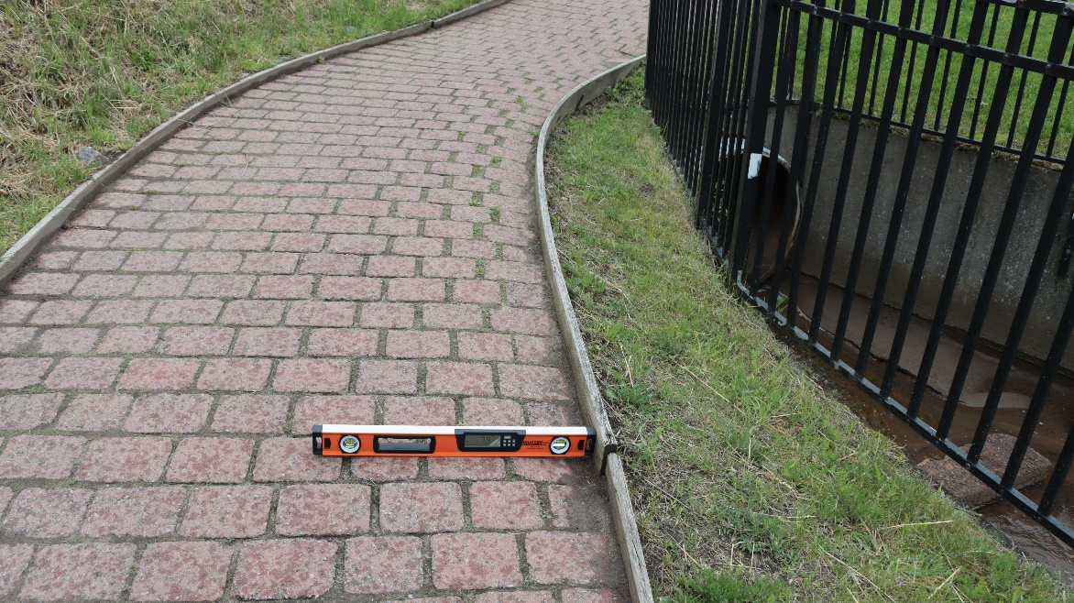
Saranac Lake Riverwalk (187)
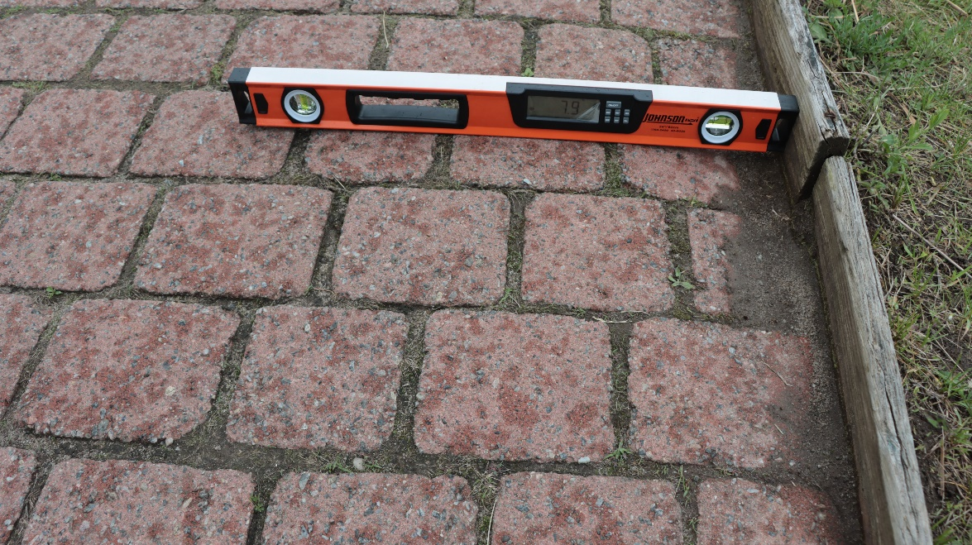
Saranac Lake Riverwalk (188)
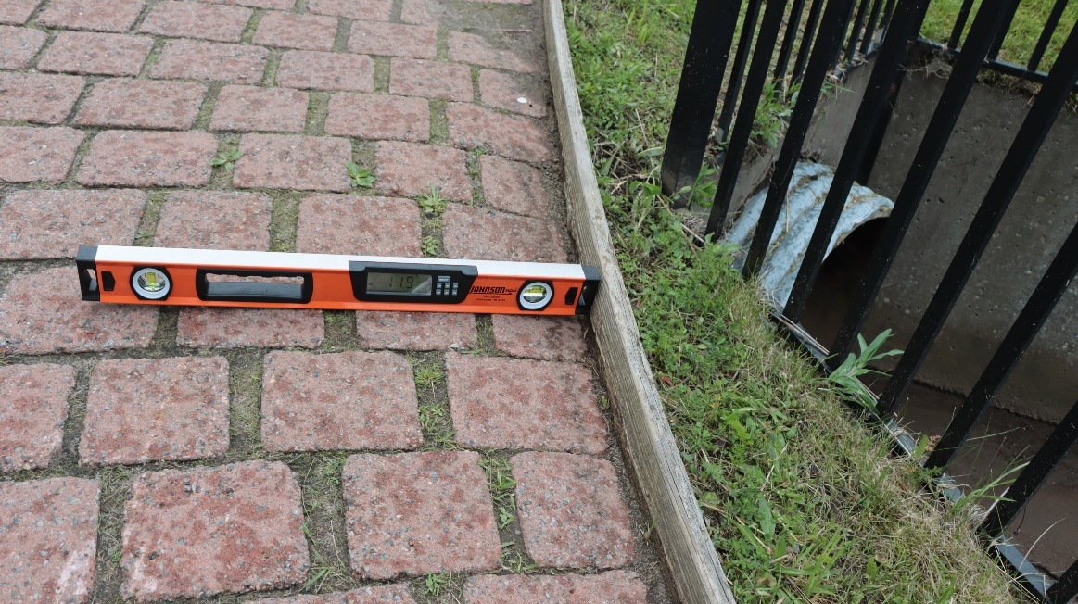
Saranac Lake Riverwalk (190)
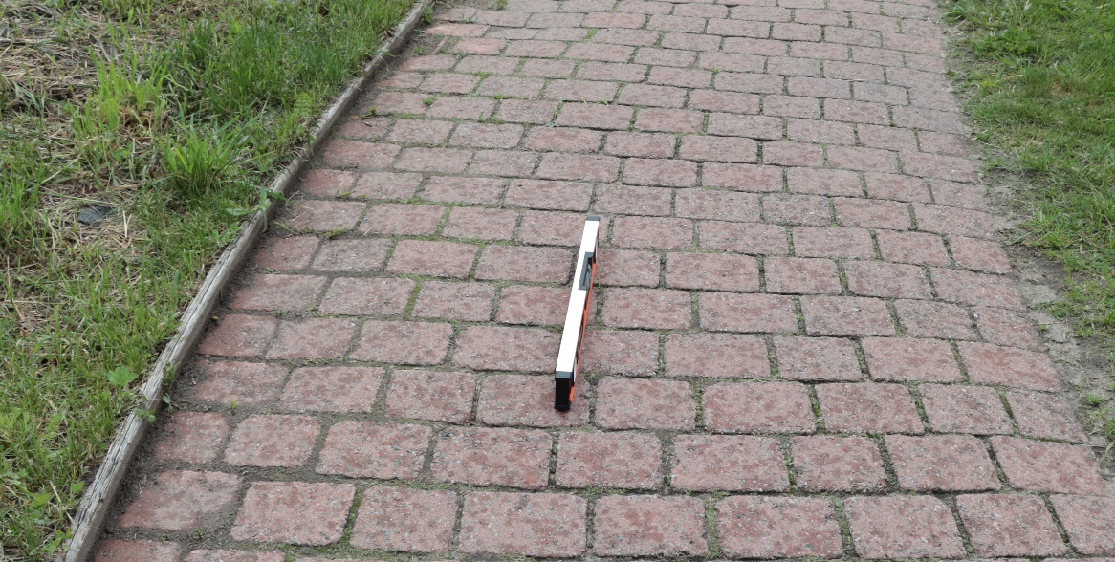
Saranac Lake Riverwalk (191)
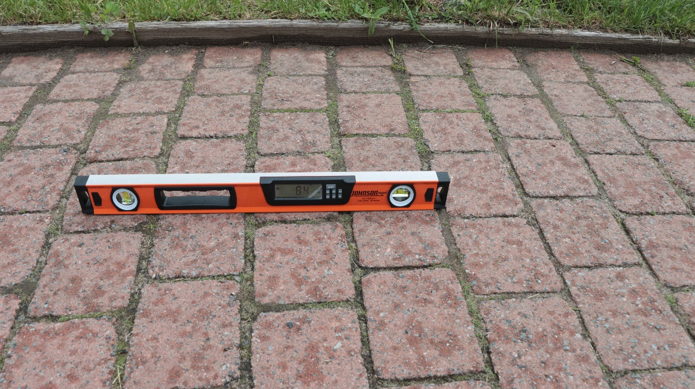
Saranac Lake Riverwalk (192)
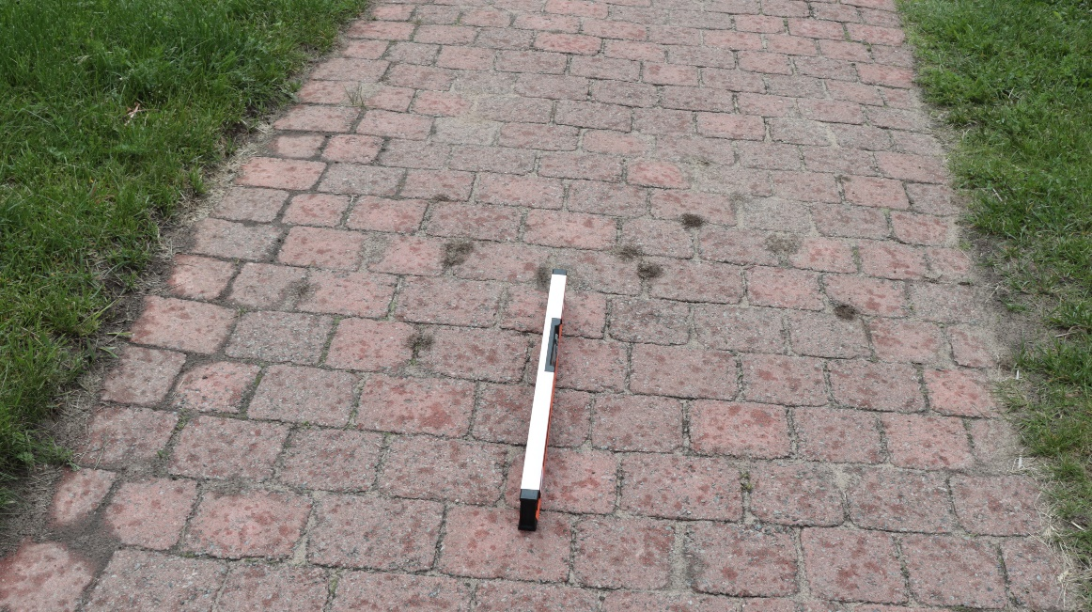
Saranac Lake Riverwalk (193)
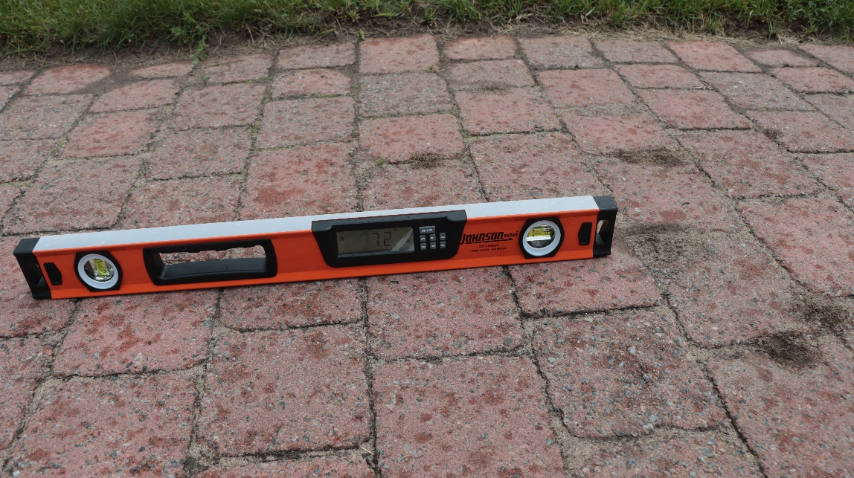
Saranac Lake Riverwalk (195)
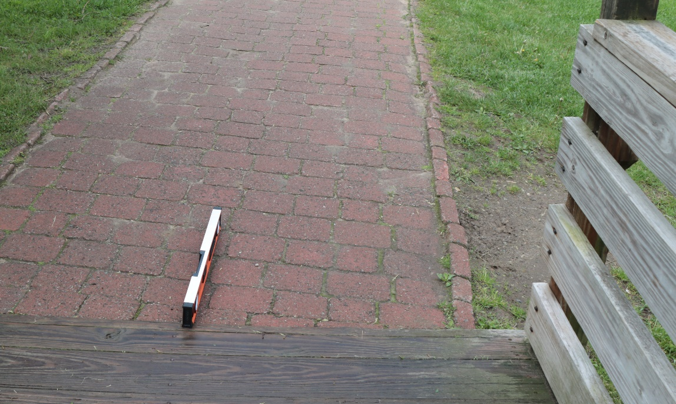
Saranac Lake Riverwalk (202)
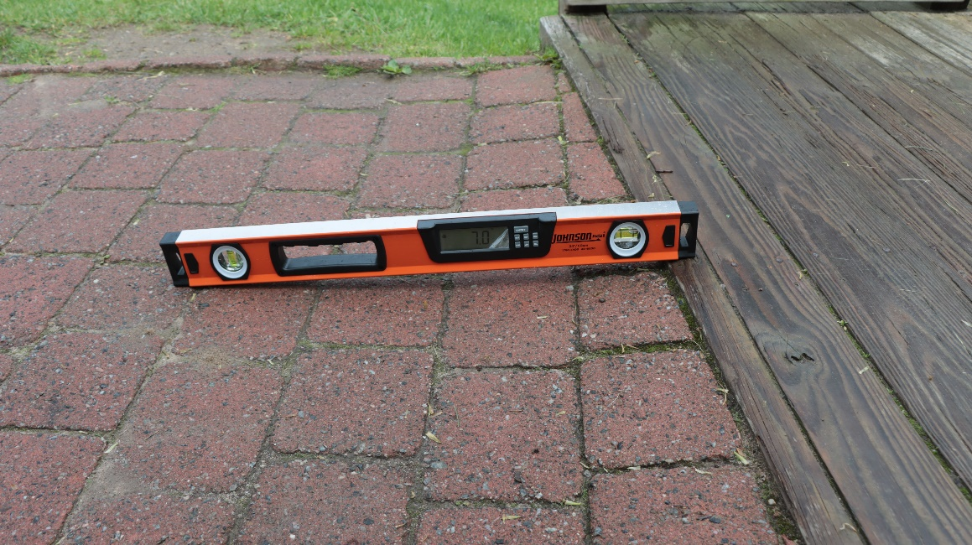
Saranac Lake Riverwalk (203)
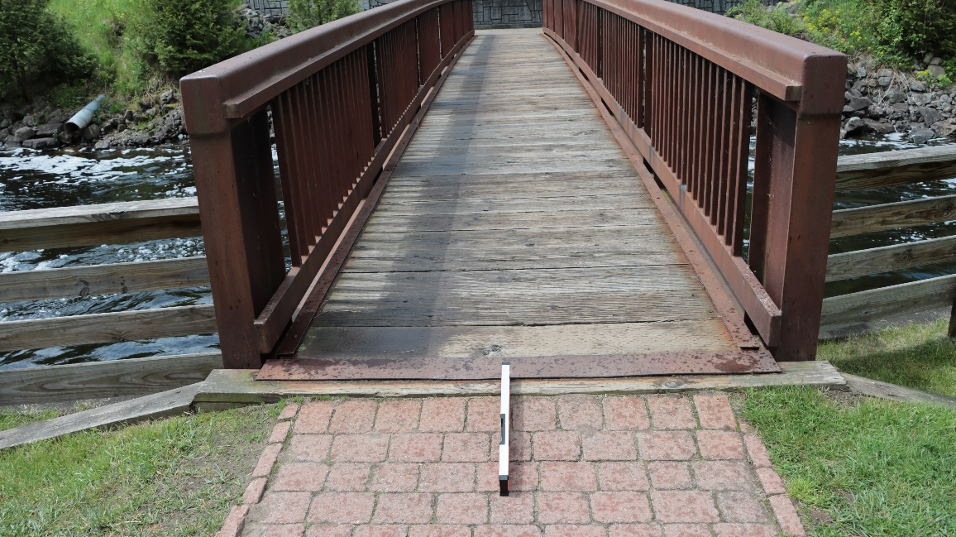
Saranac Lake Riverwalk (211)
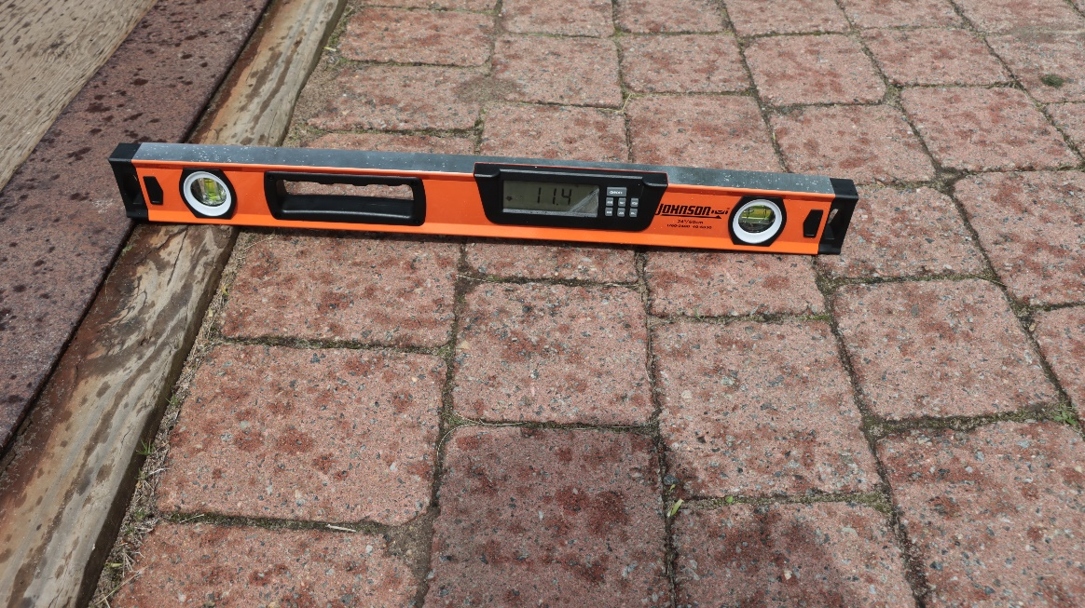
Saranac Lake Riverwalk (212)

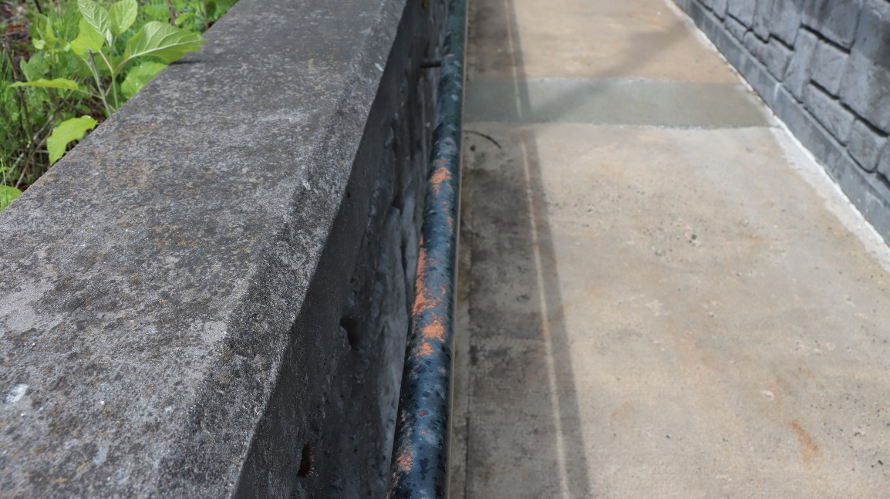
Saranac Lake Riverwalk (256)
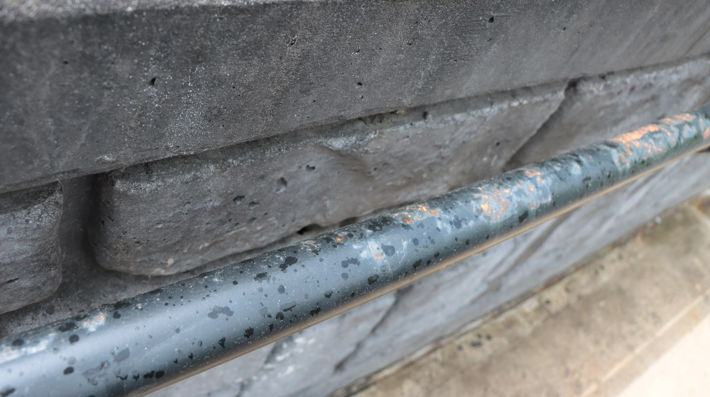
Saranac Lake Riverwalk (257)
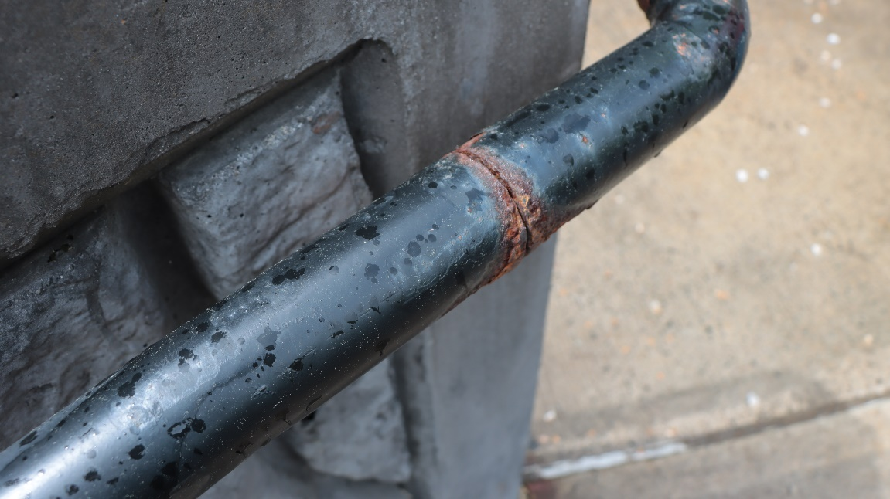
Saranac Lake Riverwalk (258)
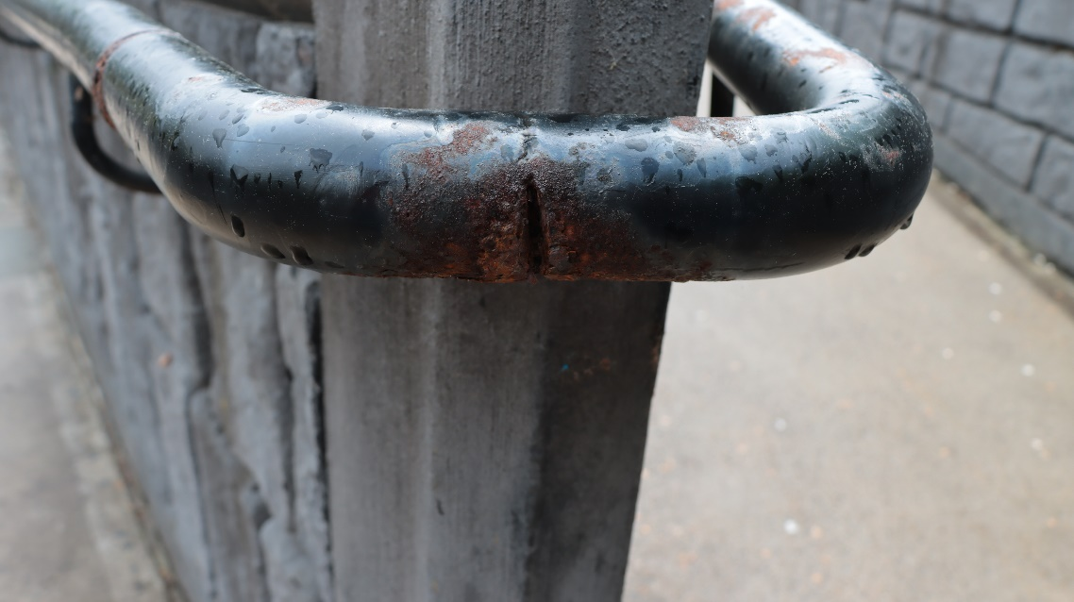
Saranac Lake Riverwalk (259)
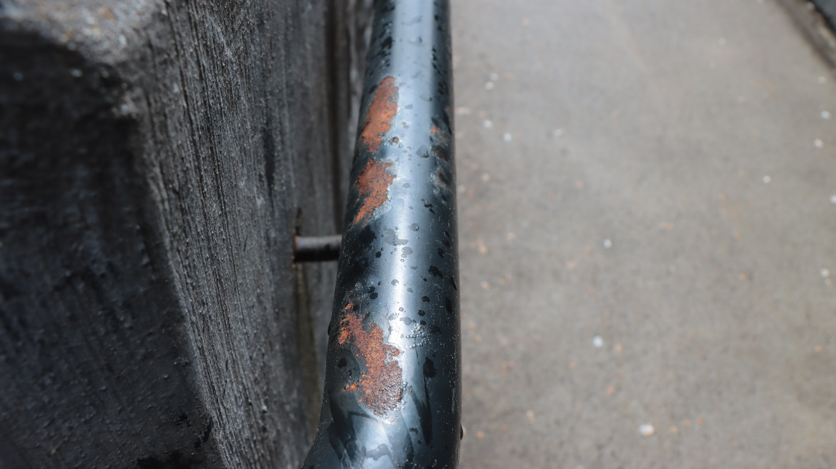
Saranac Lake Riverwalk (260)
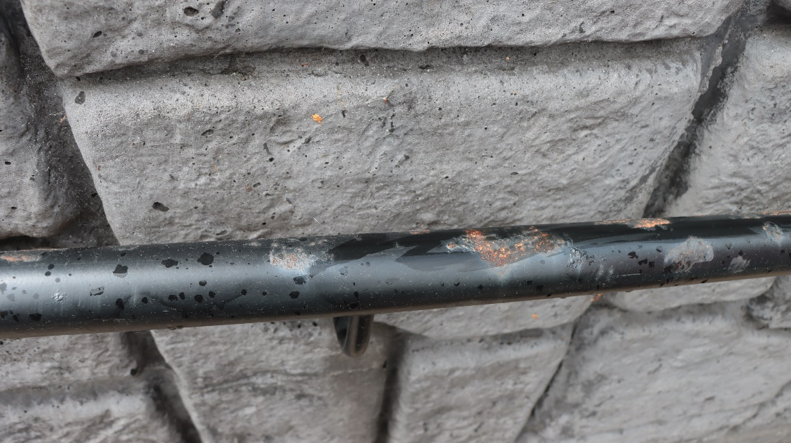
Saranac Lake Riverwalk (261)
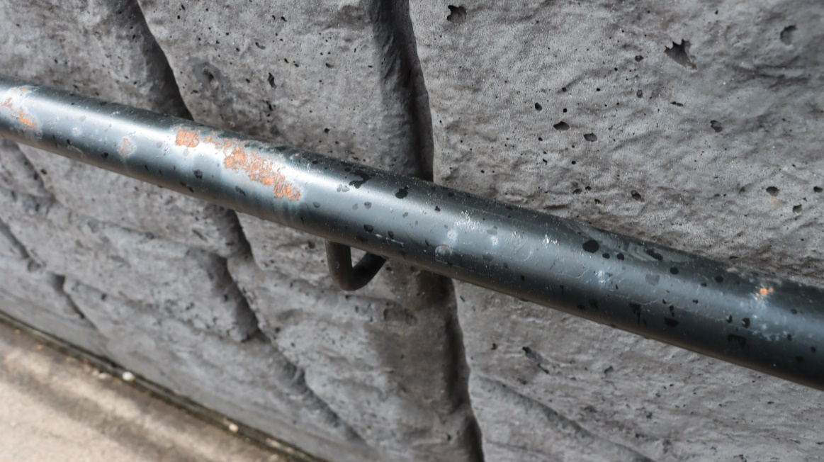
Saranac Lake Riverwalk (262)
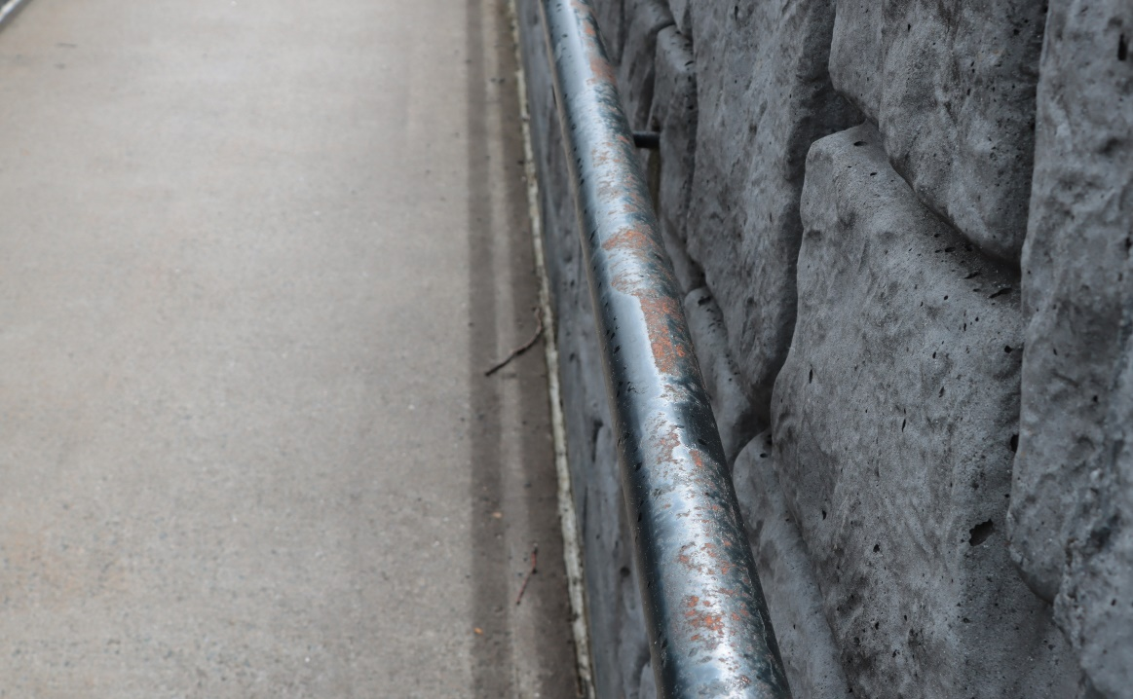
Saranac Lake Riverwalk (263)
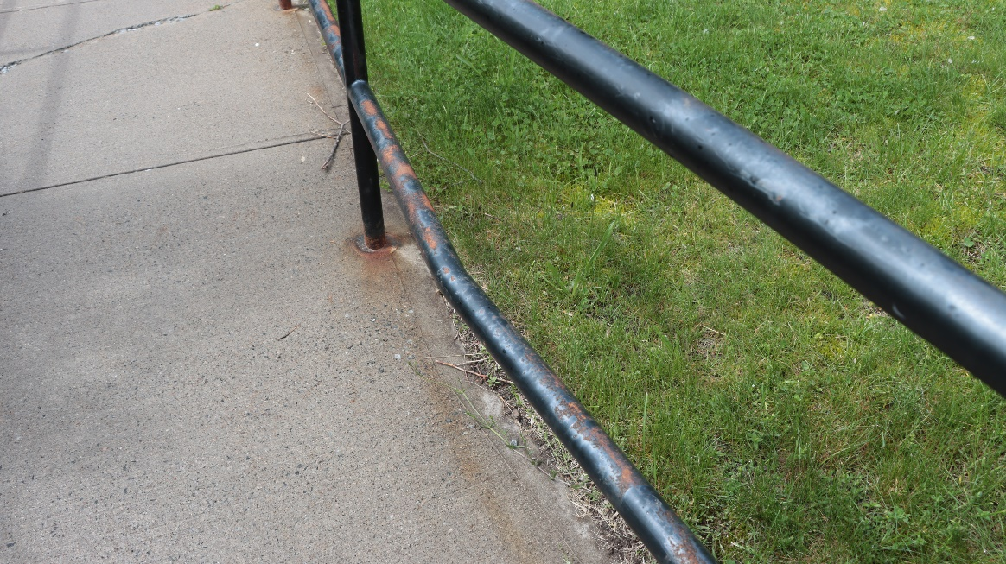
Saranac Lake Riverwalk (264)

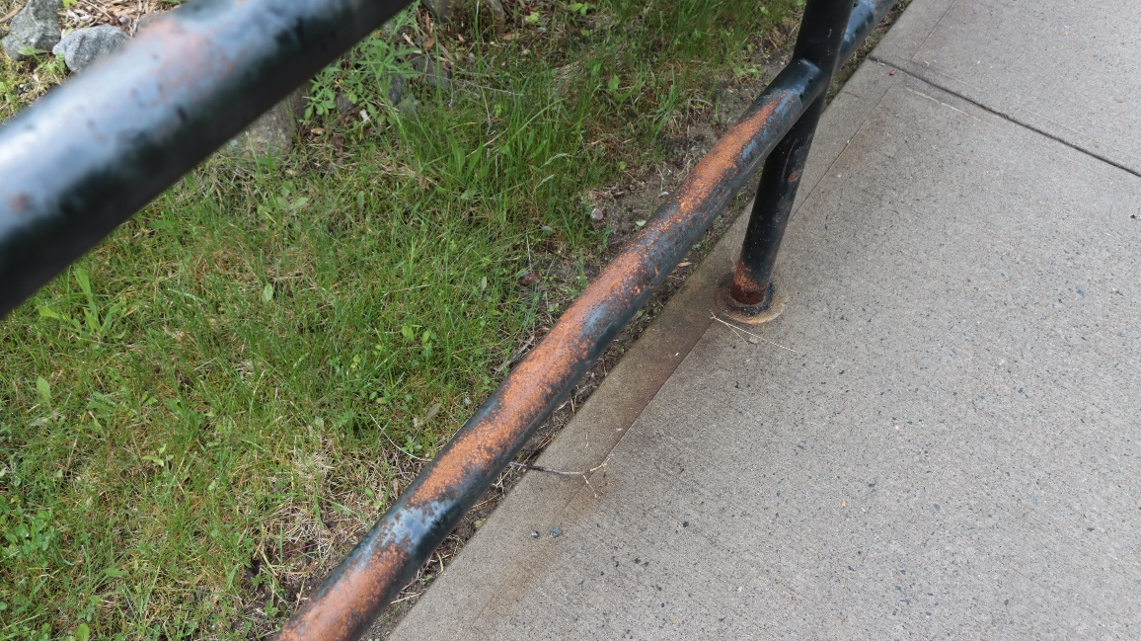
Saranac Lake Riverwalk (265)
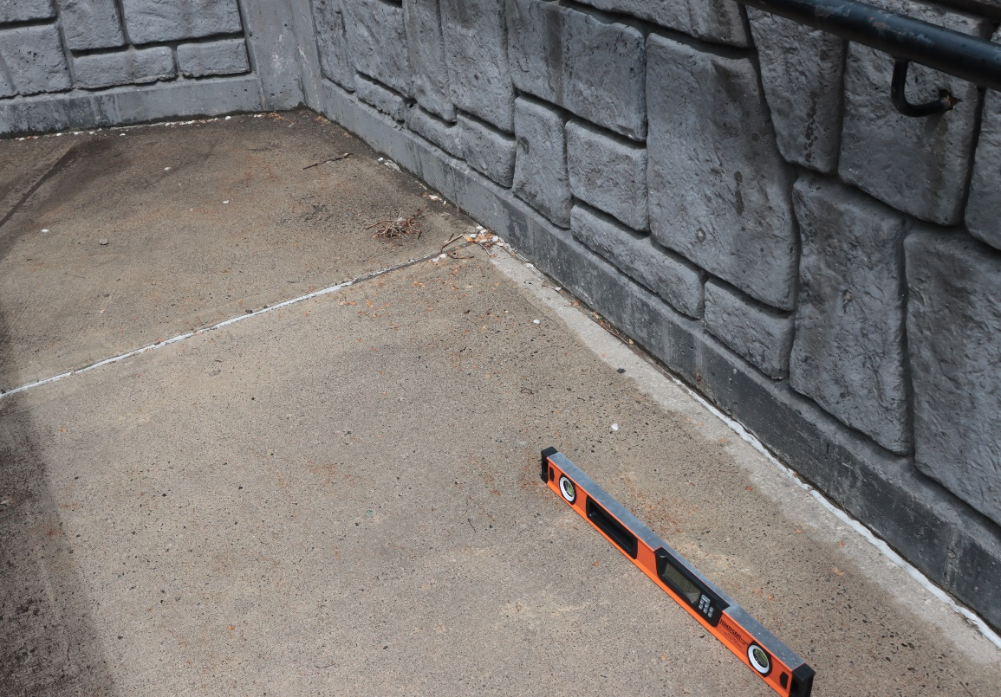
Saranac Lake Riverwalk (267)
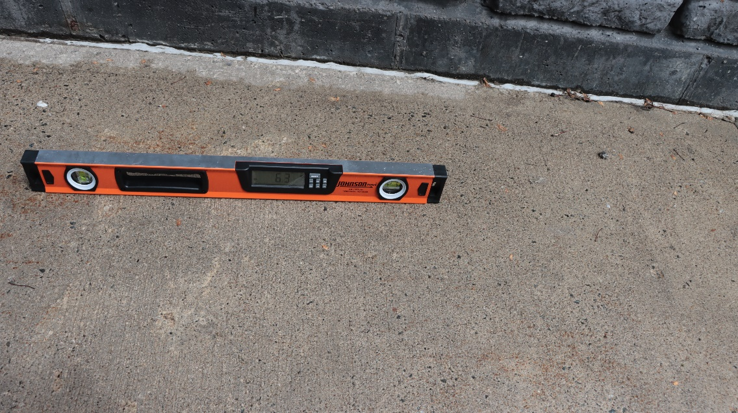
Saranac Lake Riverwalk (268)
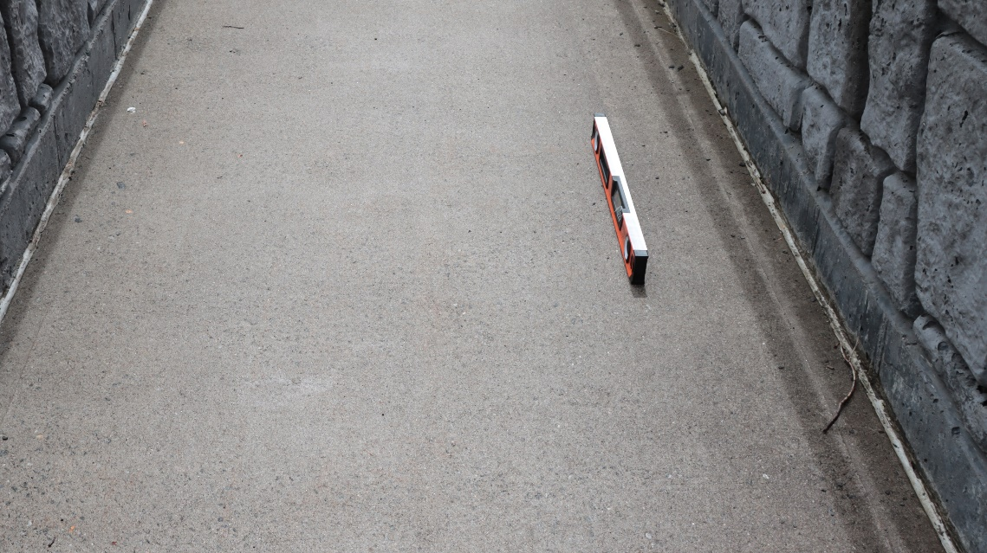
Saranac Lake Riverwalk (271)
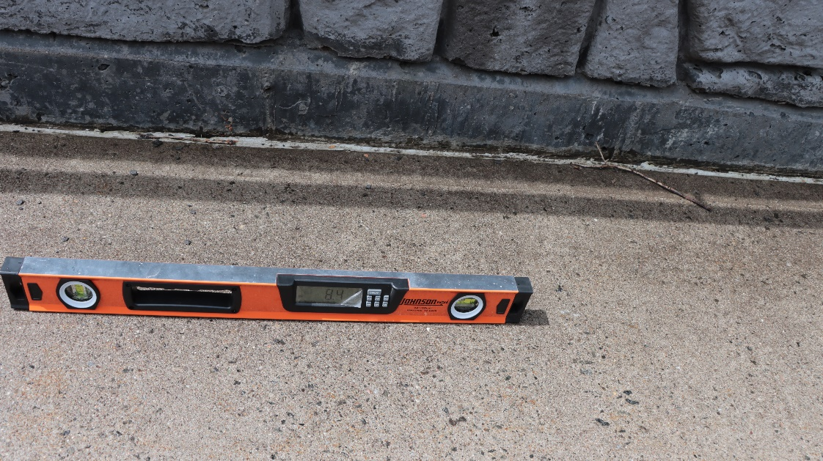
Saranac Lake Riverwalk (272)
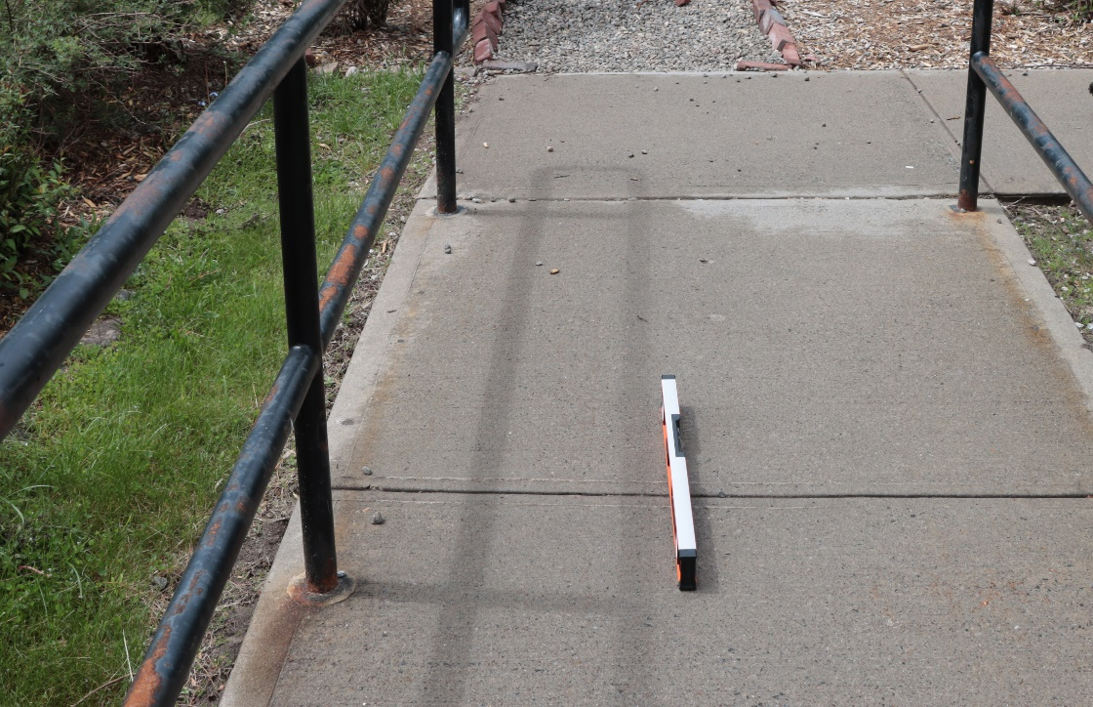
Saranac Lake Riverwalk (274)
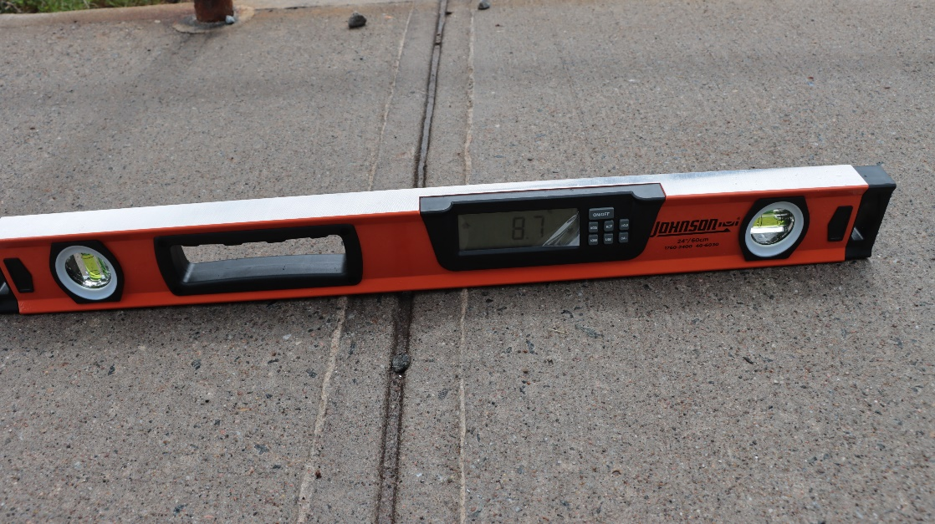
Saranac Lake Riverwalk (275)
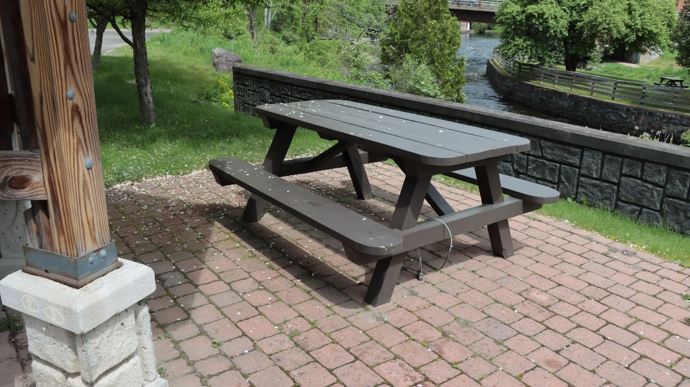
Saranac Lake Riverwalk (278)

New Route Images
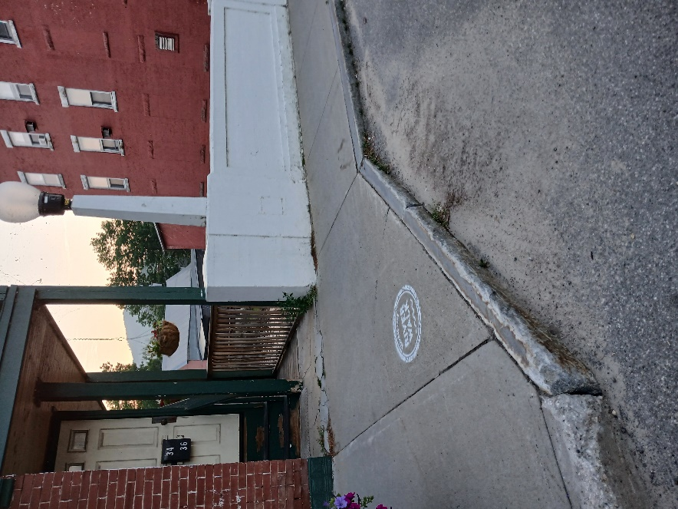
Saranac Lake Riverwalk - New Route (1)
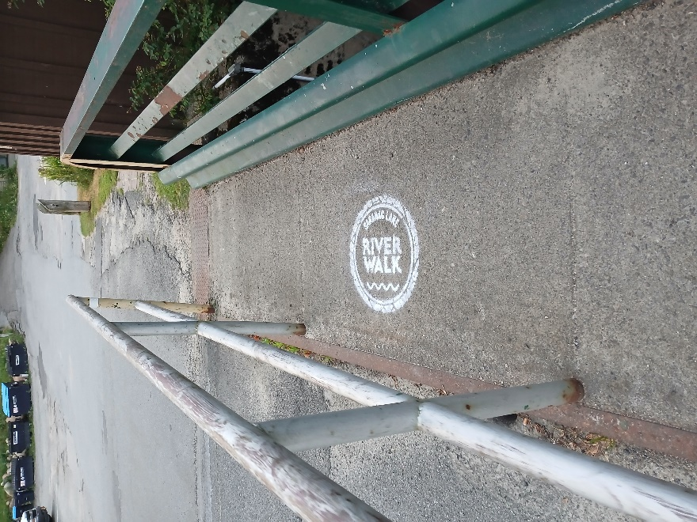
Saranac Lake Riverwalk - New Route (7)
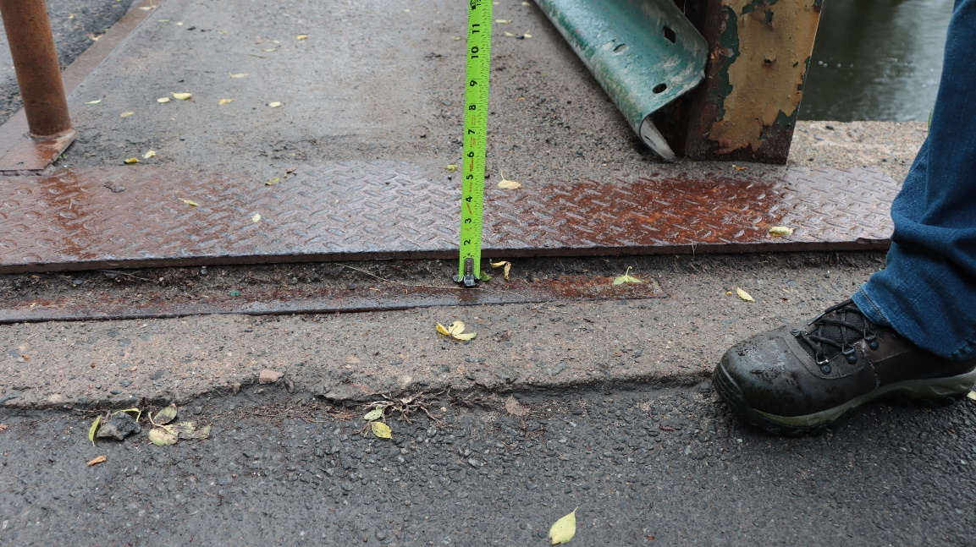
Saranac Lake Riverwalk - New Route (41)
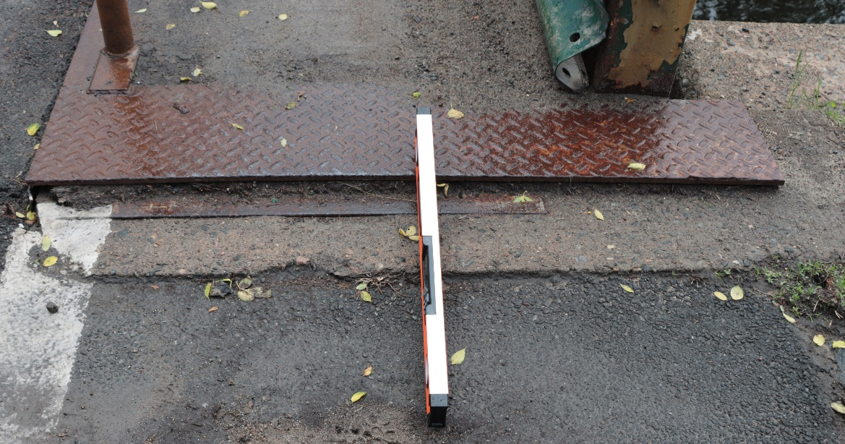
Saranac Lake Riverwalk - New Route (43)
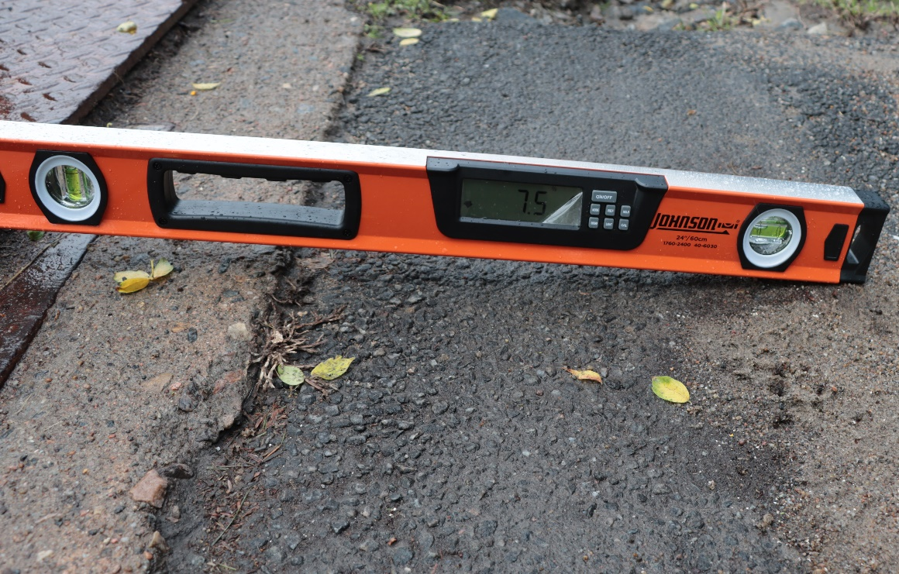
Saranac Lake Riverwalk - New Route (44)
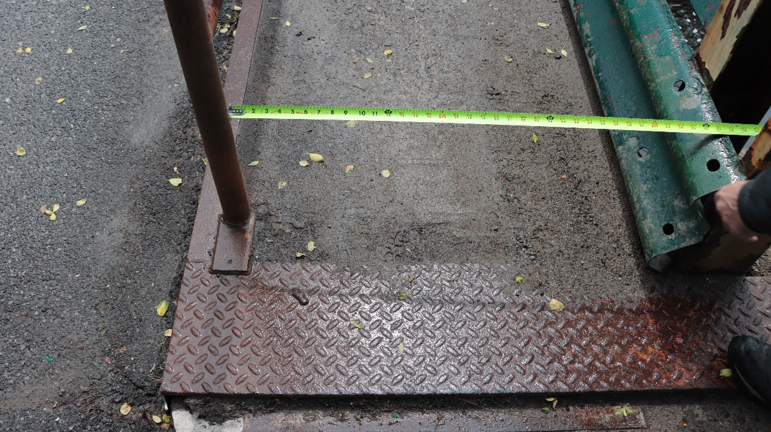
Saranac Lake Riverwalk - New Route (45)
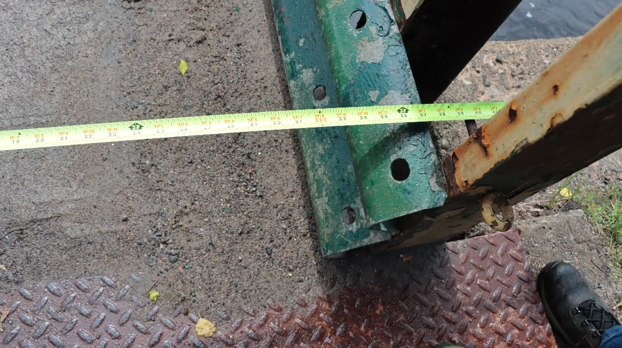
Saranac Lake Riverwalk - New Route (46)
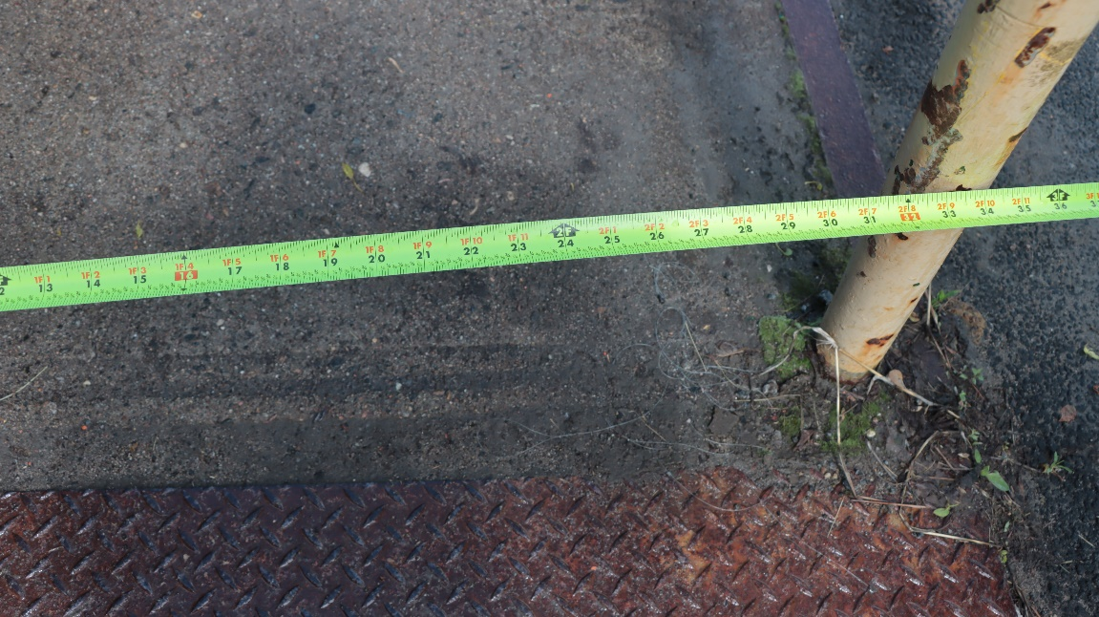
Saranac Lake Riverwalk - New Route (47)

Saranac Lake Skatepark
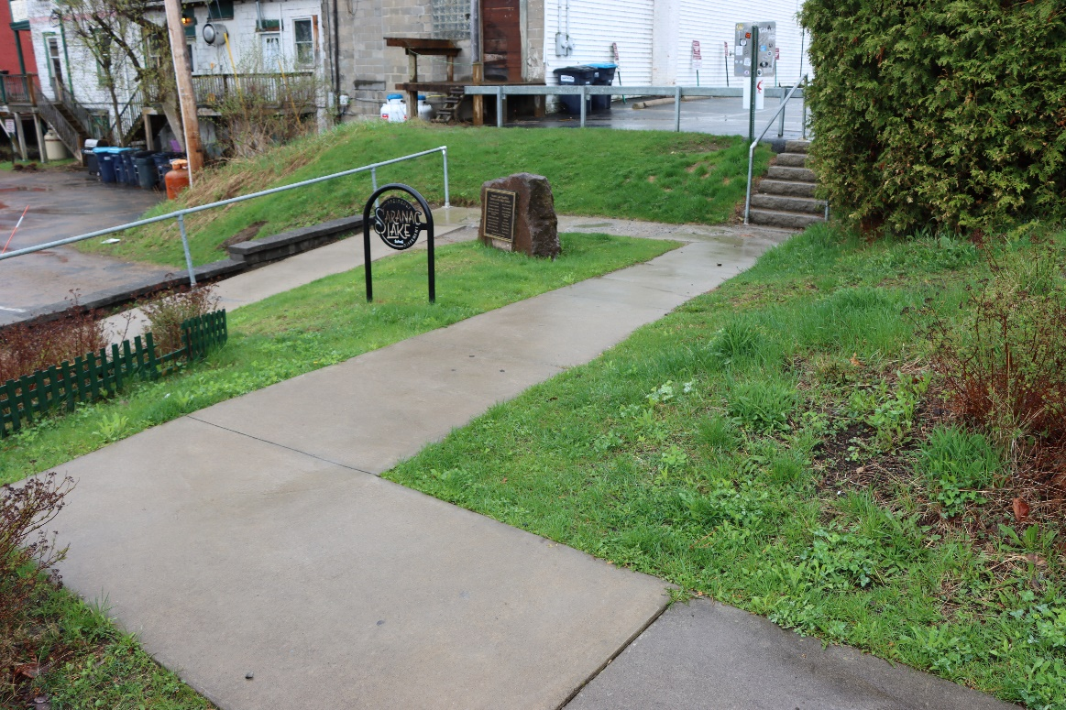
Saranac Lake Skate Park (5)
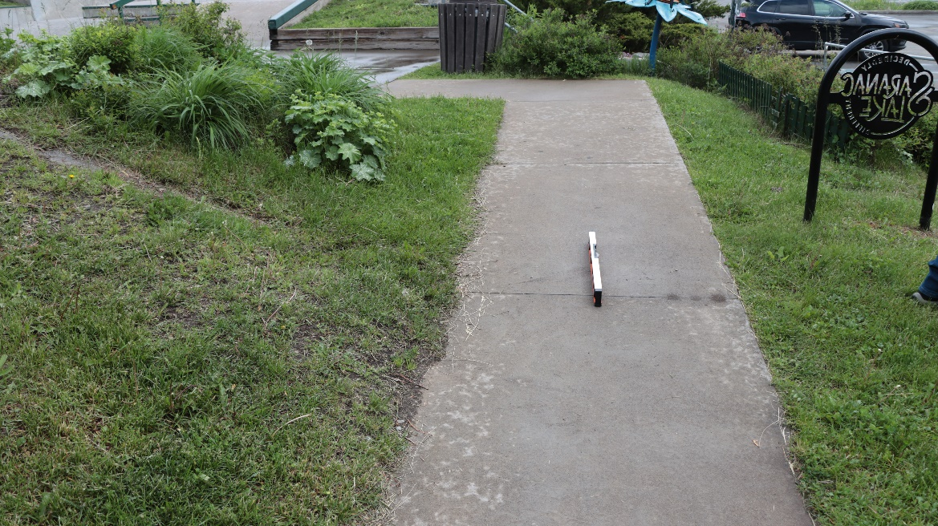
Saranac Lake Skate Park (12)
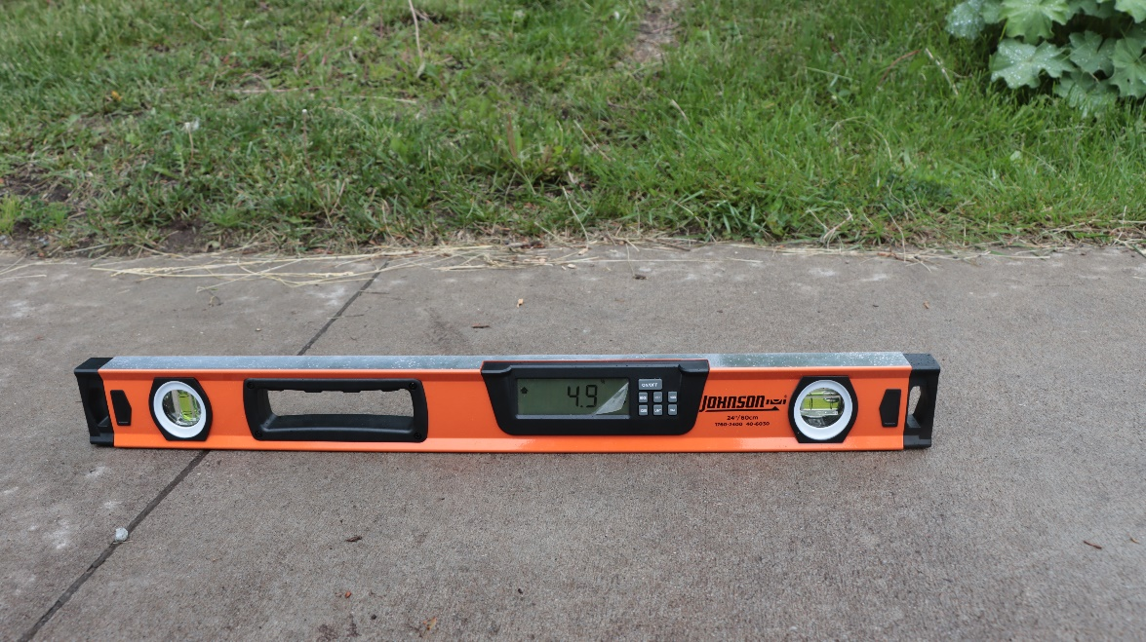
Saranac Lake Skate Park (13)

Ward Plumadore Park
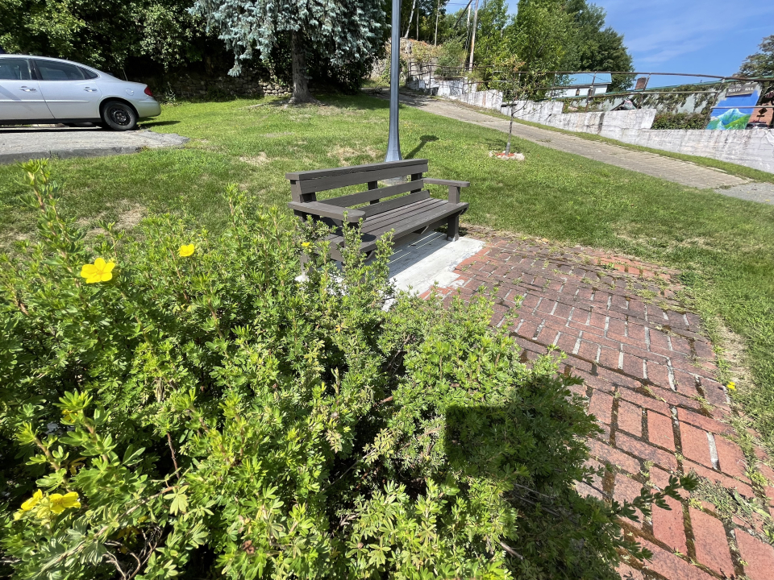
Ward-Plumadore-Pre-Renovation-(01)
Credit: Regional Office of Sustainable Tourism
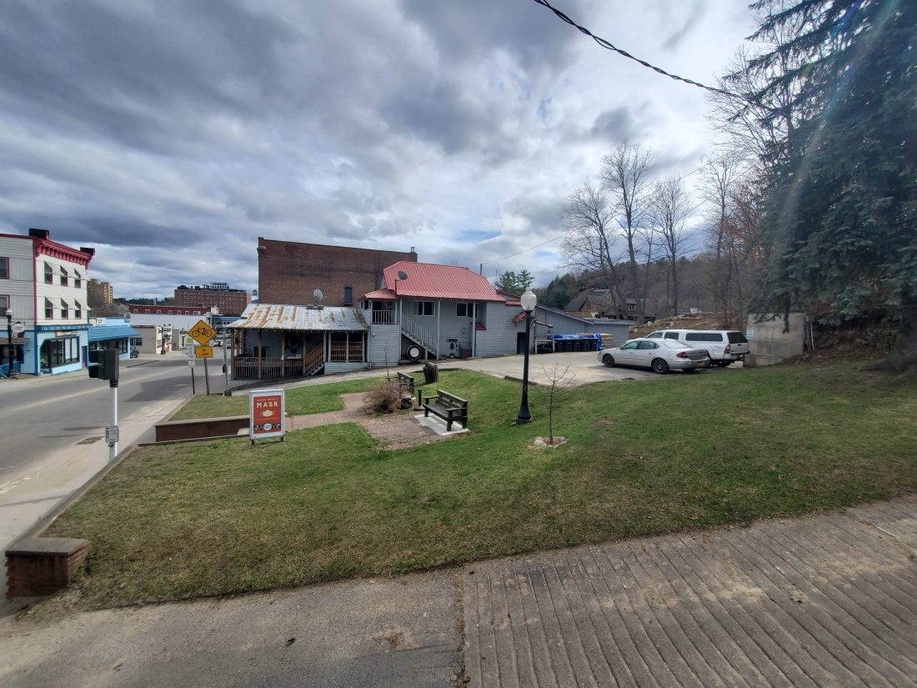
Ward-Plumadore-Pre-Renovation-(02)
Credit: Adirondack Enterprise photo — Aaron Cerbone
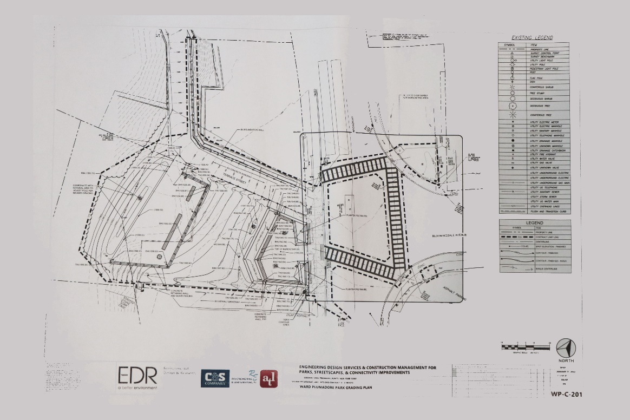
Ward Plumadore Park Grading Plan (1)
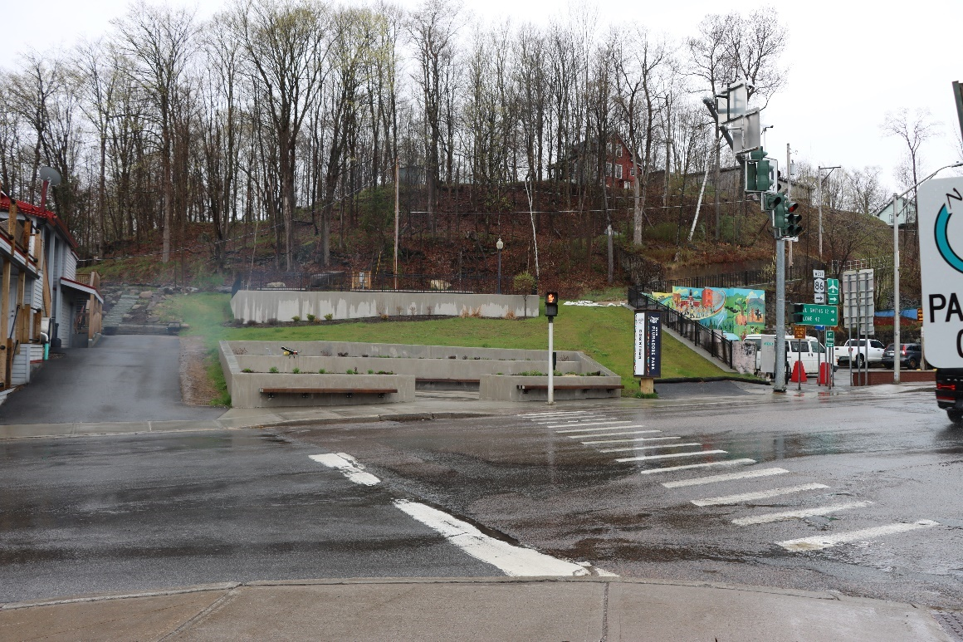
Ward Plumadore Park (2)
.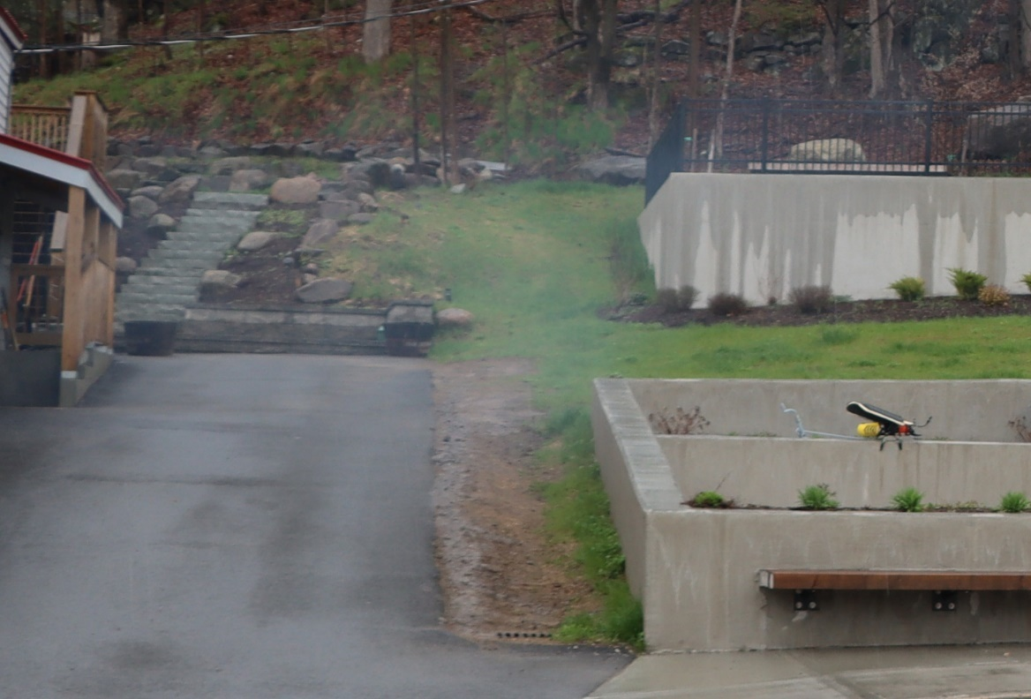
Ward Plumadore Park (2a)
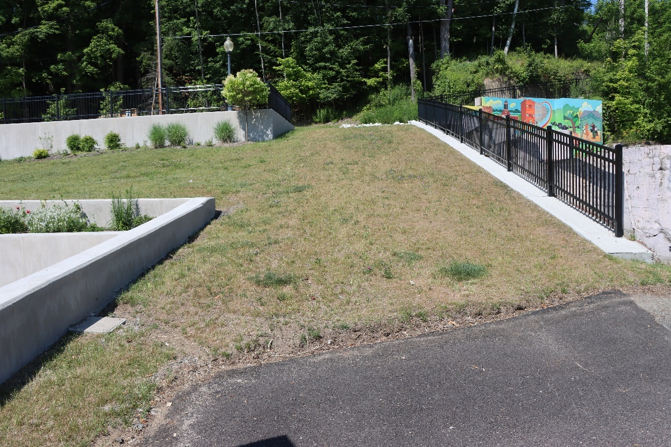
Ward Plumadore Park (11)
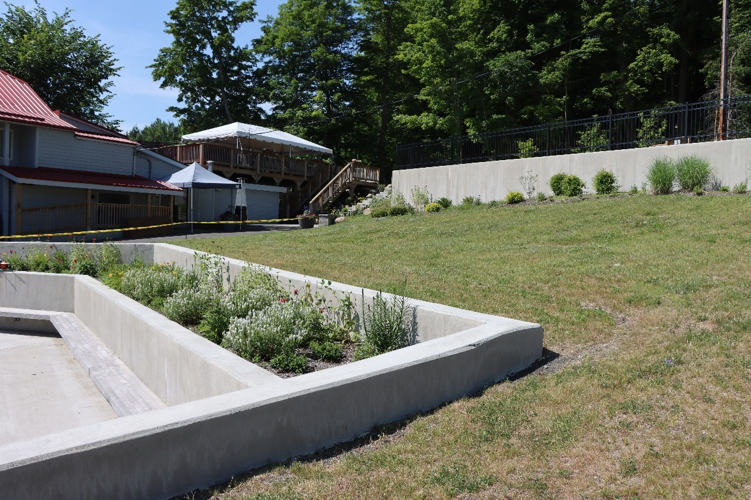
Ward Plumadore Park (12)
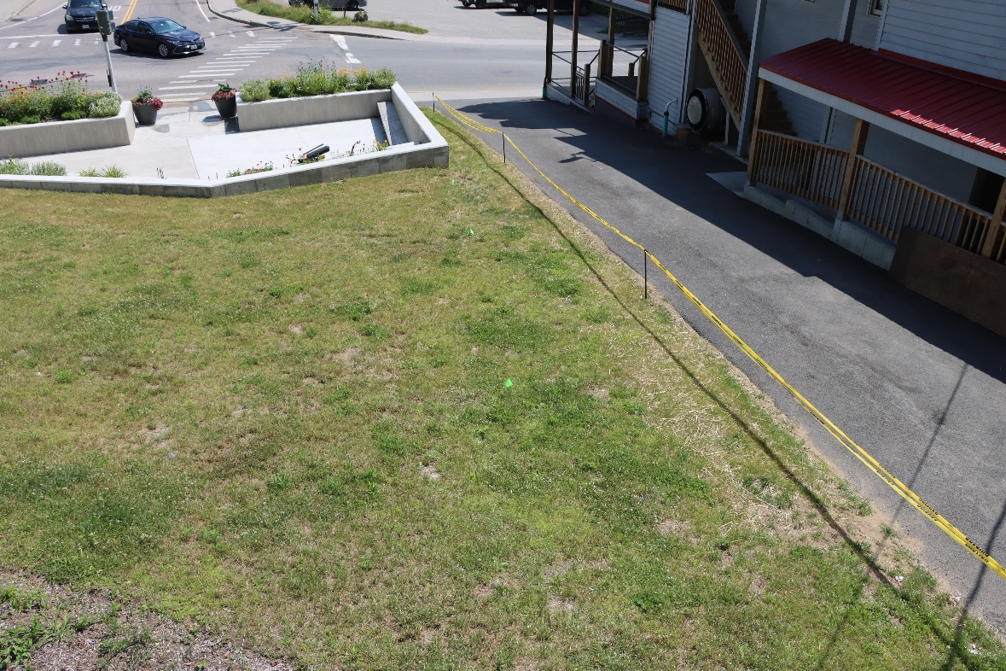
Ward Plumadore Park (25)

William Morris Park
No images provided. ADA/ABA/IBC compliant.

William Wallace Park (Lake Colby Beach)
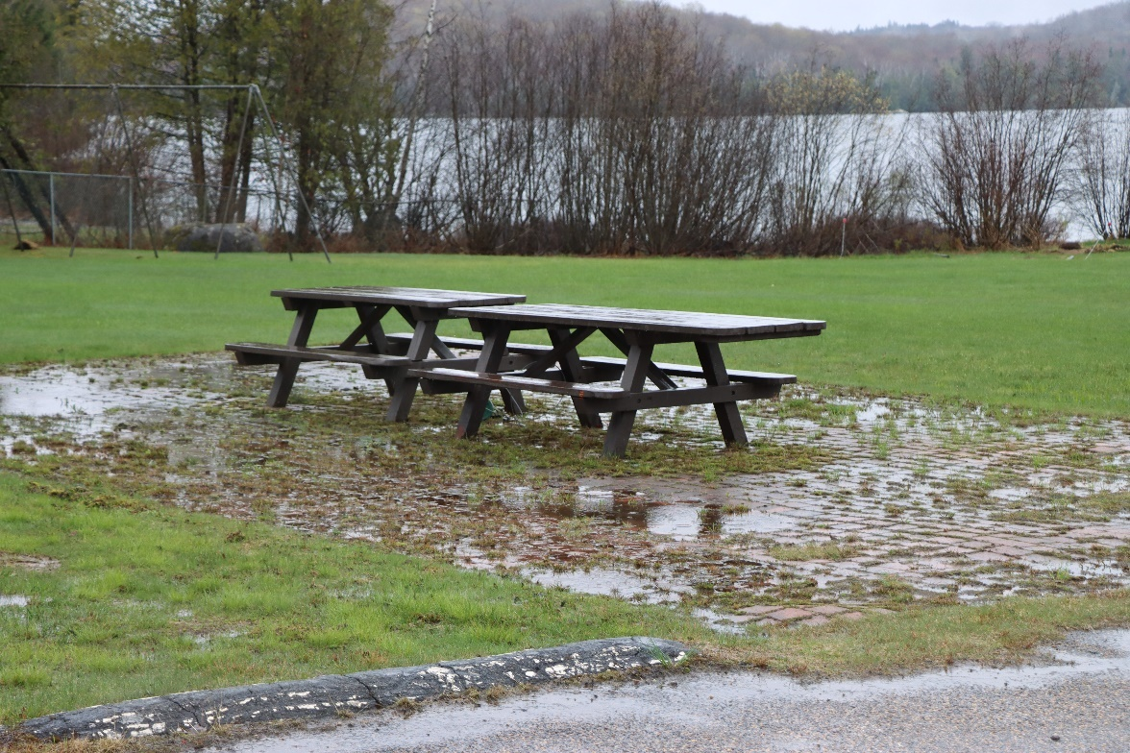
William Wallace Park Lake Colby Beach (8)
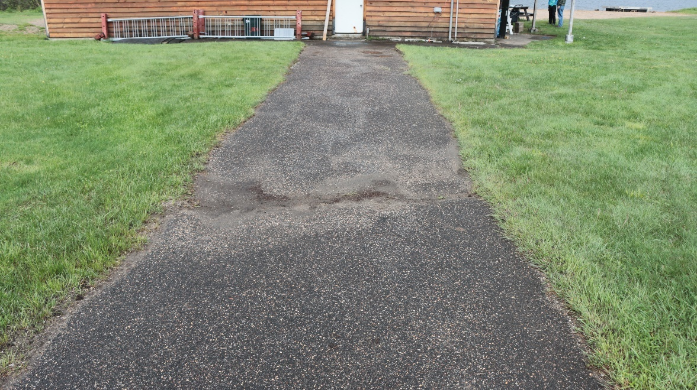
William Wallace Park Lake Colby Beach (17)
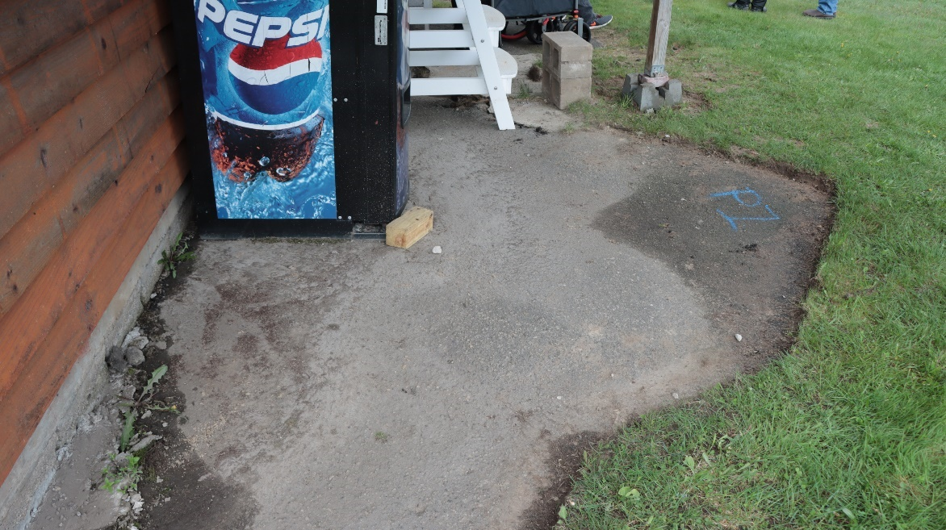
William Wallace Park Lake Colby Beach (21)
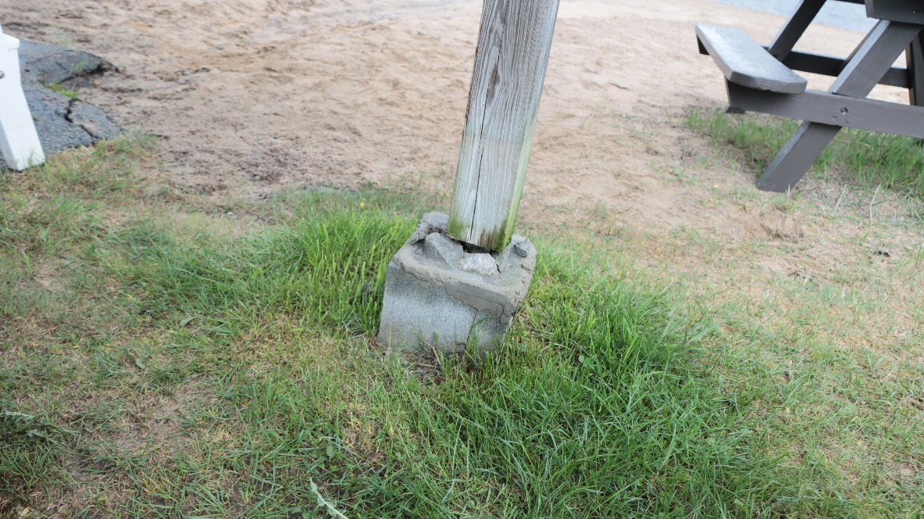
William Wallace Park Lake Colby Beach (23)
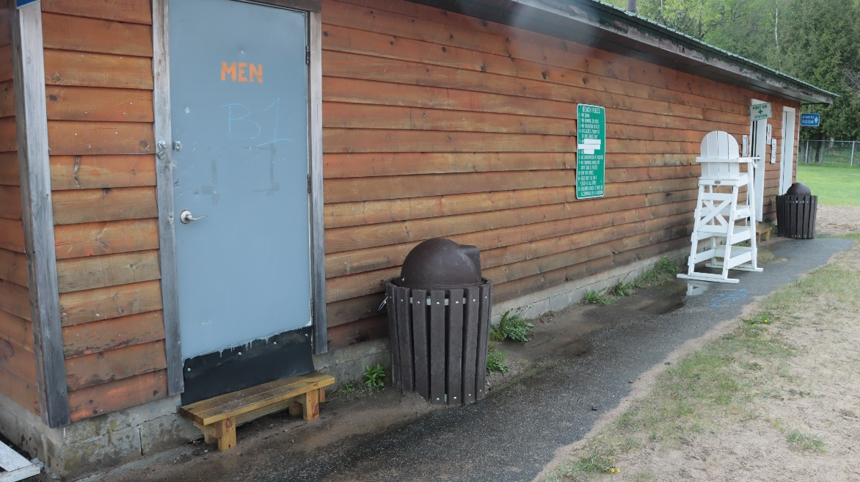
William Wallace Park Lake Colby Beach (26)
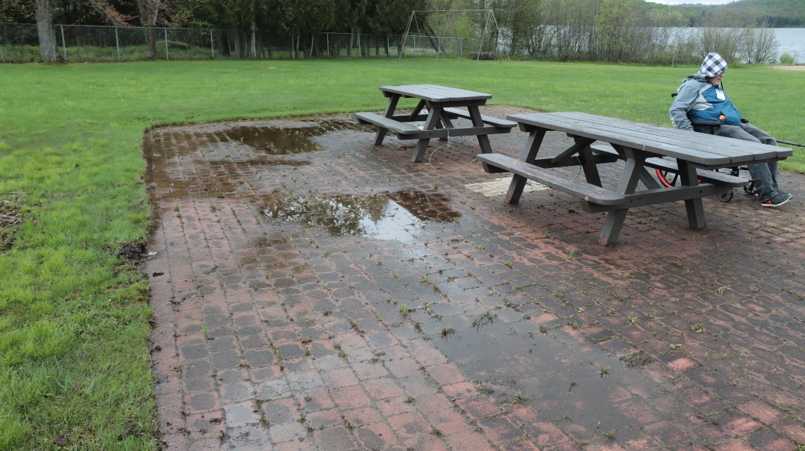
William Wallace Park Lake Colby Beach (34)

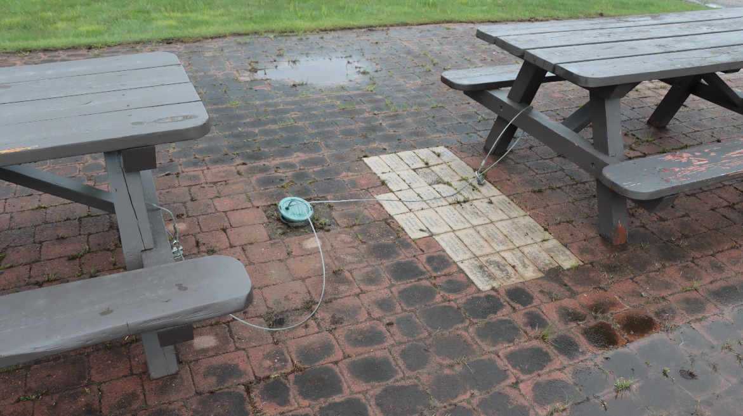
William Wallace Park Lake Colby Beach (36)
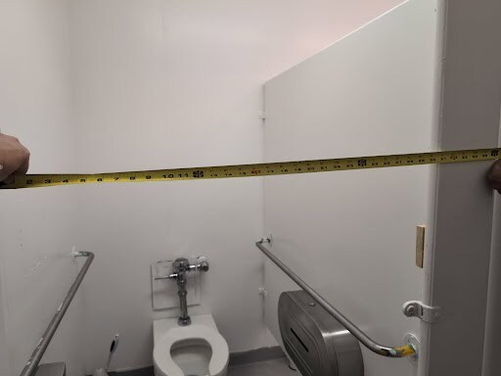
William Wallace Park Lake Colby Beach (43)
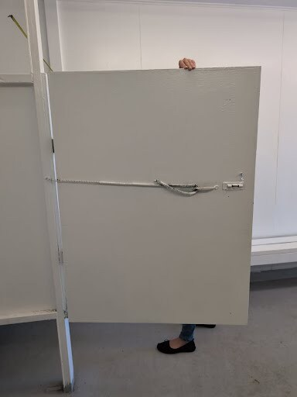
William Wallace Park Lake Colby Beach (44)
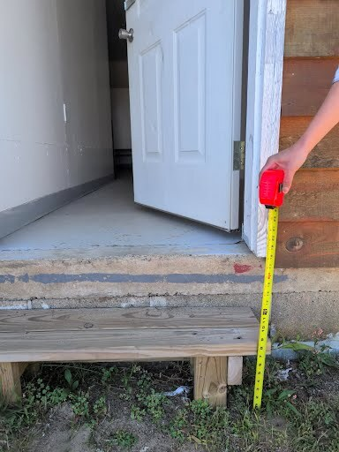
William Wallace Park Lake Colby Beach (45)
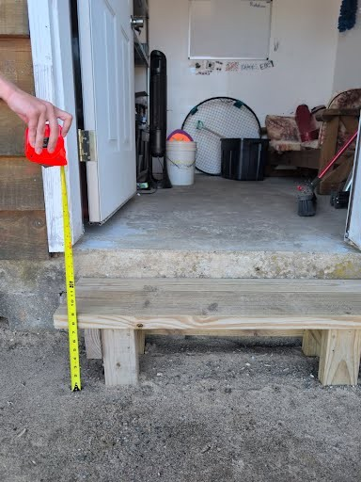
William Wallace Park Lake Colby Beach (59)
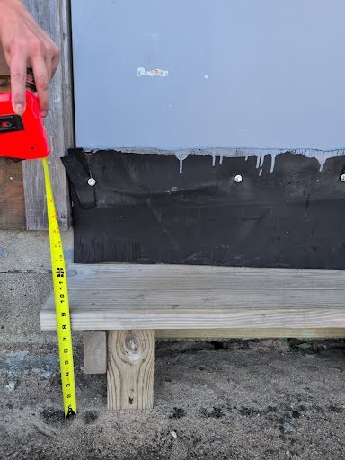
William Wallace Park Lake Colby Beach (66)
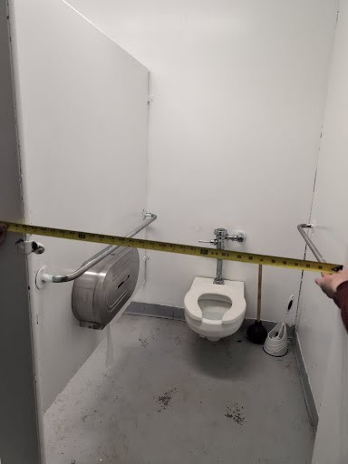
William Wallace Park Lake Colby Beach (79)

World War I Memorial
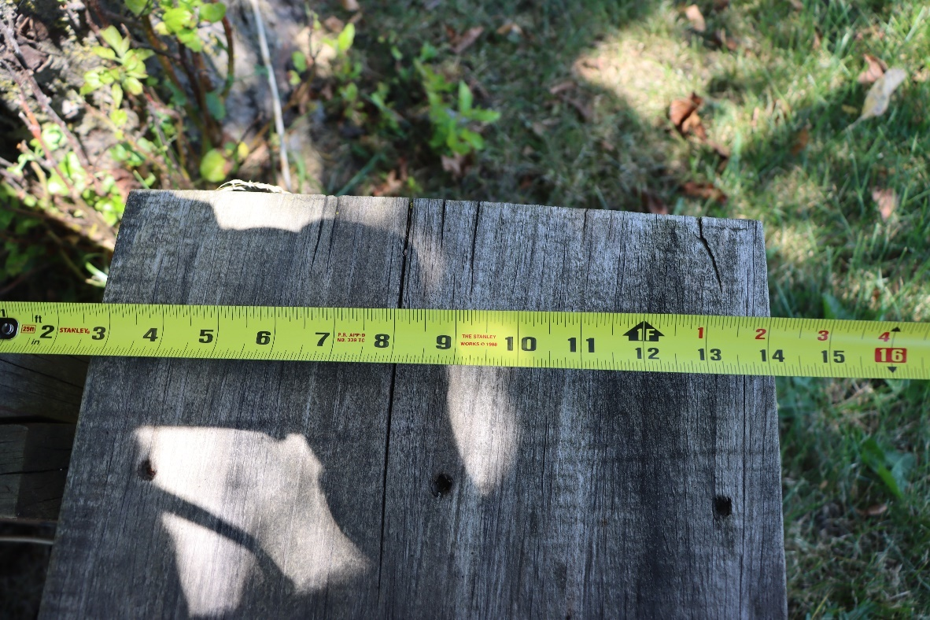
World War I Memorial (7)
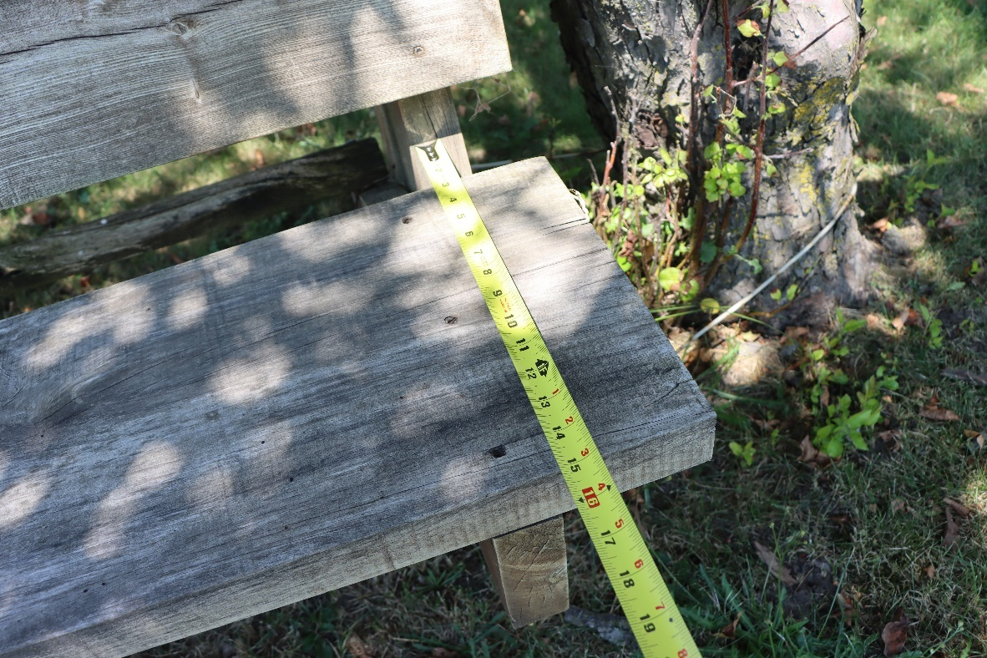
World War I Memorial (8)
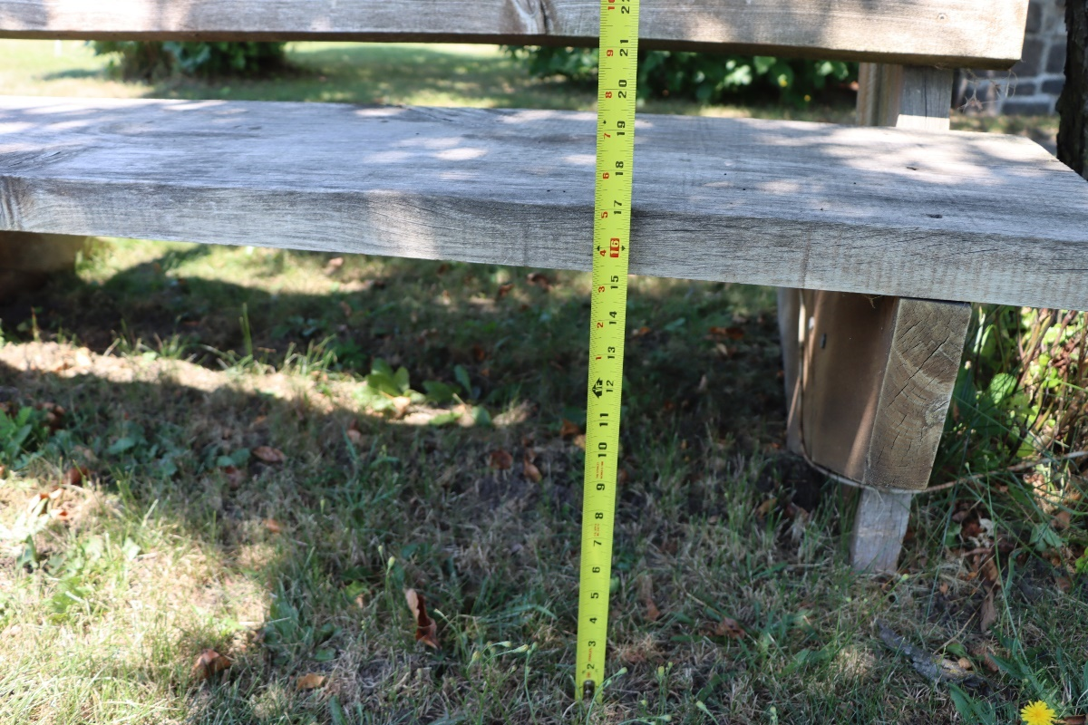
World War I Memorial (9)
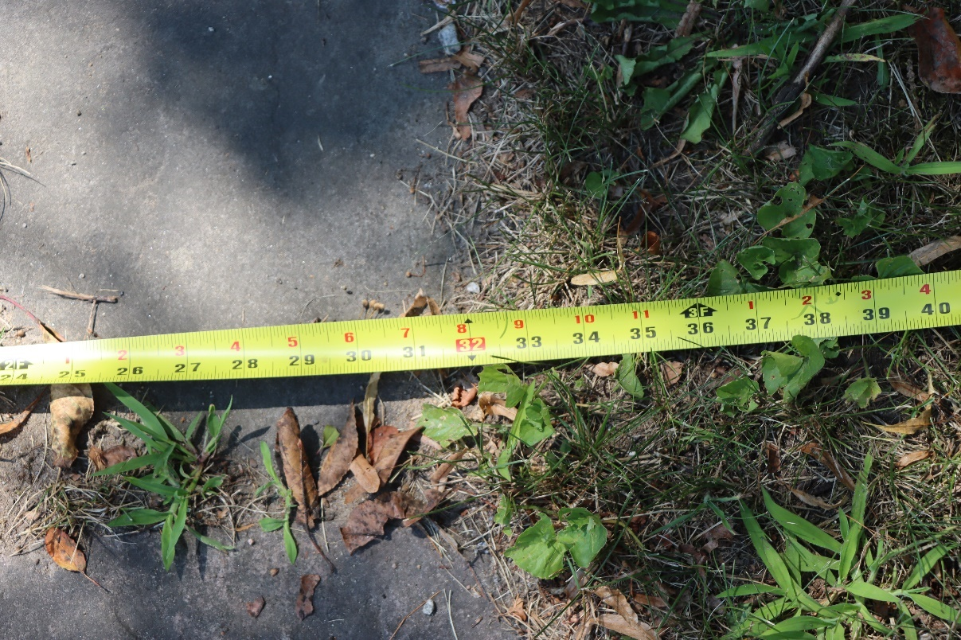
World War I Memorial (10)
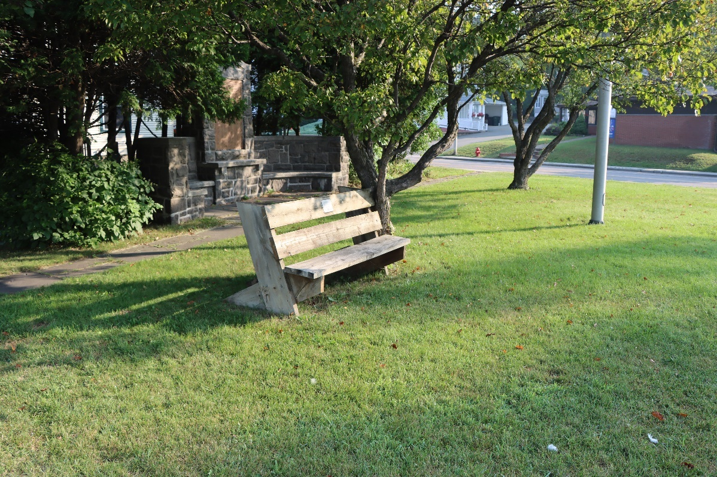
World War I Memorial (16)
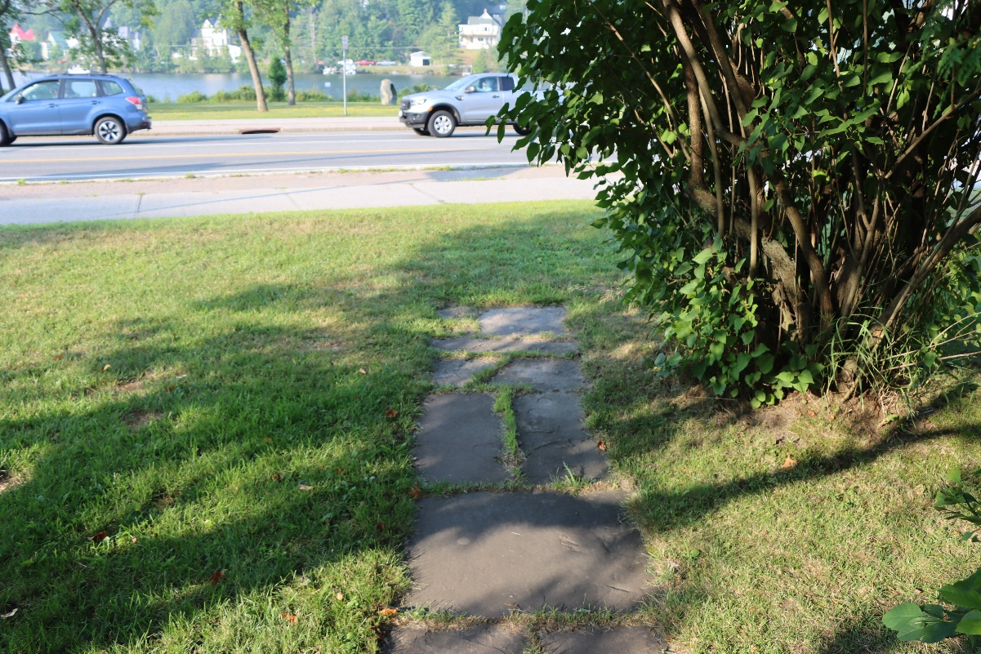
World War I Memorial (19)
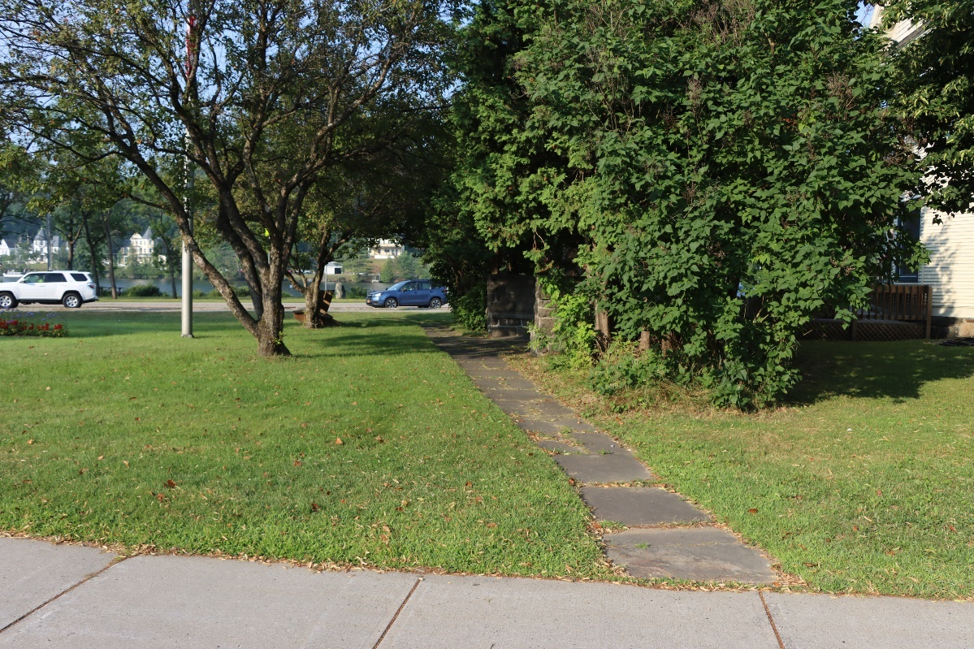
World War I Memorial (22)
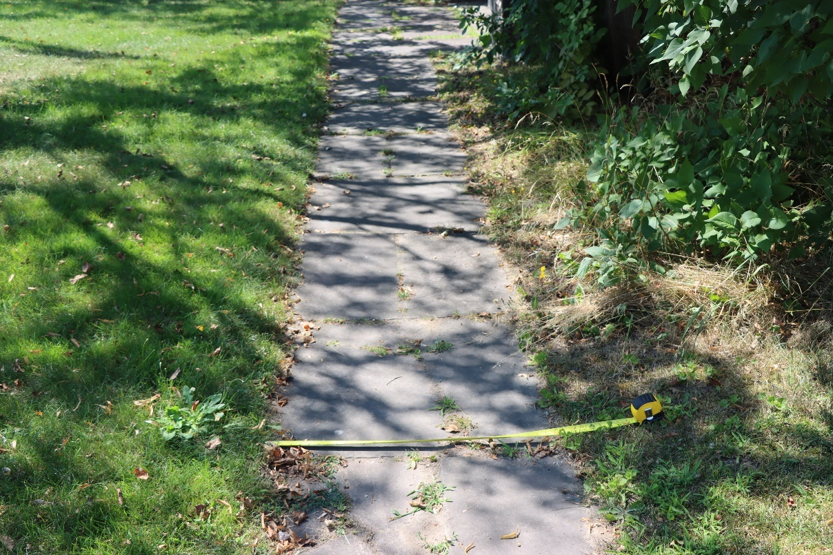
World War I Memorial (27)

Appendix B. Glossary
ANSI:
Cross slope ABA 1017.7.2: Cross slope is the side-to-side slope of the surface of an ORAR. When the surface is constructed of concrete, asphalt, or boards, the cross slope must be no steeper than 1:48 (2 percent). When the surface is constructed of materials other than concrete, asphalt, or boards, cross slopes no steeper than 1:20 (5 percent) are allowed when necessary for drainage.
ORAR (Outdoor Recreation Access Routes) – ABA F244.5, F245.4, F246.4, and F247.3.2: An ORAR is a continuous, unobstructed path that is intended for pedestrian use and that connects accessible elements, spaces, and facilities within camping and picnic facilities and at viewing areas and trailheads. ORARs cannot be used at other types of facilities, such as educational campuses, office parks, or theme parks.
ORARs must coincide with or be located in the same area as general circulation paths provided for other users.
Within camping and picnic facilities, ORARs must connect accessible elements, spaces, and facilities provided within camping and picnic units with mobility features. ORARs must also connect public and common use areas that serve camping and picnic units with mobility features and accessible elements, spaces, and facilities provided within the public or common use areas. When a circulation path connects camping and picnic facilities and adjacent recreation facilities, such as play areas or boating facilities, at least one ORAR must connect camping and picnic units with mobility features to an accessible route serving the adjacent recreation facilities.
ORAR Exceptions – ABA F202.3, Exception 4 and 1016, Exceptions 1, 2, and 3: Where elements or spaces in camping and picnic facilities, viewing areas, or trailheads are altered but the circulation path to the altered element or space is not changed, the circulation path is not required to comply with the technical requirements for ORARs.
In alteration projects, if a condition for exception does not permit full compliance with a specific provision in the technical requirements for ORARs on a portion of an ORAR, then that portion of the ORAR must comply with the specific provision to the extent practicable. The conditions for exceptions can be used for newly constructed ORARs at viewing areas. Additional information on the conditions for exceptions is provided in the section of this guide on the conditions for exceptions. Although not required, documenting use of the conditions for exceptions on a portion of an ORAR and retaining the documentation with the project records can be helpful if a complaint is filed with the Access Board alleging that the ORAR does not comply with the technical requirements.
If a roadway is the common circulation path for pedestrians within camping and picnic facilities or at viewing areas and trailheads, an ORAR may be provided within the roadway. When an ORAR is provided within the roadway, it is exempted from the technical requirements for cross slope, running grade, resting intervals, and passing spaces. The other technical requirements apply to ORARs provided within the roadway. For instance, where traffic calming devices, gates, or other barriers are provided on a paved roadway, the ORAR must have a clear width of 36 inches and obstacles cannot exceed one-half inch in height at their highest point within the clear width of the ORAR.
Running Slope ABA 1017.7.1: Running slope, also referred to as grade, is the lengthwise slope of an ORAR, parallel to the direction of travel. ORAR sections of any length may be constructed with a running slope up to 1:20 (5%). To accommodate steep terrain, ORARs may be designed with shorter sections that have a steeper running slope and length, as shown in table 3, with resting intervals at the top and bottom of each section. The running slope of any section of an ORAR must never exceed 1:10 (10%).
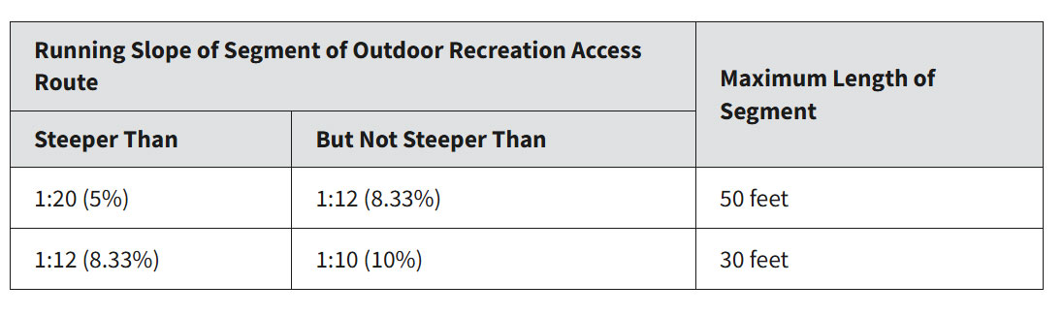

Appendix C. Resolution of the Village Board
RESOLUTION TO APPROVE PROPOSAL FROM ACCESSIBLE ADIRONDACK TOURISM
FOR ADA/ABA ACCESSIBILITYY SURVEY OF VILLAGE PARKS.
WHEREAS, the Americans with Disabilities Act (ADA) mandates that public entities provide two
forms of accessibility, physical accessibility and program accessibility; and
WHEREAS, Architectural Barriers Act (ABA) developed guidelines for outdoor developed areas; and
WHEREAS, the Village Board approved a Comprehensive Wayfinding Proposal (CWP) to develop and implement trailhead kiosks, printed maps, interpretive signage, on-trail directional signs, and a mobile friendly interactive map to support Riverwalk access, navigation, and visitor experience; and
WHEREAS, the key focus of the CWP is to highlight accessibility, ensuring that the signage and maps emphasize accessible routes and features for all visitors, and that, inclusive routes and amenities must ensure all visitors, including those with mobility challenges, can navigate comfortably; and
WHEREAS, the Village Board acknowledges that accessibility for people with disabilities is important for the people of the Village of Saranac Lake at all of our municipal parks; and
NOW, THEREFORE BE IT RESOLVED, the Board of Trustees hereby approves the proposal from Accessible Adirondack Tourism to assess 12 Village parks in accordance with the ADA through the ABA guidelines.

See, NCPR coverage entitled Saranac Lake launches accessibility review of its municipal parks: https://www.northcountrypublicradio.org/news/story/51804/20250602/saranac-lake-launches-accessibility-review-of-its-municipal-parks
Green Goat Maps, Ezra Schwartzberg. Ph.D.
Saranac Lake Riverwalk (245), (248) – next to the Adirondack Center for Loon Conservation/The Carry (GPS” 44.32654813227968, -74.13161609910993).
Saranac Lake Riverwalk (249) and video Saranac-Lake-Riverwalk-2.mov - next to the Adirondack Center for Writing (GPS” 44.327501976588536, -74.13154599492094).
Video Saranac-Lake-Riverwalk-3.mov
Video Saranac-Lake-Riverwalk-4.mov
Photos Saranac Lake Riverwalk - New Route (1), (7)
Mayor Williams was notified about the reasons for the delays on July 29, 2023.
Occurred on Saturday, August 16, 2025
See, Appendix C, Resolution of the Village Board
https://content.govdelivery.com/accounts/USCENSUS/bulletins/3a23d67
https://www.health.ny.gov/community/disability/
ADA Title II Section 35.149 provides that “Except as otherwise provided in 35.150, no qualified individual with a disability shall, because a public entity’s facilities are inaccessible or unusable by individuals with disabilities, be excluded from participation in, or be denied the benefits of the services, programs, or activities of a public entity, or be subject to discrimination by any public entity.
ADA Title II, Section 35.150(a) provides: “A public entity shall operate each service, program, or activity so that the service, program, or activity, when viewed in its entirety, is readily accessible to and usable by individuals with disabilities.”
Americans with Disabilities Act Title II Regulations, see https://www.ada.gov/law-and-regs/regulations/title-ii-2010-regulations/
https://up.codes/viewer/new_york/ibc-2018
https://saranaclakeny.gov/departments/
ADA Coordinator’s Role, https://nwadacenter.org/toolkit/ada-coordinators-role
If a public entity has 50 or more employees, it is required to designate at least one responsible employee to coordinate ADA compliance. https://adata.org/factsheet/ada-coord-role
ADA Training, https://adata.org/ada-training
ADA Requirements: Wheelchairs, Mobility Aids, and Other Power-Driven Mobility Devices, https://www.ada.gov/resources/opdmds/
Service Animals, https://www.ada.gov/topics/service-animals/, and Service Animals Allowed Where Public is Allowed, NYS Attorney General brochure, https://ag.ny.gov/sites/default/files/publications/serviceanimals- english.pdf
ADA Requirements: Ticket Sales, https://www.ada.gov/resources/ticket-sales/
Commonly Asked Questions About the ADA and Law Enforcement, https://www.ada.gov/resources/commonly-asked-questions-law-enforcement/
Understanding Conformance https://www.w3.org/WAI/WCAG22/Understanding/conformance
https://www.lflegal.com/wp-content/uploads/2025/02/Userway-complaint-filed.pdf and https://medium.com/design-domination/userway-class-action-lawsuit-9baaf67a816b
https://www.ftc.gov/system/files/ftc_gov/pdf/2223156accessibecomplaint.pdf
The team utilized a Goyojo 500N Digital Force Gauge High-Precision Push-Pull Meter for Tension and Compression Testing
https://adata.org/factsheet/adjusting-doors-access
https://www.access-board.gov/ada/guides/chapter-4-entrances-doors-and-gates/#automatic-and-power-assisted-doors-and-gates
https://www.access-board.gov/aba/guides/chapter-7-signs/#chapter-7-signs
See Glossary for more information on ORARs.
https://www.access-board.gov/aba/guides/chapter-7-signs/#chapter-7-signs
https://www.access-board.gov/aba/guides/chapter-7-signs/#chapter-7-signs
https://www.access-board.gov/aba/guides/chapter-7-signs/#chapter-7-signs
https://www.access-board.gov/aba/guides/chapter-7-signs/#chapter-7-signs
https://www.access-board.gov/aba/guides/chapter-7-signs/#chapter-7-signs
Video Saranac-Lake-Riverwalk-7.mov
https://www.access-board.gov/aba/guides/chapter-7-signs/#chapter-7-signs
https://www.access-board.gov/aba/guides/chapter-7-signs/#chapter-7-signs
https://www.access-board.gov/aba/guides/chapter-7-signs/#chapter-7-signs
https://www.access-board.gov/aba/guides/chapter-7-signs/#chapter-7-signs
https://www.access-board.gov/aba/guides/chapter-7-signs/#chapter-7-signs
https://www.access-board.gov/aba/guides/chapter-7-signs/#chapter-7-signs

